Body of Knowledge – Florin Pană

**Contents**

Ethical Hacker 1 – Basic Hacking and Pentesting Process 2

Ethical Hacker 2 – Law, Ethics and Responsible Disclosure 4

Ethical Hacker 3 – Footprinting, Reconnaissance and Social Engineering 5

Ethical Hacker 4 – Network scanning and enumeration 15

Ethical Hacker 5 – Path traversal, File inclusion and Command injection 19

Ethical Hacker 6 – SQL Injection 25

Ethical Hacker 7 – XSS and CSRF 27

Part 1: XSS 27

Part 2: CSRF 31

Ethical Hacker 8 – Network Sniffing and Spoofing 33

Ethical Hacker 9 – Password cracking 37

Ethical Hacker 10 – Wireless Hacking 43

Risk Consultant 1 – Security Threats 49

Risk Consultant 2 – IT Risk Analysis & Business Continuity 52

Security Engineer 1 – Information Security Concepts 56

Security Engineer 2 – Network Separation and Segmentation 58

Security Engineer 3 – Secure Network Connections 70

Security Engineer 4 – Secure Remote Access and Management (VPN) 82

Security Engineer 5 – Intrusion Detection and Prevention 91

Security Engineer 6 – System defense 106

Security Engineer 7 – Law, Standards & Compliance 110

Security Analyst 1 – IT basic monitoring 112

Security Analyst 2 – Security Incident Management 120

Security Analyst 3 – IT security monitoring 122

Security Analyst 4 – Common vulnerabilities and exposures 130

# Ethical Hacker 1 – Basic Hacking and Pentesting Process

* **What are the process steps of every pentest in general?**

A pentest has 5 process steps, but only the first 4 are used in general, because ethical hacking does not involve the post-exploitation (and sometimes even exploitation) part because serious and unnecessary damage can be made to the system.

These four steps are:

1. Intel gathering: during this step the pentesters gather all the information they need to proceed with the actual testing: email addresses, phone numbers, etc.
2. Footprint: this step consists of gaining more knowledge about the IT system that is going to be tested.
3. VuIn analysis: in this step some more in depth pentests are being made to look for vulnerabilities in the system.
4. Exploitation (sometimes not even this process step is used in pentesting): after a weakness has been found, if the contractor agrees, the pentester can go further and use that weakness to enter the system. This step requires maximum caution in order to prevent unwanted damage to the tested IT system.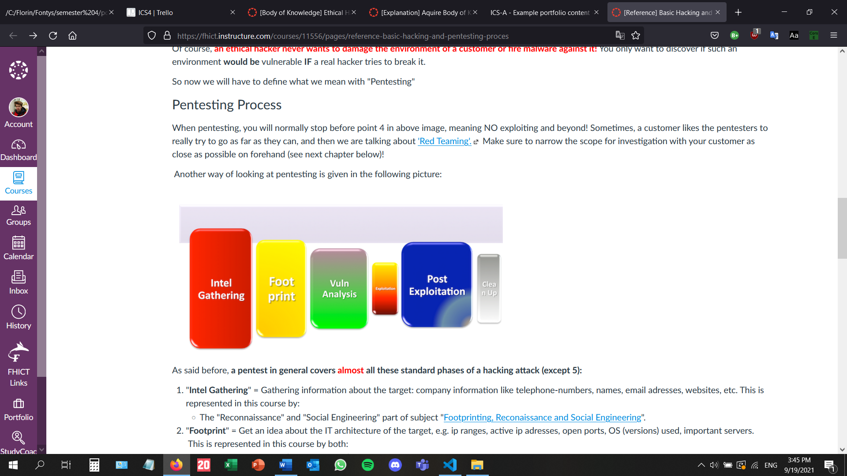

* **What are the minimal requirements for a good pentest contract and pentest report?**

A good pentest contract is very important because of the legal issues involved. There can sometimes be a thin line between (illegal) hacking and ethical hacking. Therefore, the contract should contain the following:

1. Indemnification clause: the client allows the testers to do the pentest and becomes aware of the risks, since the testers are not liable for these risks.
2. Confidentiality agreement: it is important to keep the test and especially its results confidential. Otherwise, ill-intended people could find out about a system’s weaknesses way before the client can repair them and the system could be severely damaged.
3. Information about the tested systems: it is important for the pentesters to know precisely what they are dealing with.
4. Test origin and period: the client should know when a test is being carried out to prevent the confusion between it and an actual cyber-attack.
5. Escalation procedure: it is always indicated to think of every scenario, even the worst-case one. Both parties should know from the very beginning what would happen in case of an unforeseen event.

After the pentest is finished, the results must be written on a report.

A good report should contain the following:

1. The scope of the pentest
2. The goals of the pentest
3. The findings
4. The approach
5. Conclusions

All of this should be included in a clear and concise presentation in front of the client.

# Ethical Hacker 2 – Law, Ethics and Responsible Disclosure

* **Find a few examples of cyber-crime cases (sentences and penalties). If you are a student from abroad, find such example cases from your home country.**

My home country, Romania, is among the last countries in Europe to adopt a cyber-security set of laws. Until now I was not aware of any sentence for this crime in my country and after rigorous research, I still did not manage to find anything. However, it is quite often that public Romanian institutions get attacked because of their low security. The most common cyber-attacks against these institutions consist of obtaining passwords and leaking confidential data. Attackers from Romania and eastern Europe, especially from Russia take advantage of the poor security of our institutions’ IT systems and for now there are very little to no consequences for them.

* **Describe what you will do if you find a high risk vulnerability, unexpected, in a website or IT-infrastructure. Take into consideration if you want to make money or make the world a safer place.**

I would comply to the disclosure regulations, if applicable and would report the vulnerability found straightaway, no matter what the preconditions and the promises of the company may be. In my opinion it would not be worth the risk since there are countless other ways to make money.

* **Find two or three companies and explain the concept of responsible disclosure they have in place and compare those companies.**

1. Philips -> they put more emphasis on the reward and are very vocal when it comes to what the tester can and cannot do. Their reporting procedure is slightly more complicated in comparison to the other two companies.
2. Microsoft -> they are very specific when it comes to defining the risks and vulnerabilities found by the tester. They specify that no legal action would be taken against the tester, but no mention of a reward. They believe that the knowledge gained throughout this process is rewarding enough.
3. Carestream -> their reporting procedure is very simple and straightforward: one form the tester has to fill in. They specify that no legal action would be taken against the tester, and also a mention of a reward. They are very specific when it comes to what the tester should do and what the company should do throughout this process.

* **References:**
* Philips: <https://www.philips.com/a-w/security/coordinated-vulnerability-disclosure.html>
* Microsoft: <https://query.prod.cms.rt.microsoft.com/cms/api/am/binary/RW5Alv>
* Carestream: <https://www.carestream.com/en/us/services-and-support/cybersecurity-and-privacy/coordinated-vulnerability-disclosure>

# Ethical Hacker 3 – Footprinting, Reconnaissance and Social Engineering

* **Explain why this is an important phase of the pentesting process.**

This is an extremely important phase of the pentesting because this is the part in which the testers gather all the information that they need to create a plan. If this phase is taken seriously and is carried out properly, then the rest of the pentest will be significantly easier and the objectives will be much clearer.

* **Make sure that you can show and explain at least 3 different techniques for searching useful information.**

1. **Google searching** -> Google can be used for hacking. By typing very specific queries, many useful and interesting things can be found and made. This is an easy way to find weaknesses on low security websites.
2. **Network information discovery** -> this technique is gathering private information from online databases and is mainly used to discover more about people or entities.
3. **Social network analysis** -> it involves manual searching on social media networks, but this process can also be facilitated by automated tools, such as Social Mapper or Maltego.

* **Find how frontpage of nu.nl looked like 10 years ago using waybackmachine.org**

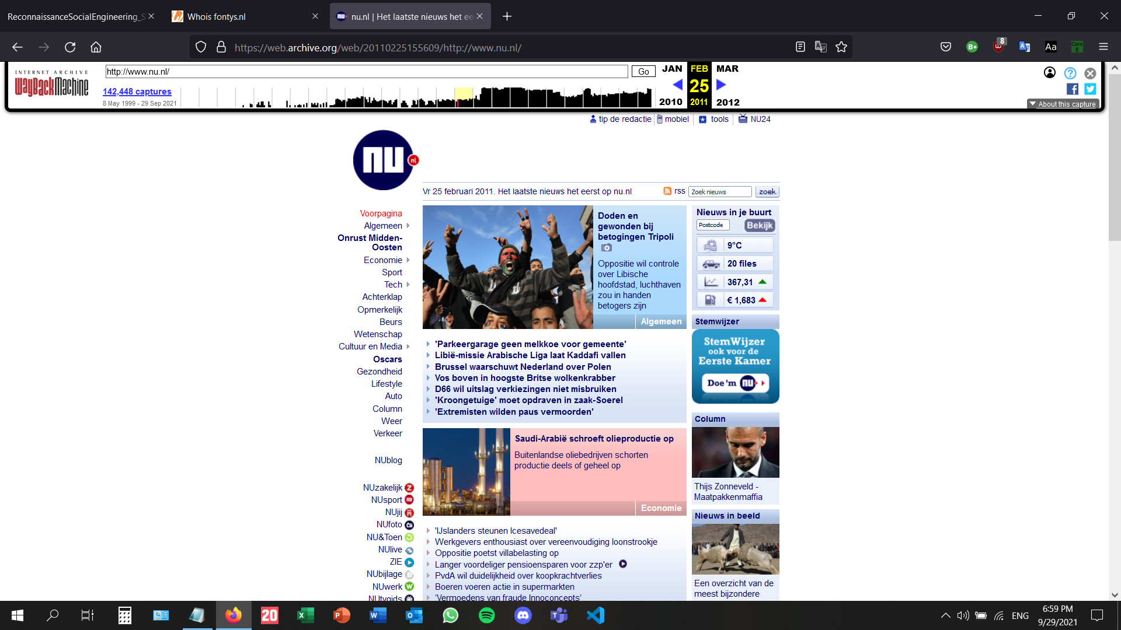

* **Discover what URLs are hidden from search robots in robots.txt files of Pentagon and Whitehouse.**

If the domain contains a robots.txt file, the administrator of the domain can specify the URLs that should not be taken into consideration by search bots. As a consequence, the search engines will not check these URLs.

The robots.txt file of the Pentagon: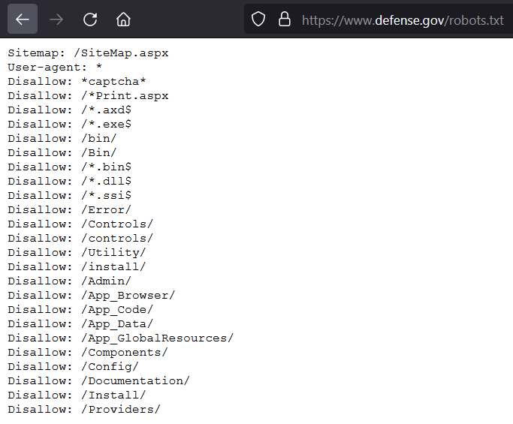

The robots.txt file of the White House: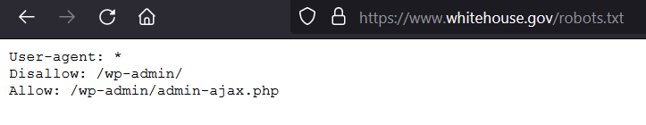

* **Find at least 3 people including email adress (not management) that work within a large International Company, for example using social networks like Linkedin**

1. Amanda Yaw – senior visual designer at Zappos family of companies: amandayaw@justsayyaw.com (Zappos)
2. Georgios Gousios - g.gousios@tudelft.nl (Facebook)
3. Jessie Xu - jessieunc@gmail.com (Google)

* **Use tooling for:**
* **Traceroute to determine path to fontys.nl, fhict.nl**

Traceroute to fontys.nl: using the command tracert followed by a URL you can display possible routes and measure the transit delays of packets across an IP.

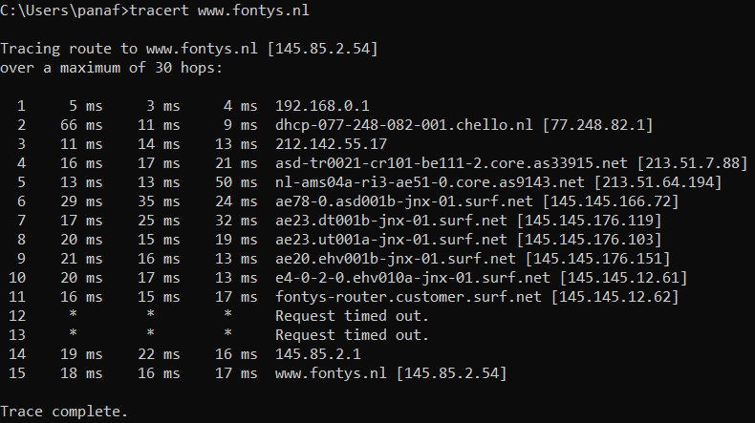

Traceroute to fhict.nl: applying the same principles to a different website this time:

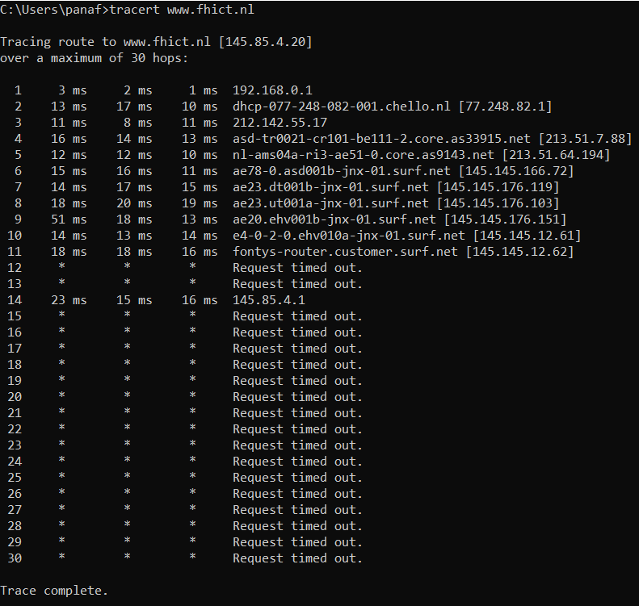

* **determine which DNS and email servers are used by fontys and fhict:**

DNS and email servers used by fontys: in order to find out this information, the nslookup instruction is required. After that, I wrote fontys.nl after the generated text.

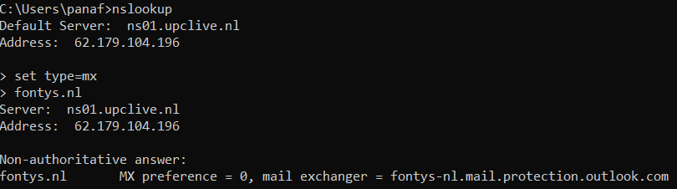

DNS and email servers used by fhict: I have done the same thing, but typed fhict.nl at the end instead:

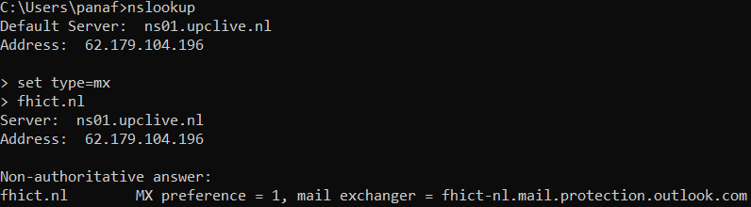

* **determine which ip-adressess are used by fhict by whois utility and non whois tool**

IP addresses used by fhict:

**Whois utility:**

I have searched whois on google to find the website whois.com. I have searched for fontys and the result is this:

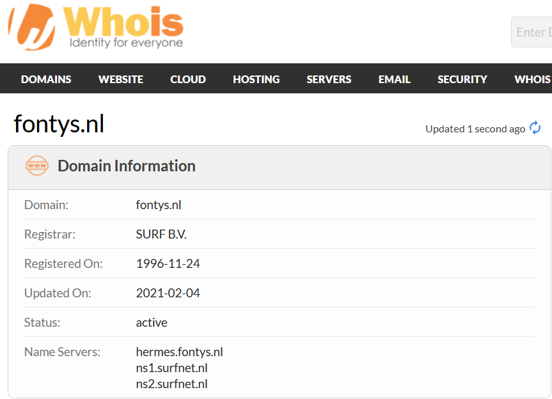

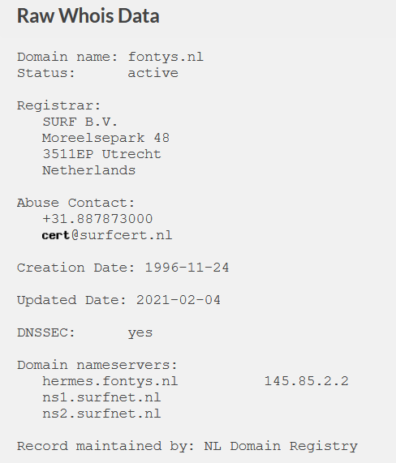

**Non whois utility:**

IP adress of fontys.nl:

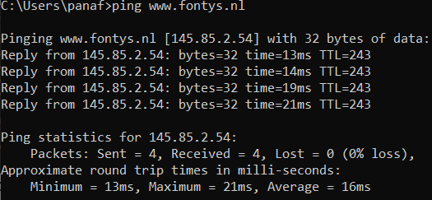

* **run the harvester utility for domain fontys.nl**

Running the Harvester utility by typing the command “theHarvester” in the kali machine terminal:

-d represents the domain, -l represents the limit of the number of results, and -b represents the search engine: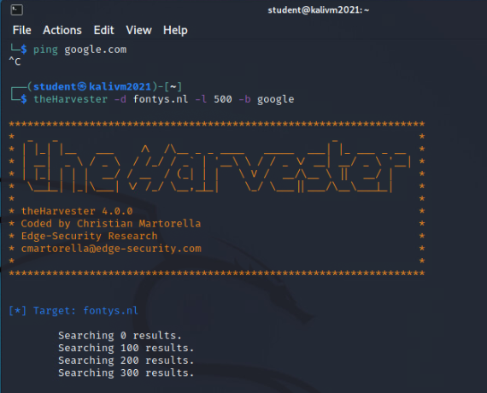

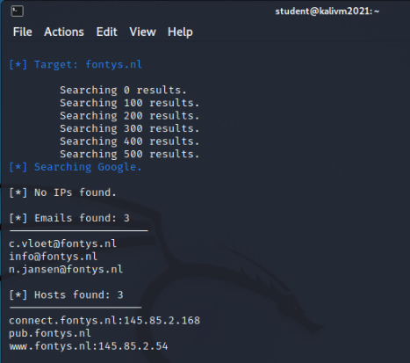

References:

* <https://www.gohacking.com/use-google-for-hacking/>
* <https://web.archive.org/web/20110225155609/http://www.nu.nl/>
* <https://www.whois.com/whois/fontys.nl>
* <https://www.defense.gov/robots.txt>
* <https://www.whitehouse.gov/robots.txt>

# Ethical Hacker 4 – Network scanning and enumeration

Credentials:

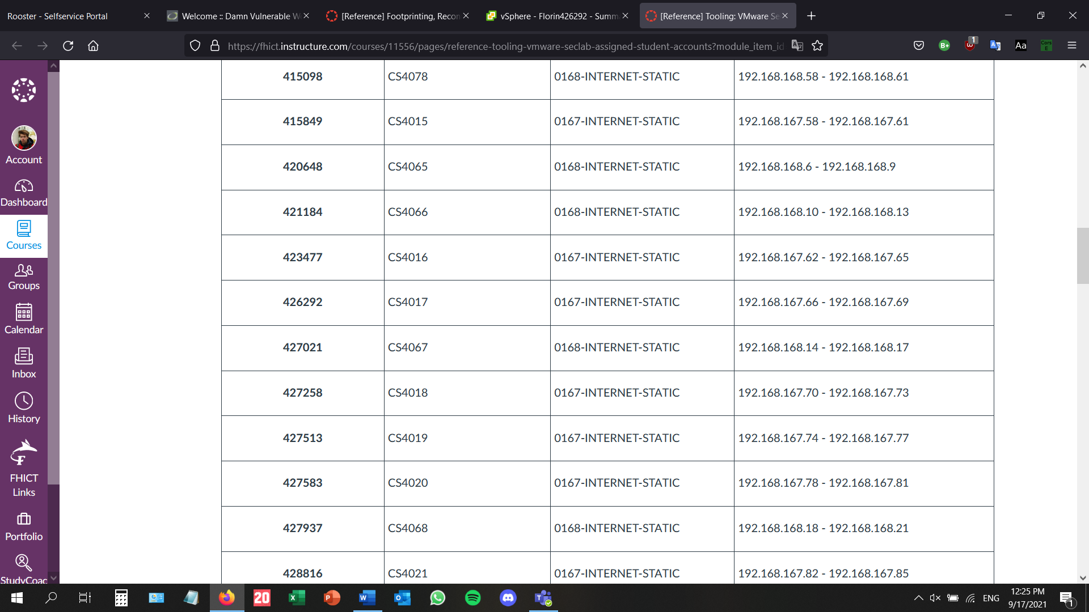

* **Read, show, and explain about the different type of portscanning techniques.**

The terminal has found 37 out of the 256 possible hosts in the 192.168.167/24 network running by using the -sP scanning. It also works for finding my own hosts: 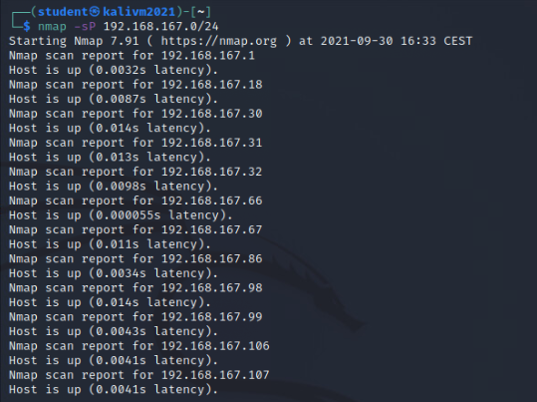

Example of a TCP SYN scan: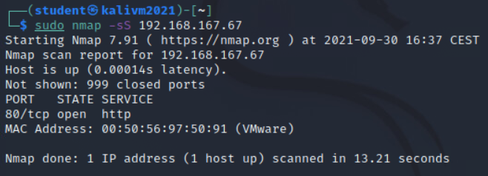

example of a TCP connect scan: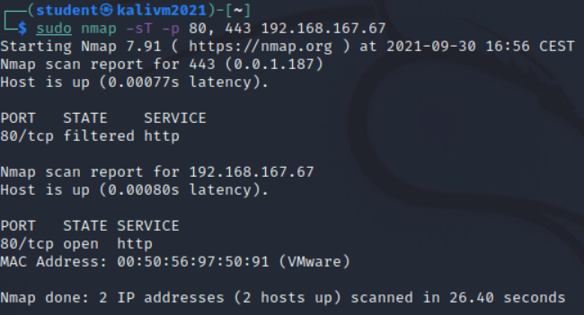

The -sT scan type is for the TCP connection scanning. The server receives SYN from the client to find out if the server is there. After that, the server sends a response containing SYN/ACK to notify the client of its presence. Finally, the client sends ACK to notify that they are ready to establish a communication. Nmap can find out if a port is open or closed by using this 3-way handshake. In the given example, the ports 80 and 443 have been chosen because they are used to deliver http services.

example of a UDP scan: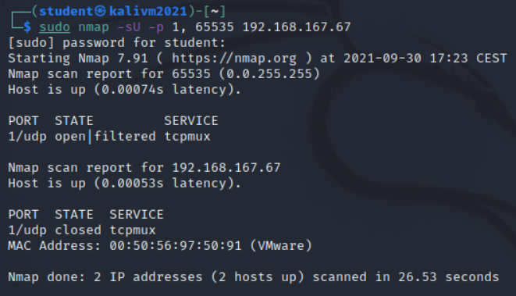

The -sU scan type is for the UDP connection scanning. It sends UDP packet for the targeted port. The port is close if an ICMP (Internet Control Message Protocol) “port unreachable” is returned. Otherwise, the service responds with a UDP packet.

* **Read, show, and explain about** **service scans for enumeration**.

Example of a version detection scan: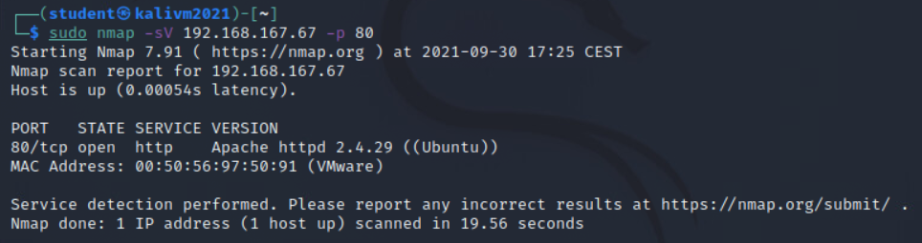

The detection command searches through open ports to find useful information about what is currently running and how. This example shows the service and version run on port 80.

* **Read, show, and explain how you can detect the OS of a system.**

**Example of an operating system detection scan:**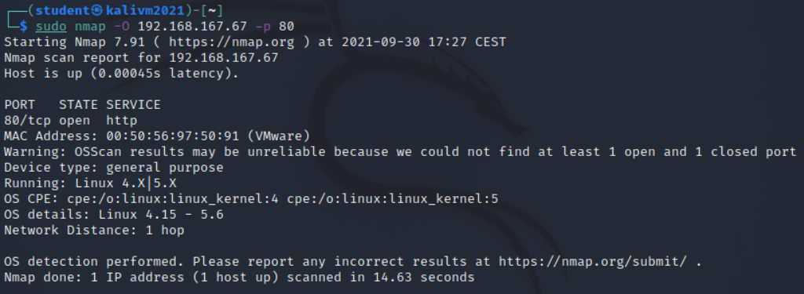

The OS detection scan is run using the -O flag. Nmap sends multiple TCP and UDP packets to the remote host and examines the responses thoroughly. After multiple tests have been performed, nmap searches through the contents of its database to look for a match.

# Ethical Hacker 5 – Path traversal, File inclusion and Command injection

* **What is path traversal and how does it work?**

Path traversal is an attack through which the content of files outside the root directory is shown. The most common method is using the “../” sequence. Path traversal is not as common as SQL injection, for example, but is still a threat for the web applications.

* **What is remote file inclusion and how does it work?**

Remote file inclusion is a method used by attackers to get the web application to include a remote file. Malicious code can also be entered for the web application to execute it if there is no security in place for such input. Below there are some examples of file inclusion attacks:

Modifying the URL (page=*file4.php*) to find a hidden file:

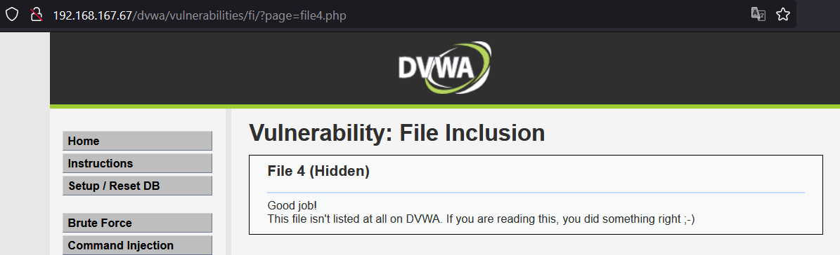

Modifying the URL (using the “../” sequence repeatedly) to get the user account: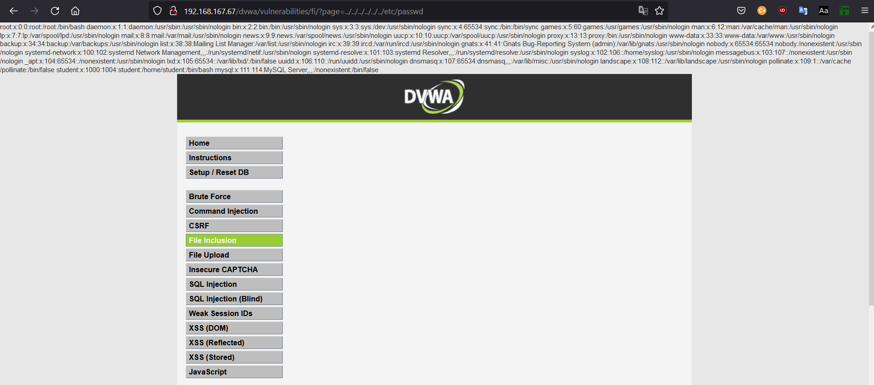Modifying the URL to get the OS type: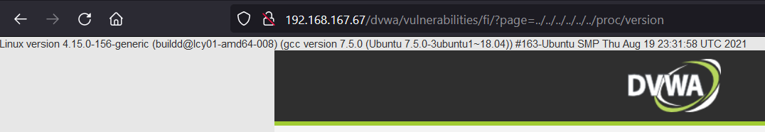Modifying the URL to find the TCP connections: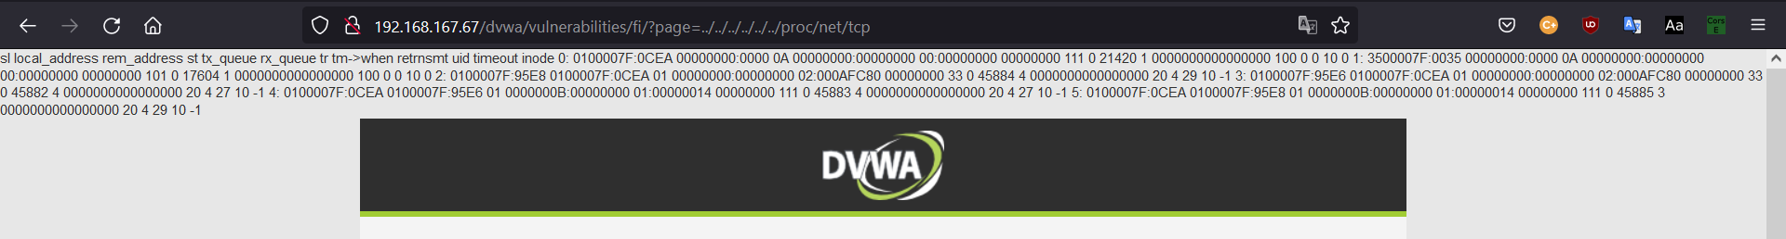Modifying the URL to find the UDP connections: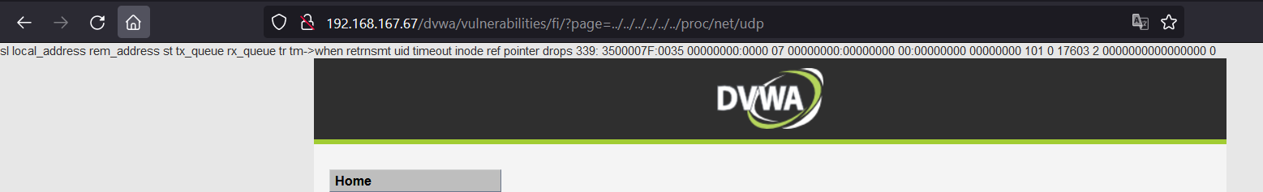

Modifying the URL to include the Google search page to the initial web page: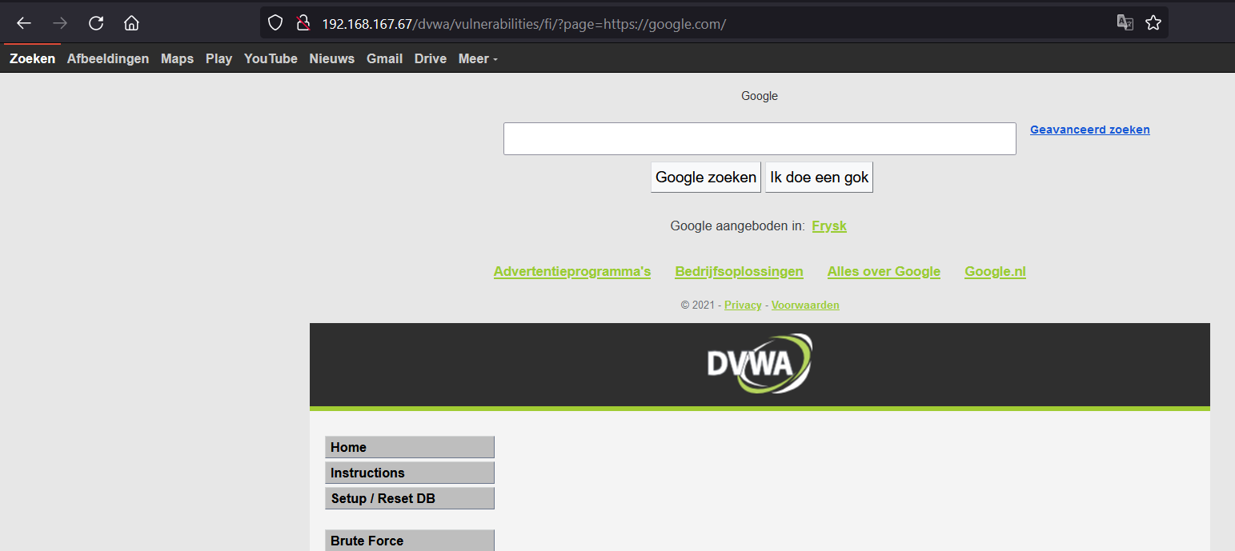

* **What is command injection and how does it work?**

Command injection is a form of attack in which the commands are transmitted by exploiting one of the application’s vulnerabilities, most commonly through user input, when the input validation is not sufficient or non-existent. Below, there are a few examples of command injection attacks:

Browsing the directory using the *ls* command: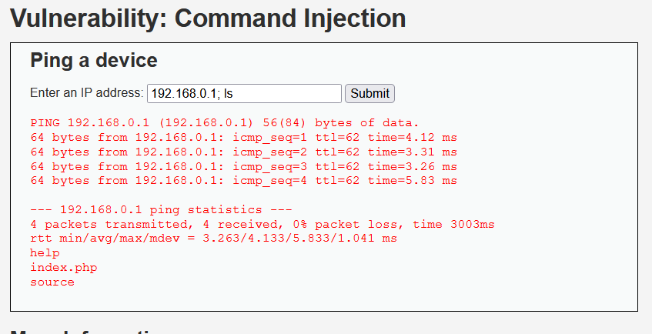

Using the *cat* command and index.php to create a new form: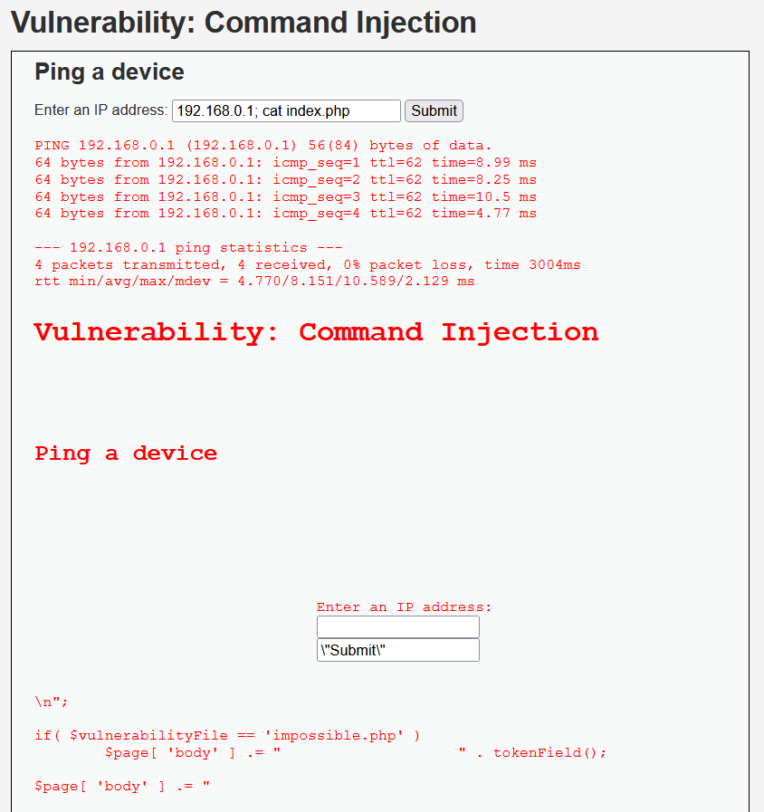

Using command injection to find the name of the user, the host name, and the IP address: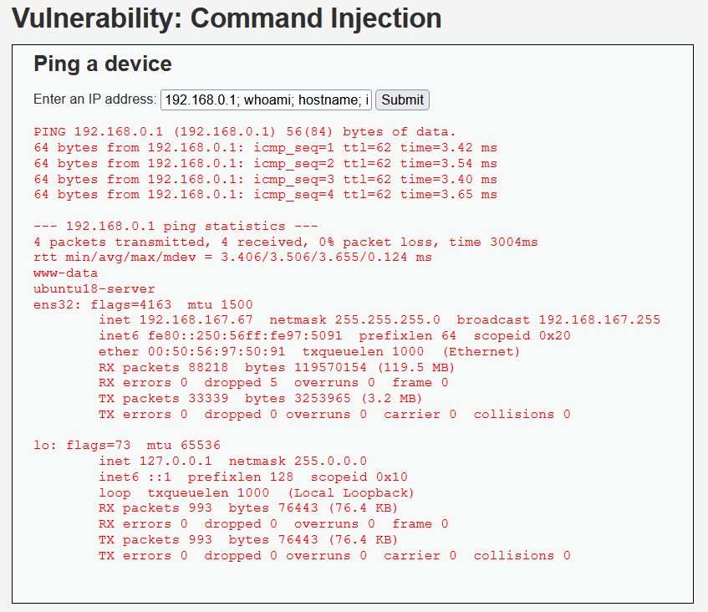

* **How are path traversal, remote file inclusion and command injection related?**

All of these methods can be used on web applications, via the user input. They mainly make use of the lack of input validation, which is relatively easy to solve but it still is an important security issue among many web applications.

* **Resources:**
* [**https://www.acunetix.com/blog/articles/path-traversal/**](https://www.acunetix.com/blog/articles/path-traversal/)
* [**https://www.acunetix.com/blog/articles/remote-file-inclusion-rfi/**](https://www.acunetix.com/blog/articles/remote-file-inclusion-rfi/)
* [**https://www.imperva.com/learn/application-security/command-injection/**](https://www.imperva.com/learn/application-security/command-injection/)

# Ethical Hacker 6 – SQL Injection

* **A lot of interesting MySQL challenges are available where you can to 'create' programming code containing SQL statements.**
  + **DVWA - SQL injection & Blind SQLi (style 1) -> Objective: There are 5 users in the database, with id's from 1 to 5. Your mission... to steal their passwords (hashes) via SQLi.**

Performing an injection attack to get all 5 users: the data in a form is between ‘’ these characters. If one of them is typed in the form, it counts as the end of the message. What goes after is considered actual code and it will be executed. If an information that is always true, such as 1=1, all information will be displayed: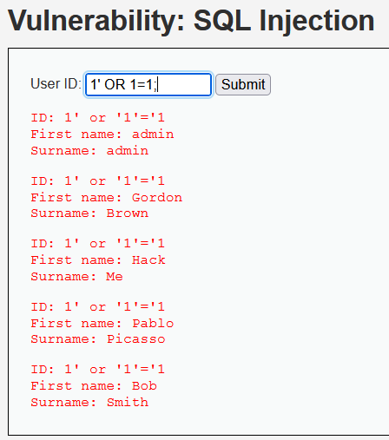

Figuring out the number of columns: using the same technique, typing an SQL command after the ‘ character, it will be executed.

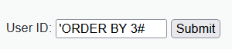

In this instance, the table has 2 columns.

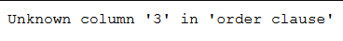

Typing the command below inside the textbox will generate this information:

**' UNION SELECT user, password FROM users#**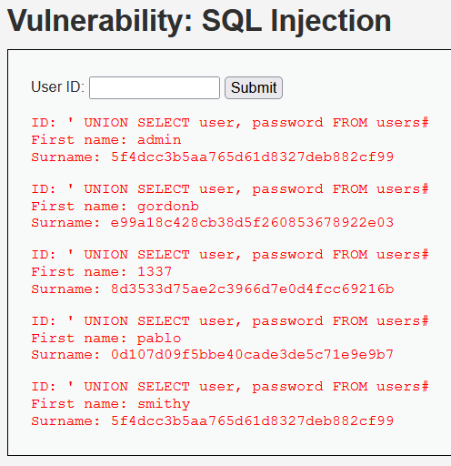

**Resources:**

* <https://portswigger.net/web-security/sql-injections>

# Ethical Hacker 7 – XSS and CSRF

## Part 1: XSS

* **What is cross-site scripting and how does it work?**

Cross site scripting is a security vulnerability found in some web applications. Cross site scripting attacks are a way for the attackers to inject client-side scripts into the web pages. Such a cross site scripting vulnerability can be used by attackers for a variety of purposes, such as bypassing the access controls. However, given the large amount of possibilities, there is a great variety in risk of these attacks depending of the sensitivity of the data handled.

Example of cross site scripting: first doing what I am supposed to do with this form to see the result:

Reflected Cross site scripting: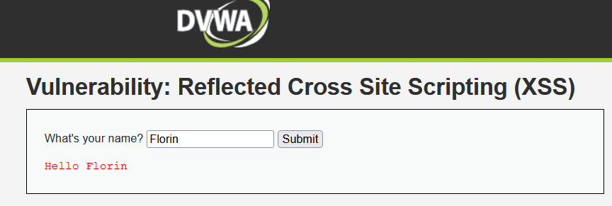

Typing <script>alert("The script in the user input works!")</script> in the textbox: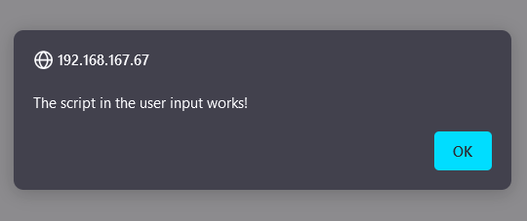

Typing <script>alert(document.cookie)</script> in the textbox:

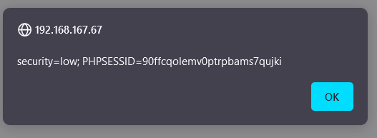

These above are examples of injection via the input form.

Stored XSS: initial completion according to the purpose of the form: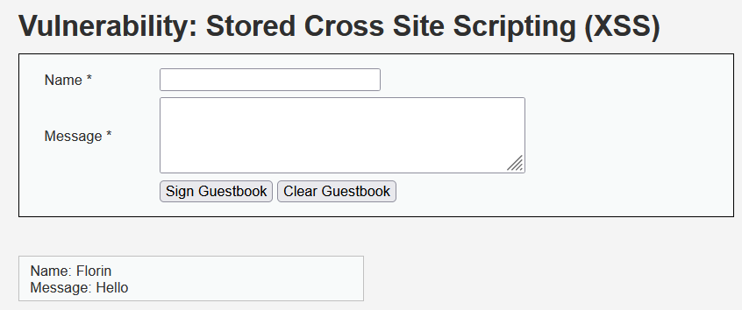

Injecting script code in the message field: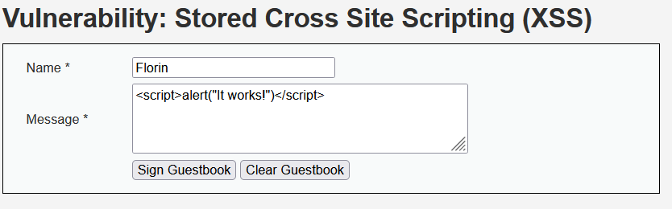

Typing the text above will lead to this:

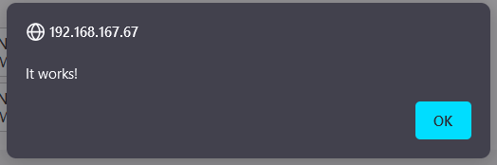

* **Explain the different types of XSS attacks: persistent versus non-persistent.**

The screenshots above are made for stored and reflected cross site scripting. As a matter of fact, persistent XSS is another name for stored XSS. This a more devastating sort of XSS vulnerability. It occurs when the data provided by the attacker is saved by the server and becomes a regular part of the web page, for every user to see. The screenshot above, showing the message “It works!” is displayed every time I am opening the respective DVWA page. It has been saved and it is an integral part of that page.

Non-persistent XSS or reflected XSS is the most common type of web vulnerability. It can be noticed when the data provided by the user, usually in a form, is taken and used by the server and displays the results immediately without properly sanitizing the content.

* **Give some other examples of XSS from Escape Alf.**

This example is very similar to an SQL injection attack. In the input field, the first characters to be typed in represent the characters in the actual code that mark the end of the input text. What is written after these characters is considered actual code and will be treated accordingly.

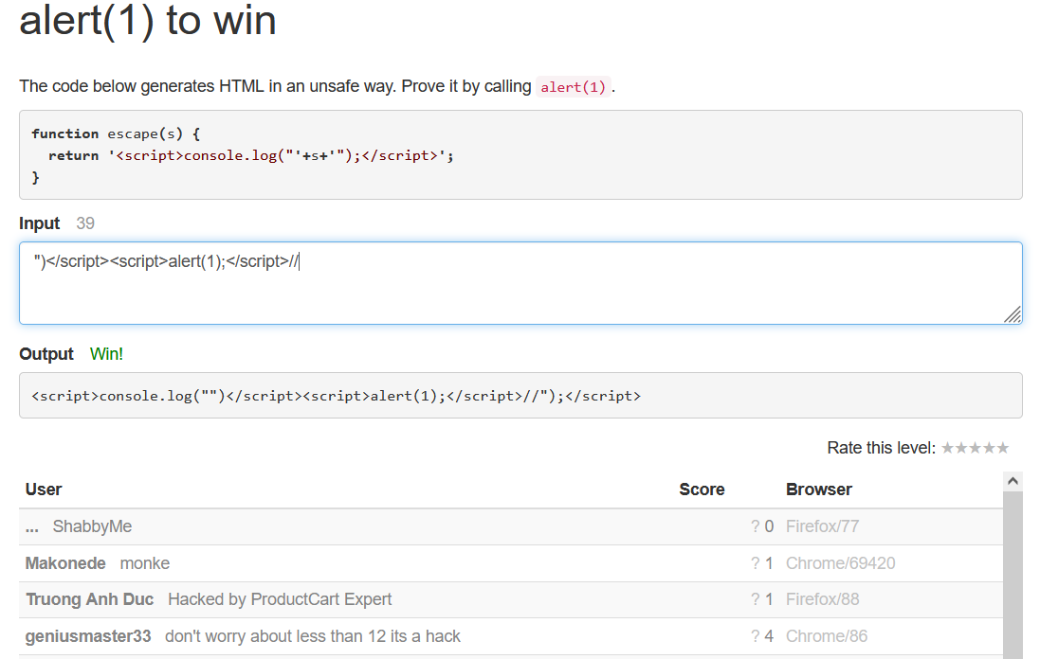

* **XSS exploitation possibilities conclusion: what could an attacker do if XSS is possible?**

There is a wide range of possibilities when it comes to XSS attacks. They could use persistent XSS to permanently modify the contents of a web page, at least until the code is cleaned up. The attacker could also use different XSS types in order to steal cookies, harvest credentials, force downloads, record audio or take pictures, and many more.

* **How to prevent XSS attacks?**

XSS filters need to be created in order to sanitize all the data the website receives. The main points of data entry that require sanitizing are the URL, the cookie data, the headers data and the database data, if not properly validated on user input.

## Part 2: CSRF

* **What is CSRF and how does it work?**

Cross site request forgery is a type of a malicious exploit of a web page in which unauthorized commands are submitted by a user that the web application trusts. It can be transmitted through hidden forms, specially crafted image tags, or javascript XMLhttp requests. This makes it possible to work without the user acknowledging it. In a CSRF attack the user is tricked by an attacker into submitting a web request they did not intend. This may cause actions to be made on the website that can include even client data leakage, change of session state or manipulation of an end user’s account.

The input data can be seen in the URL. This is a severe vulnerability, since the information is taken from that URL, so whatever is written there will be registered as valid.

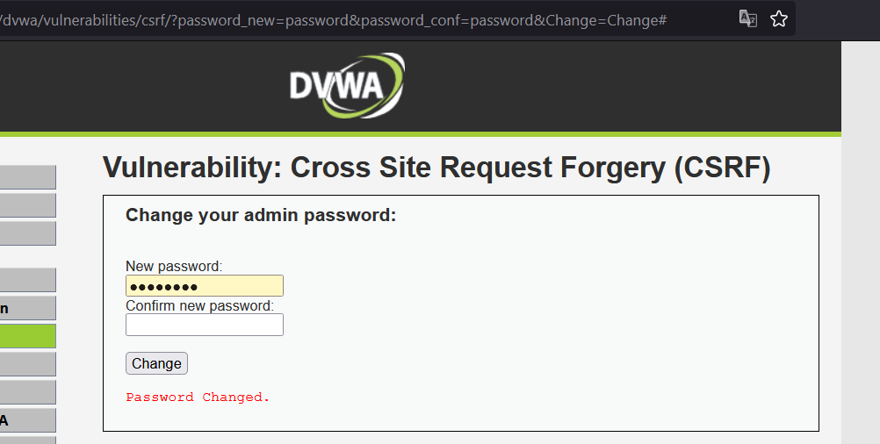

If I modify the URL, I can change the password. Sensitive information such as the password in this case can be easily changed without authentication being required.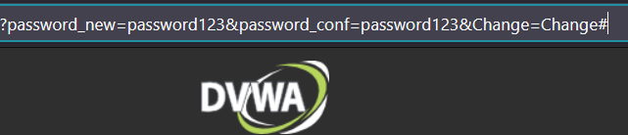

If I log in using the new credentials in the URL, it will work. The old password is no longer available. I have changed the user password using a CSRF attack.

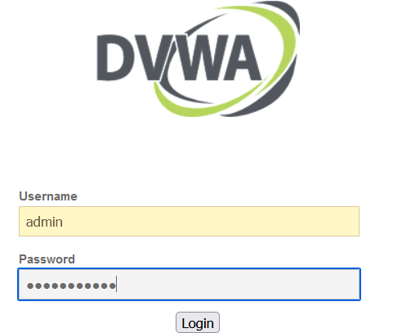

* **Explain the different way of cross site request forgery attacks.**

There are several ways of CSRF attacks. The most common ones are modifying GET or POST statements. Before the attack, the attacker studies the website so the attack can blend in the code without causing any suspicions. Usually, for a GET statement, a <a> tag is modified in the HTML code, by embedding a bad request in a hyperlink. For a POST statement, a CSRF attack can be delivered by modifying code inside a <form> tag.

* **Resources:**
* [**https://resources.infosecinstitute.com/topic/how-to-prevent-cross-site-scripting-attacks/**](https://resources.infosecinstitute.com/topic/how-to-prevent-cross-site-scripting-attacks/)
* [**https://en.wikipedia.org/wiki/Cross-site_scripting#Related_vulnerabilities**](https://en.wikipedia.org/wiki/Cross-site_scripting#Related_vulnerabilities)
* [**https://en.wikipedia.org/wiki/Cross-site_request_forgery**](https://en.wikipedia.org/wiki/Cross-site_request_forgery)
* [**https://www.imperva.com/learn/application-security/csrf-cross-site-request-forgery/**](https://www.imperva.com/learn/application-security/csrf-cross-site-request-forgery/)

# Ethical Hacker 8 – Network Sniffing and Spoofing

* **What can and cannot be seen when sniffing traffic with Wireshark?**

On the capturing screen, the user can see the time of capture, the number of each package, the source (the IP address of the device where the traffic comes from), the destination (the IP address that the package is trying to reach), the protocol, the length of the package, and additional information.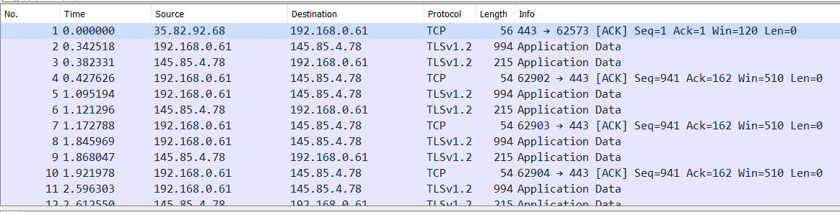

* **Try to intercept a plain text password (HTTP or FTP) by capturing a login-name and password:**
* The first step is to enter on a non-secured website with a login form. In this example, I am using one of my older websites made for a semester 2 assignment.

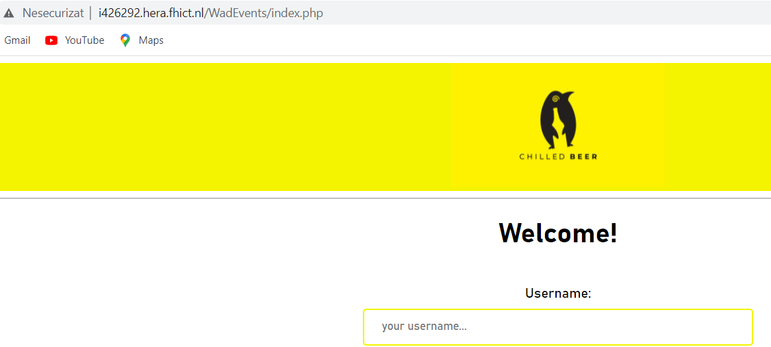

This is followed by typing a random username and password. In this case, the username is “something” and the password is “somethingelse”.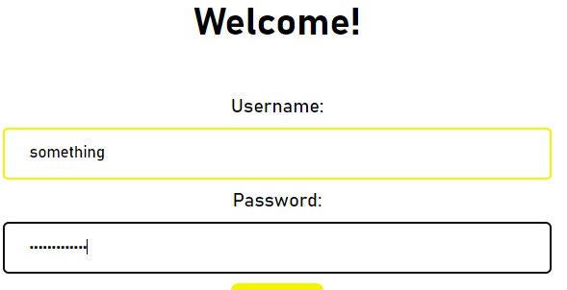

After filtering the traffic using the instruction on the green background, the name and file in question of the website is present in 2 of the 3 entries.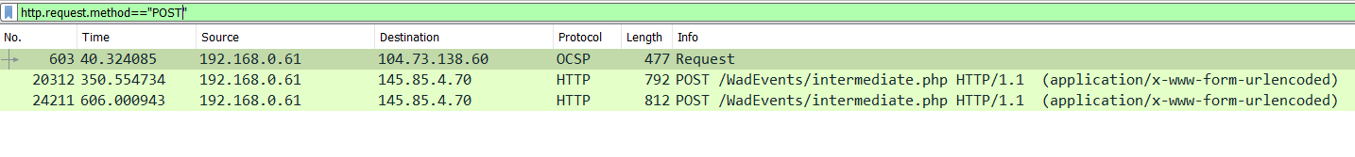

Now that the correct package has been found, the following instructions will lead to more information about it:

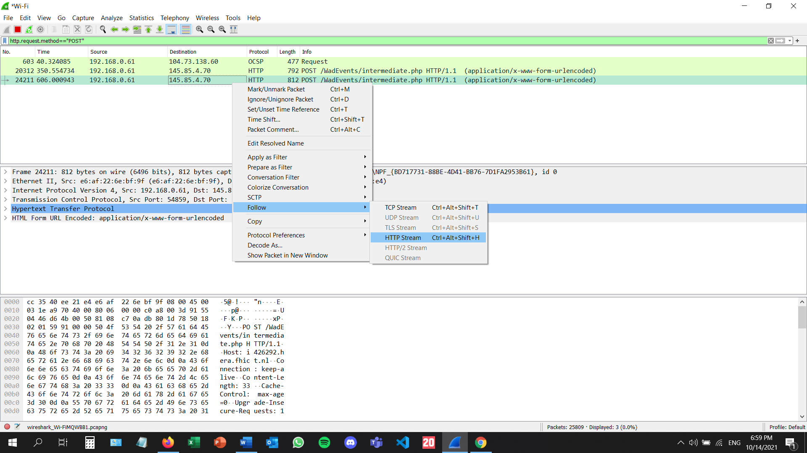

The username and password can be seen in the Follow HTTP Stream page, and they have been highlighted by me: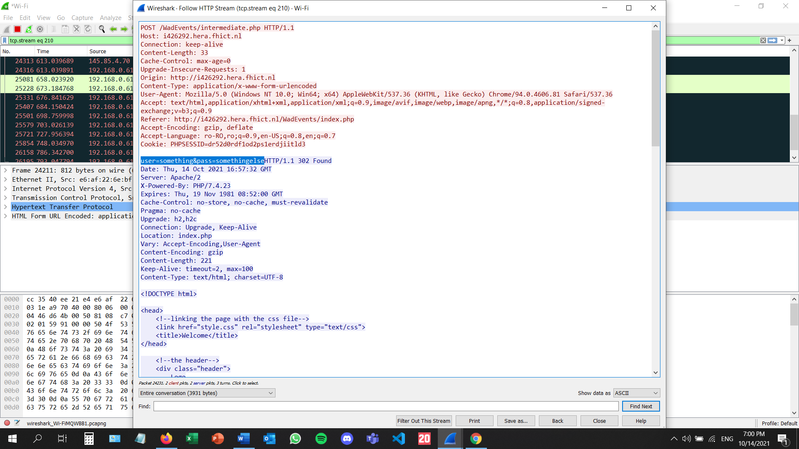

* **Demo and explain ARP spoofing a private VLan in the seclab with arpspoof.**

First, I will find out what my IP address is, using *ipconfig* on my windows command prompt: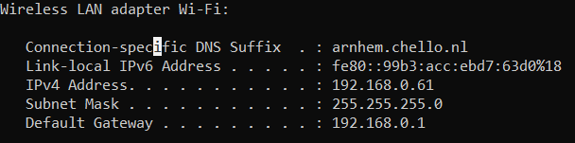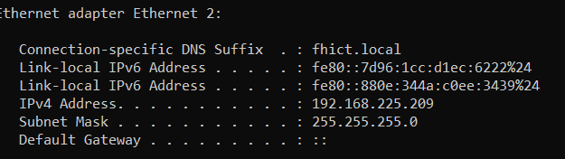

I will open 2 terminals in the kali machine because I have to initialize the ARP spoof twice. In the following command, i stands for interface, in this case wlan0, t is for target, which is the windows IP address, followed by the default gateway.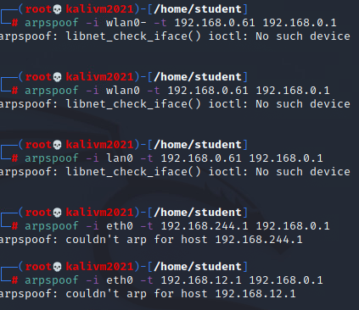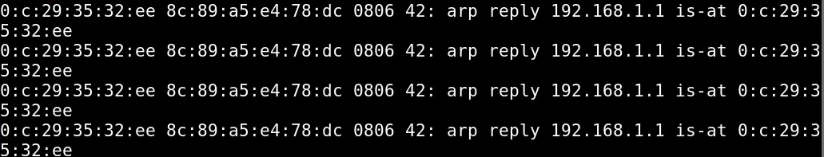

* **Explain what can be done to protect against ARP spoofing.**

There are several ways you can prevent ARP spoofing attacks. One of them is to invest in detection software that will allow you to spot potential threats. Alternatively, you could set yourself up with packet inspection software, that will check all the data on the network perimeter. This type of filtering can usually be performed by a firewall. Another option would be to create a static ARP address for every device on the network. Static ARP addresses cannot be manipulated by ARP reply packets. Although useful, this will only mitigate the most basic of threats.

* **Resources:**
* [**https://proprivacy.com/blog/ARP-spoofing**](https://proprivacy.com/blog/ARP-spoofing)
* [**https://www.youtube.com/watch?v=lb1Dw0elw0Q**](https://www.youtube.com/watch?v=lb1Dw0elw0Q)
* [**https://www.youtube.com/watch?v=FcwrrAT1H7o**](https://www.youtube.com/watch?v=FcwrrAT1H7o)
* [**https://www.guru99.com/wireshark-passwords-sniffer.html**](https://www.guru99.com/wireshark-passwords-sniffer.html)
* [**https://www.golinuxcloud.com/man-in-the-middle-attack-arp-spoofing/**](https://www.golinuxcloud.com/man-in-the-middle-attack-arp-spoofing/)
* [**https://www.youtube.com/watch?v=8SIP36Fym7U**](https://www.youtube.com/watch?v=8SIP36Fym7U)

# Ethical Hacker 9 – Password cracking

* **What is password cracking?**

Password cracking is the process of recovering passwordsfrom data that has been stored in or transmitted by a computer system in scrambled form. A common approach (brute-force attack) is to repeatedly try guesses for the password and to check them against an available cryptographic hash of the password or a list of passwords.

* **How does password cracking work?**

I began by logging in on DVWA and went to the **Brute Force** page. I typed my username and a wrong password on purpose, then pressed the submit button. After this, I opened Burp Suite and went to the proxy tab.

I looked at the request and response for this specific request and sent this line to the intruder:

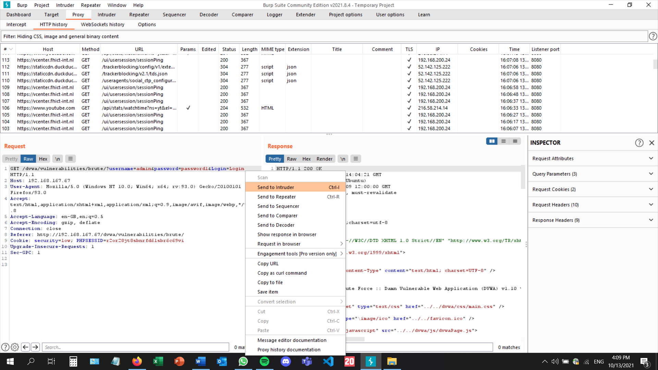

Adding a payload marker on the password field:

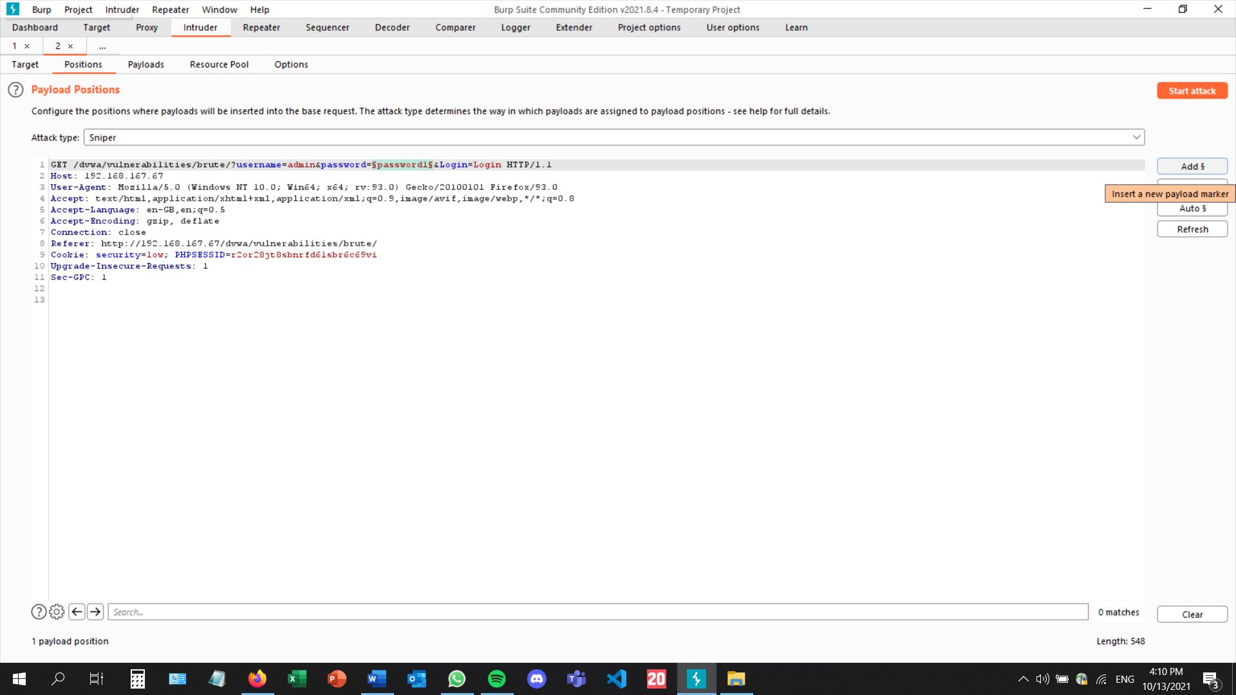

Adding the most common 100 passwords on the simple list:

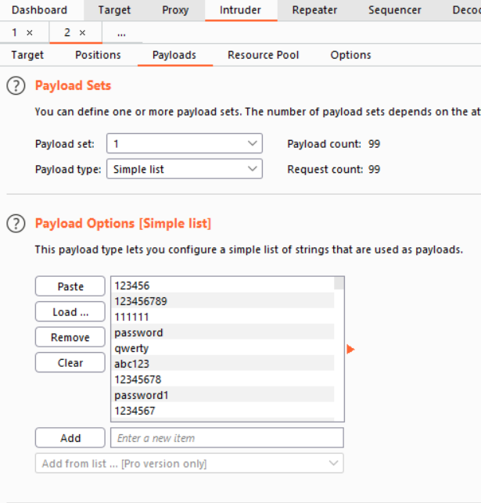

I went back to DVWA and intentionally typed a wrong password so I can copy the message received.

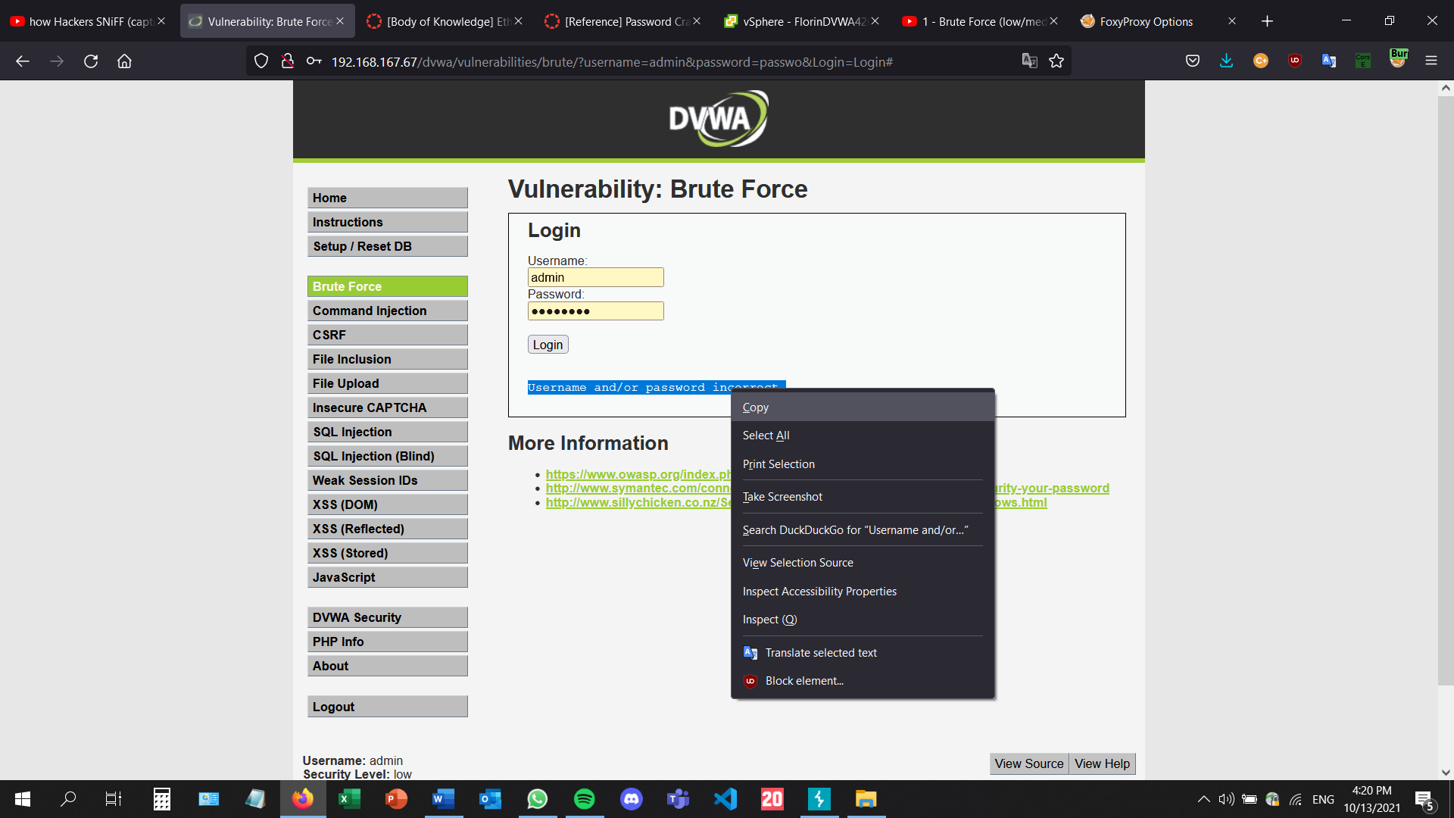

I have pasted the message in the grep section so that the incorrect passwords, which will generate this message, will be flagged: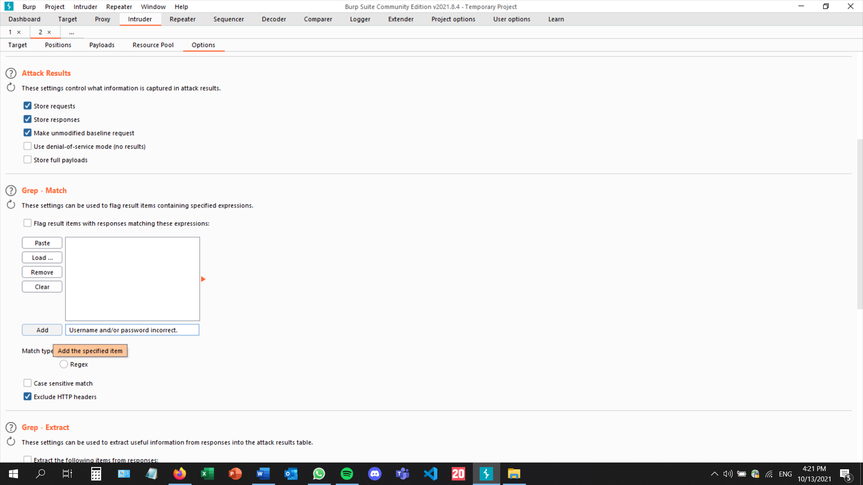

I then went to the attack section, with this part automatically filled in, and began the attack.

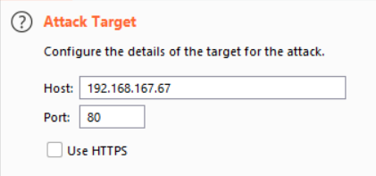

The attack tries all the passwords, and if the **Username and/or password incorrect** is displayed, the box will be ticked. The only unchecked password in this case will be the correct one.

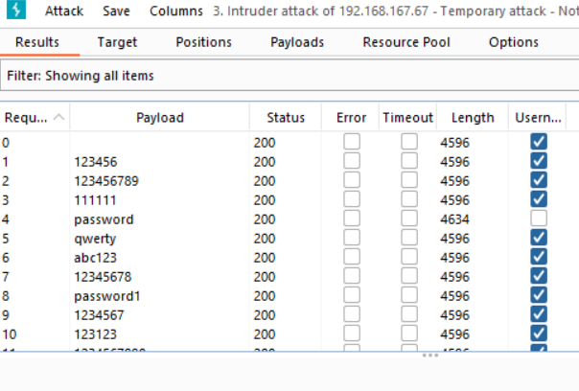

There are many alternatives to this. For instance, the message generated by typing the correct password can be copied and pasted, and then only the correct password will be checked.

* **Give examples of famous password cracking attacks.**

On June 5th, 2012, LinkedIn has been hacked and the passwords for nearly 6.5 million user accounts have been stolen by cyber criminals. As a result, a United States grand jury indicted Nikulin and three unnamed co-conspirators on charges of aggravated identity theft and computer intrusion.

In 2013, Tumblr has been attacked by hackers. 65,469,298 unique emails and passwords were leaked from Tumblr. The data breach's legitimacy is confirmed by computer security researcher Troy Hunt.

* **How to make password cracking harder for an attacker?**

The easiest way to make password cracking harder for an attacker is to use a long password which contains lowercase and uppercase letters, numbers, and special characters. This makes the password cracking process extremely lengthy and difficult.

* **Resources**
* [**https://en.wikipedia.org/wiki/Password_cracking**](https://en.wikipedia.org/wiki/Password_cracking)
* [**https://en.wikipedia.org/wiki/List_of_security_hacking_incidents**](https://en.wikipedia.org/wiki/List_of_security_hacking_incidents)

# Ethical Hacker 10 – Wireless Hacking

* **Crack WPA (2) with airmon-ng and aircrack-ng from Kali Linux**.

I have downloaded a new kali virtual machine using this link: [https://www.offensive-security.com/kali-linux-vm-vmware-virtualbox-image-download/](https://eur01.safelinks.protection.outlook.com/?url=https%3A%2F%2Fwww.offensive-security.com%2Fkali-linux-vm-vmware-virtualbox-image-download%2F&data=04%7C01%7Cf.pana%40student.fontys.nl%7C617e498c0bf14179a54708d98e354c4c%7Cc66b6765b7944a2b84ed845b341c086a%7C0%7C0%7C637697182641574247%7CUnknown%7CTWFpbGZsb3d8eyJWIjoiMC4wLjAwMDAiLCJQIjoiV2luMzIiLCJBTiI6Ik1haWwiLCJXVCI6Mn0%3D%7C3000&sdata=2wyc%2BX%2F5r9PJhmoTUGr%2FU9DuisA1r8Vm5Go9LWS8Ecs%3D&reserved=0)

I have installed it and entered it. Afterwards, I have used s WiFi USB-stick Netgear WNA1100, which I have borrowed from the ISSD.

Afterwards, I have started the wireless interface using airmon-ng:

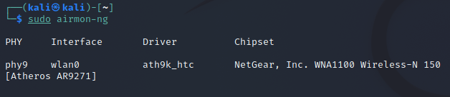

Then, I am typing iwconfig to make sure there are no other athX interfaces.

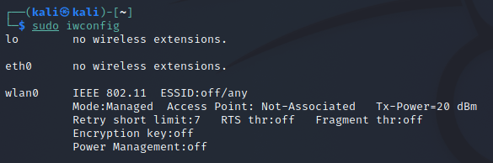

Using airmon-ng again, this time in order to start the wireless card on channel 9 in monitor mode:

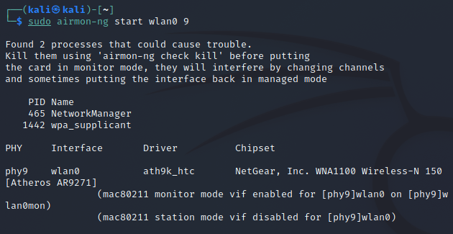

Using airodump-ng to discover the information I need from the wi fi network that I am about to attack: megabeast1:

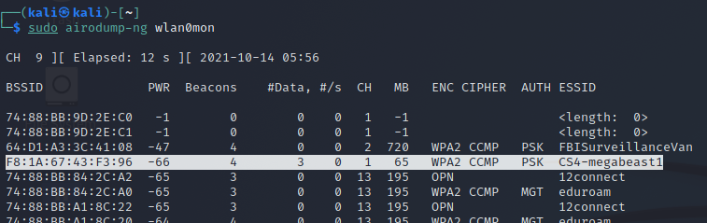

Copying the authentication handshake and pasting it next to the capture instruction from airodump-ng:

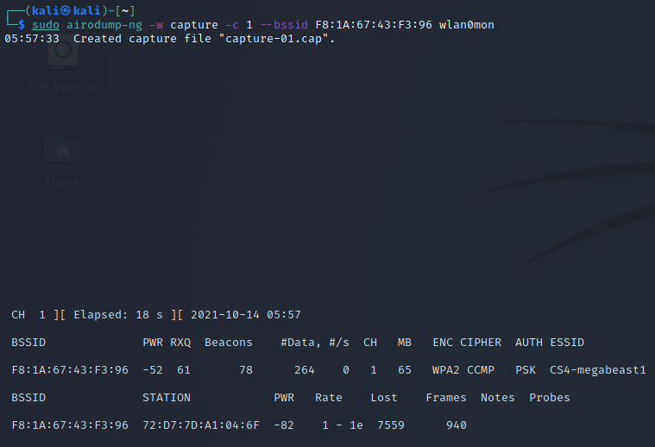

The handshake has happened after opening a separate terminal and using the aireplay-ng instruction along with the authentication handshake. The initial terminal is notified and displays the WPA handshake on the botton left of the screenshot:

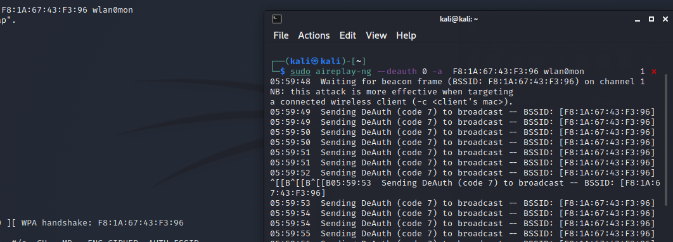

After obtaining the needed information and creating the handshake, I can now stop wlan0mon and move on to the next step: unzipping the rockyou.txt file:

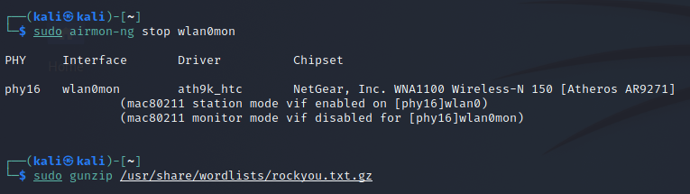

Using the aircrack-ng instruction to start the password cracking process:

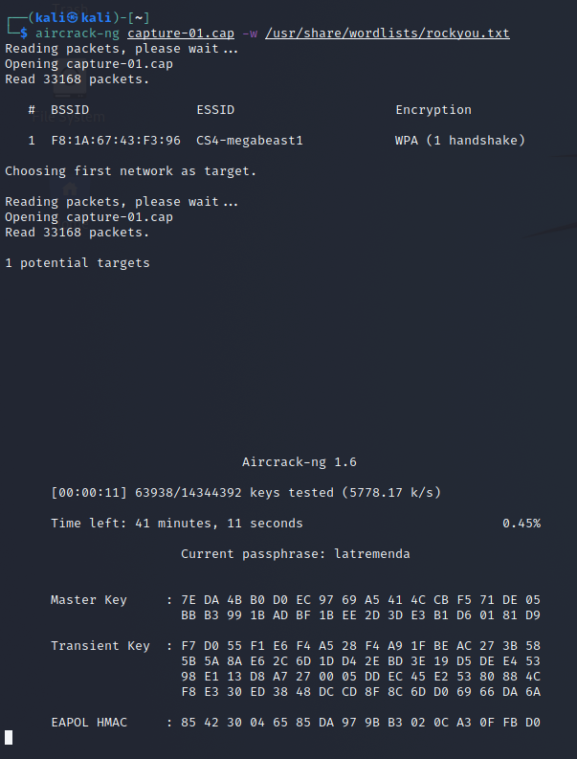

The process has started, the program tries different elements of the rockyou file until it finds the one that matches the actual password. In this case, the correct password is Zanzibar, and it has been cracked after 2 minutes and 57 seconds.

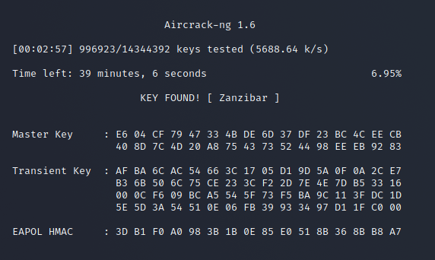

# Risk Consultant 1 – Security Threats

* **To get a better understanding of these threats and attacks find articles on internet about malware, spam, phishing, adware, ransomware, DDOS attacks, Advanced Persistent Threats what it is, how they work and how to protect. Give a brief description of what it is, how it works and how to protect your 'company X' in your portfolio.**

|  |  |  |  |
| --- | --- | --- | --- |
| Name | Definition | Way of working | How to protect |
| Malware | Software intentionally designed to cause damage to a computer, server, client, or computer network. There are several types of malwares, such as viruses, trojan horses, or worms. | Virus-> It requires user action to transmit from one system to another and attaches bits of its own malicious code to other files.  Trojan horse->it can hide in cracked software, in shady websites, etc. Trojan is a way for the attackers to send malicious software. | Virus-> Learn to spot phishing, invest in security, do not click suspicious links, check their authenticity  Trojan-> run periodic diagnostics scans, get a firewall, use complex passwords, avoid suspicious websites. |
| Spam | The use of messaging systems to send multiple unsolicited messages to large numbers of recipients | Malware can be sent via these messages through phishing, the victim can fall to a scam or simply have malware installed on their device. | Learn to spot phishing, install security, report found spam, use two-factor authentication |
| Phishing | An attack in which the attacker poses as a trusted person or organization to trick the victim into sharing sensitive information or giving away their money | The email invites the victim to click on a link and take an action or download an attachment. This can lead to the victim giving away sensitive information or downloading malware on their device. | Do not open e-mails from senders you are not familiar with. Don't ever click on a link inside of an e-mail unless you know exactly where it is going. Mouseover the link to see if it's a legitimate link. |
| Adware | Unwanted software designed to throw advertisements up on your screen, most often within a web browser. | Adware generates revenue for its developer by automatically displaying online advertisements in the user interface of the software. | Practice safe computing. Proceed carefully when downloading software, install security |
| Ransomware | Type of malware that prevents users from accessing their system or personal files and demands money in order to give back access. | The attacker uses spam, advertisements, or phishing, attaching malicious files to as many people as possible. | Prevent it from happening in the first place, invest in security, create backups of your data regularly |
| DDOS attacks | Form of attack consisting of sending large amounts of traffic from multiple sources to a service or website, intending to overwhelm it. | A huge amount of traffic all at once can block the site and deny access to its legitimate users. | Plan ahead of such an attack, have protection turned on at all times |
| Advanced Persistent Threats | Covert cyber-attack on a computer network where the attacker gains and maintains unauthorized access to the targeted network and remains undetected for a significant period. | During the time between infection and remediation the hacker will often monitor, intercept, and relay information and sensitive data.  The malware searches for vulnerabilities in the system and exploits them. | Multiple layers of security working together, constant network monitoring, install a firewall, install antivirus software. |

* **Describe the organization you are implementing your network for and use the CIA matrix to describe each item in a (few) line(s) of text in the context of information relevant for your example company. This will be input for the next Body of Knowledge subject.**

I am going to use an imaginary example company named DartsMasters. This is the name of the website I created during the third semester, and it is a forum for darts enthusiasts to share content and discuss topics related to this sport.

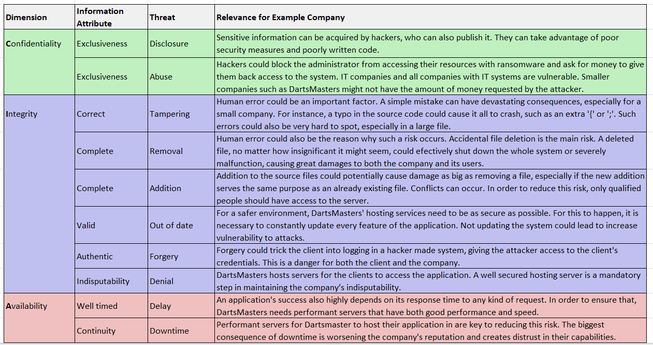

Resources:

* <https://www.malwarebytes.com/malware>
* <https://en.wikipedia.org/wiki/Malware>
* <https://www.malwarebytes.com/spam>
* <https://www.malwarebytes.com/phishing>
* <https://www.malwarebytes.com/adware>
* <https://www.malwarebytes.com/ransomware>
* <https://www.malwarebytes.com/ddos>
* <https://www.cisco.com/c/en/us/products/security/advanced-persistent-threat.html>
* <https://www.malwarebytes.com/computer-virus>
* <https://www.malwarebytes.com/trojan>

# Risk Consultant 2 – IT Risk Analysis & Business Continuity

* + **Perform a qualitative risk analysis for the company environment that you are analysing and developing this semester.   
      
    1. List and describe the threats for your company in terms of possible attackers (threat actors) and their motivations.  
    2. For each threat determine and explain the probability (likelihood) on a qualitative scale.   
    3. For each threat determine and describe the possible impacts if it occurs.**

The impact will be determined by the following factors:

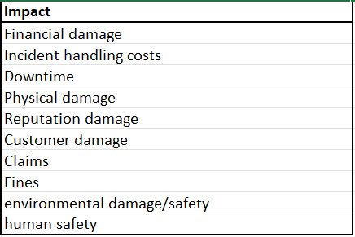

Determining the impact level per event:

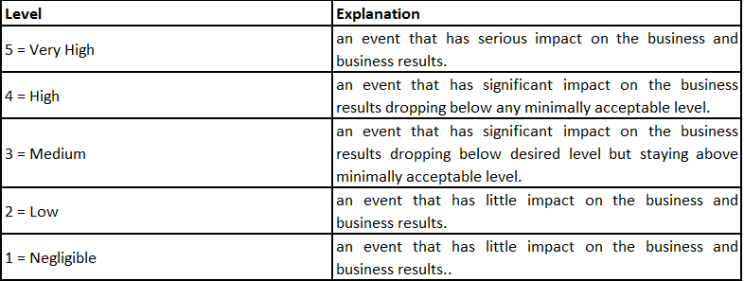

Determining the probability for each event:

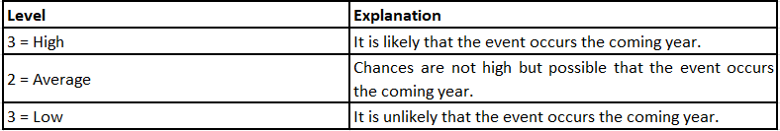

Determining the risk (probability * impact):

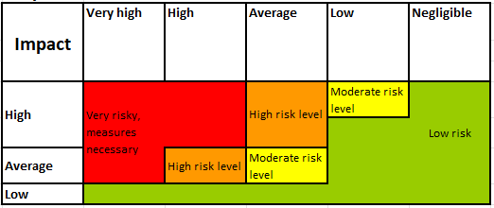

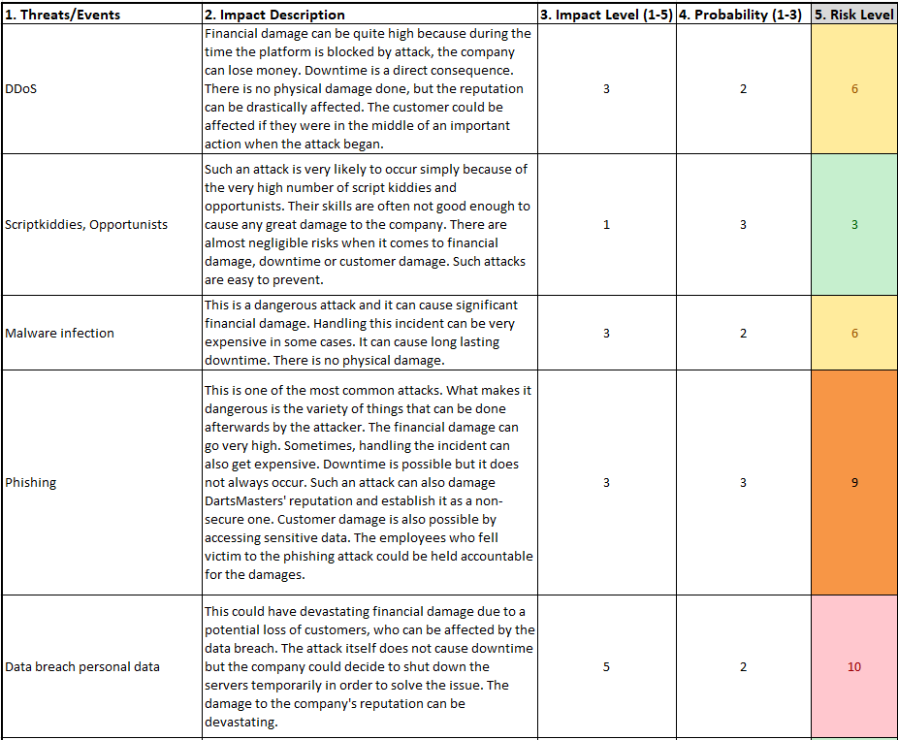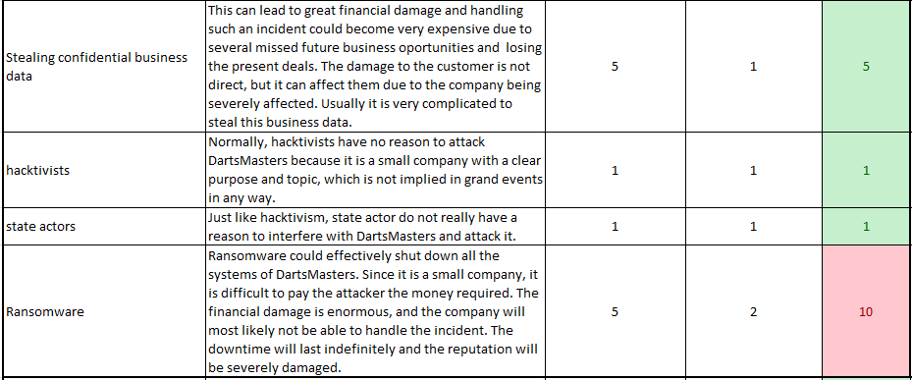

* **Take your top 5 risks from the Risk analysis assignment and think of as many mitigating measures as possible. Determine physical, technical, and organizational measures that are needed and find a good balance in preventive, detective, repressive and corrective measures.**

The 5 biggest risks are:

1. Ransomware
2. Malware infection
3. Personal data breach
4. Phishing
5. DDoS attacks

A good prevention method for phishing, ransomware and malware infection is raising awareness to the problem by instructing the employees to pay maximum attention to suspicious emails and websites. They should always check the email address, not click links, and not download suspicious attachments.

In order to prevent data breaches, the code surrounding data should be as secure as possible. The information in the database has to be encrypted and security measures need to be put in place, such as 2 factor authentication, protection against cross site request forgery, or protection against SQL injection.

A famous backup strategy is 3-2-1. It has 3 principles. The first one is that the employee should keep at least 3 copies of their data, including the original copy and 2 backups. Also, in order to improve safety, the backups should be stored in different places. The second principle states that the backup data should be kept on 2 different devices, in case one of the devices gets corrupted. It is suggested to store the two backups on 2 different storage types, such as external hard drives, or USB flash drives. The third and final principle addresses the importance of keeping at least one of the copies offsite. Storing the data in another distance remotely significantly increases the security.

Redundancy is an engineering term which means “the duplication of critical components or functions of a system with the intention of increasing reliability of the system, usually in the form of a backup or fail-safe, or to improve actual system performance”. In ICT there are four main forms of redundancy: Hardware, software, information, and time, with hardware redundancy being the most common one. This means adding a duplicate device or component in the system with the goal to ensure zero downtime. Server redundancy means creating a replica of the company server. It is kept offline and in case of failure, downtime, or excessive traffic, likely cause of a DDoS attack at the primary server, the redundant server can be turned on and take a share of the primary server’s load. This is a very good disaster recovery option, but it comes with doubling the cost of the server solution, along with doubling the storage space.

RTO and RPO are part of the business impact analysis, which differentiates critical and non-critical organization functions. For each function, two values are assigned: Recovery Point Objective (RPO) and Recovery Time objective (RTO). RPO is the acceptable amount of data that will not be recovered. RTO is the acceptable amount of time to restore the function.

* + **Resources:**
* <https://www.ubackup.com/3-2-1-backup-strategy.html>
* <https://www.your-itdepartment.co.uk/knowledge-bank/what-is-redundancy/>
* <https://en.wikipedia.org/wiki/Business_continuity_planning#Maximum_RTO>

# Security Engineer 1 – Information Security Concepts

* **Explain the concept of CIA in your own words.**

The CIA security triad is a model used to determine the level of security within an organization. The three functions of CIA are:

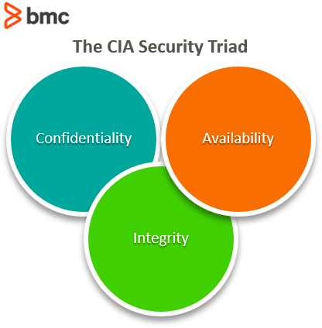

* **Confidentiality**

Confidentiality is the way the system ensures that only the authorized person(s) or system can view or change the data. Confidentiality can be achieved through methods such as IDs or passwords.

* **Integrity**

Integrity is the way the system makes sure that the information or data is accurate and can be trusted. Data encryption and hashing can ensure system integrity.

* **Availability**

Availability means that the data and information are available whenever required. Software upgrades and network optimization can help achieving availability.

Resources:

* <https://www.deepwatch.com/blog/cia-in-cybersecurity/>
* <https://flank.org/faqs/what-is-the-concept-of-cia>
* <https://www.bmc.com/blogs/cia-security-triad/>
* <https://www.techopedia.com/definition/25830/cia-triad-of-information-security>

# Security Engineer 2 – Network Separation and Segmentation

* **Design and implement a network with 2 pfSense firewalls, a web server in the DMZ, a management server, and a workstation.**

Throughout the exercises for this learning outcome, I will work on creating a network according to this diagram: 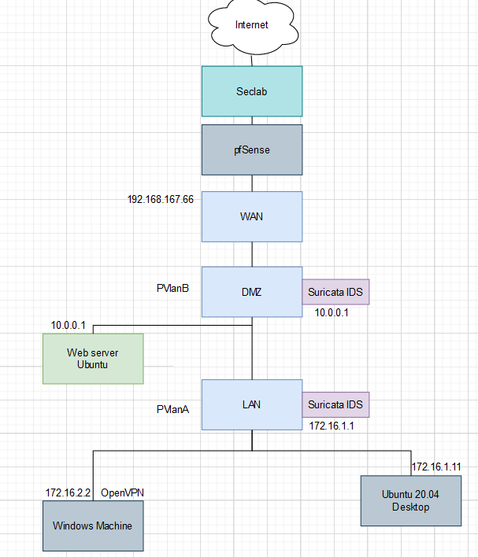

The first step is to deploy a virtual machine with the pfSense template: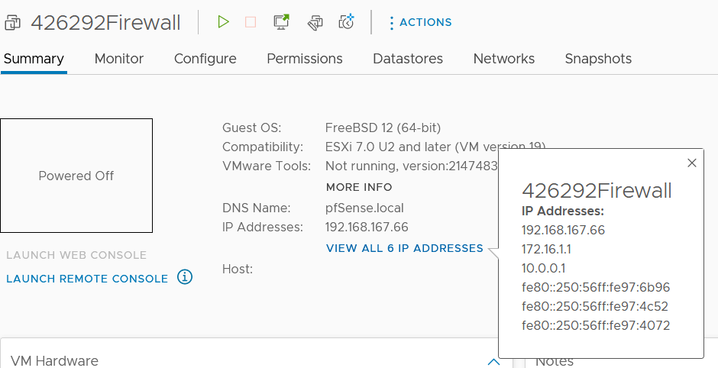

Creating 3 interfaces using the pfSense machine: WAN, LAN, and the DMZ: In this screenshot, I am assigning an IP address to the DMZ. The same step has been taken for the WAN and LAN interfaces. The available interfaces shown are the ones I have created for this exercise: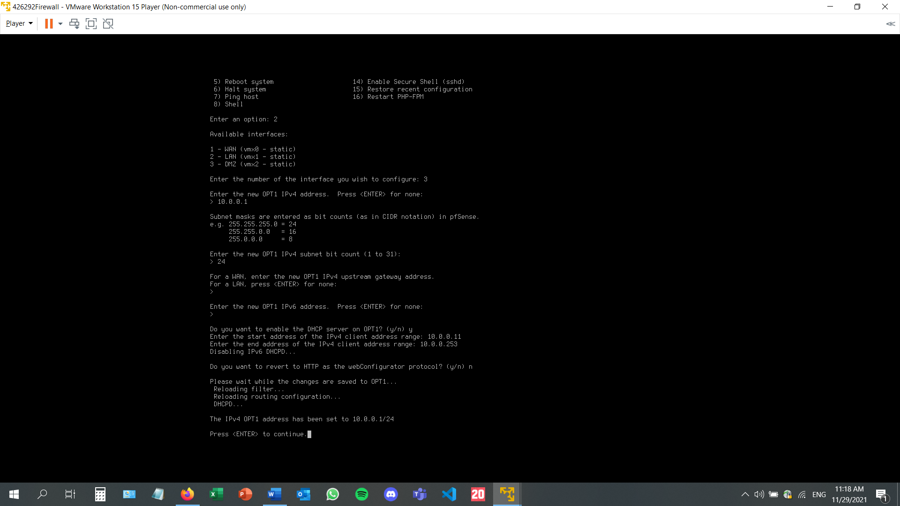

After configuring the interfaces, this is the result: the IP addresses are displayed next to their name. Each interface has been assigned using setting 1. Separate virtual machines have been created for the LAN and DMZ.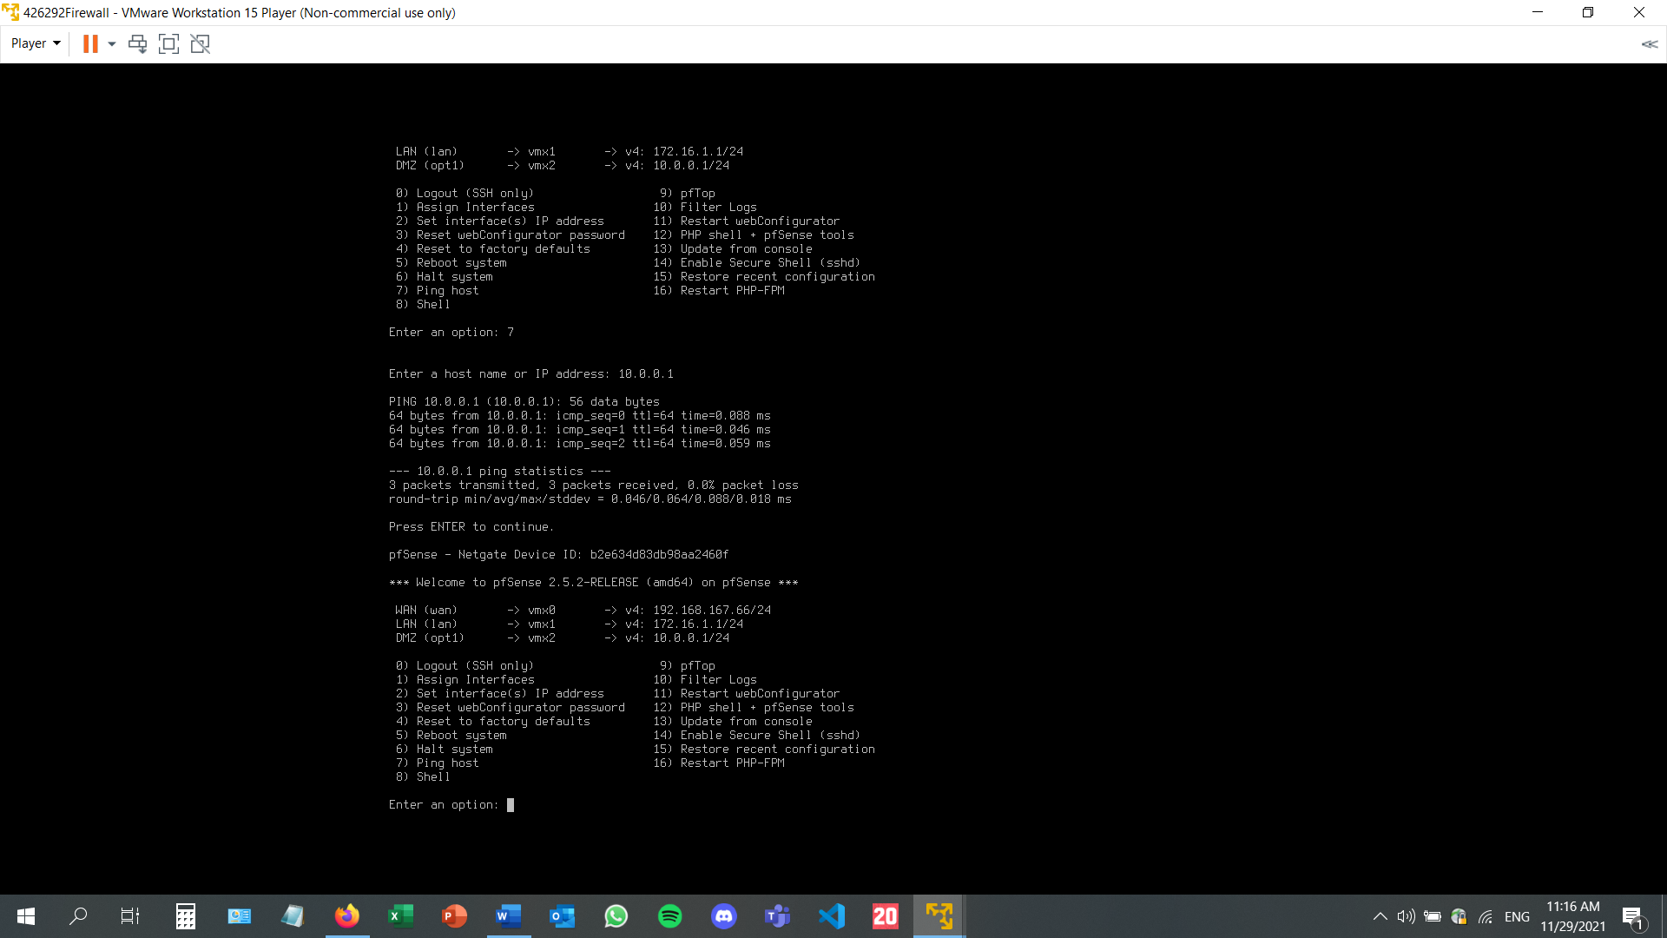

Once the machines have been created, I entered the LAN machine and accessed the pfSense website, using the IP address of the LAN interface: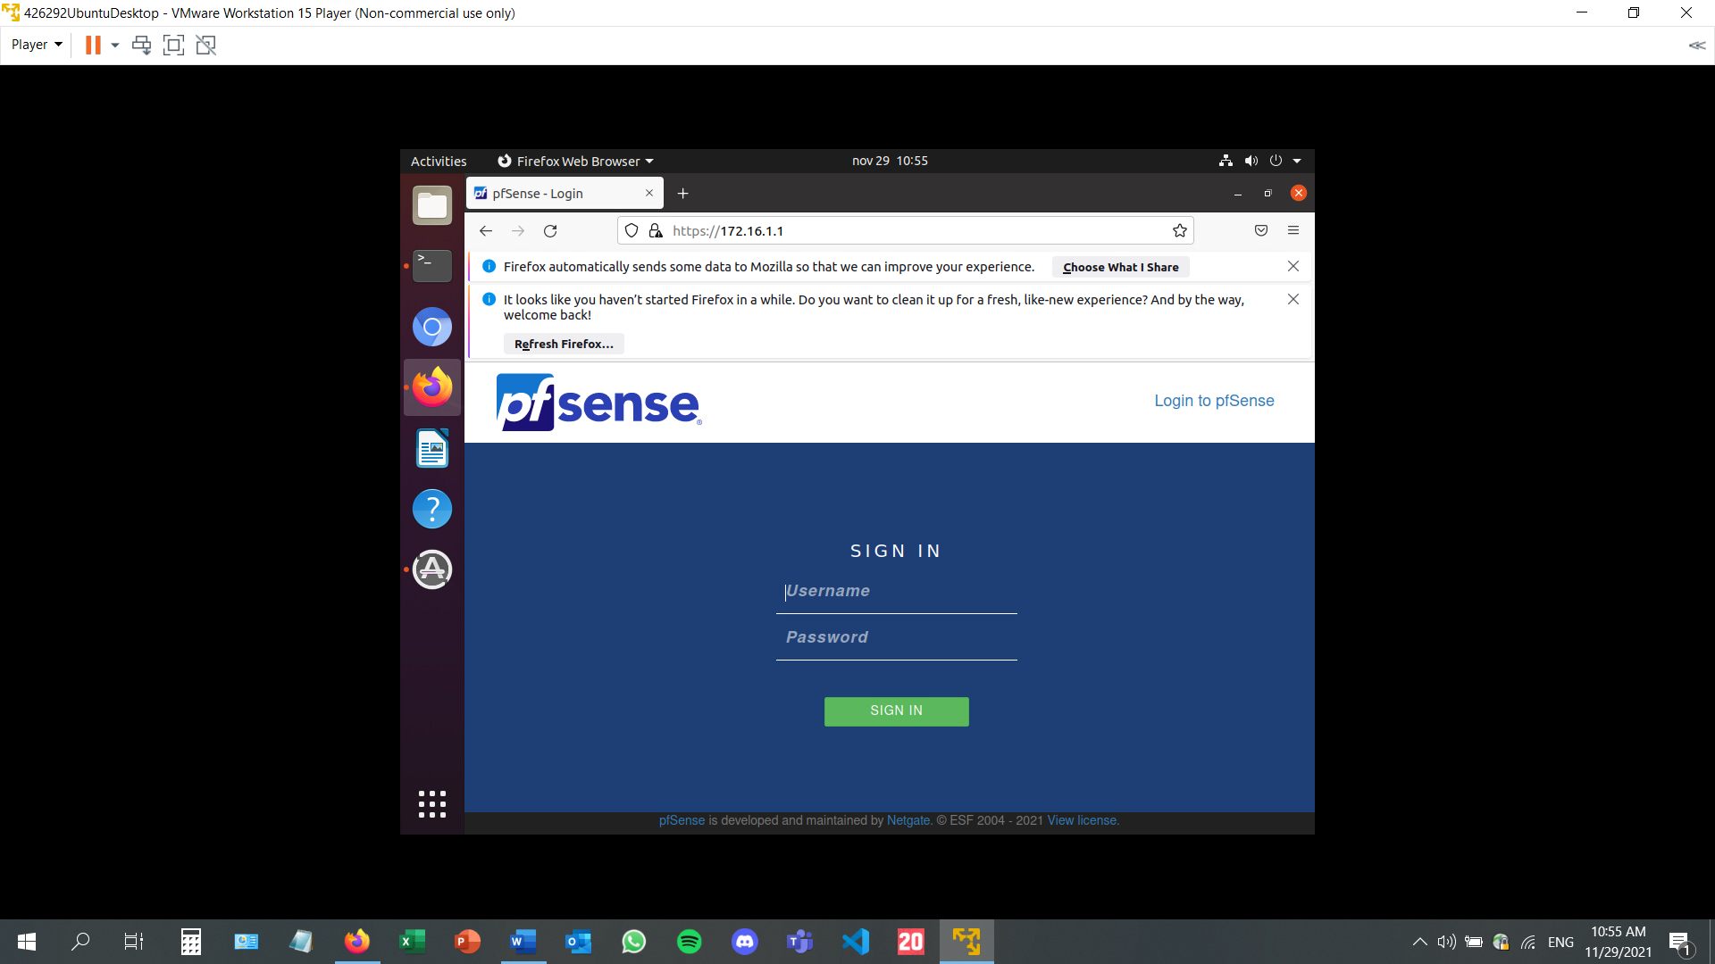

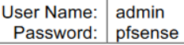

Configuring the network settings. In the wired settings of the LAN Linux machine, the DNS has been written down, and the IPV4 method has been set to automatic (DHCP).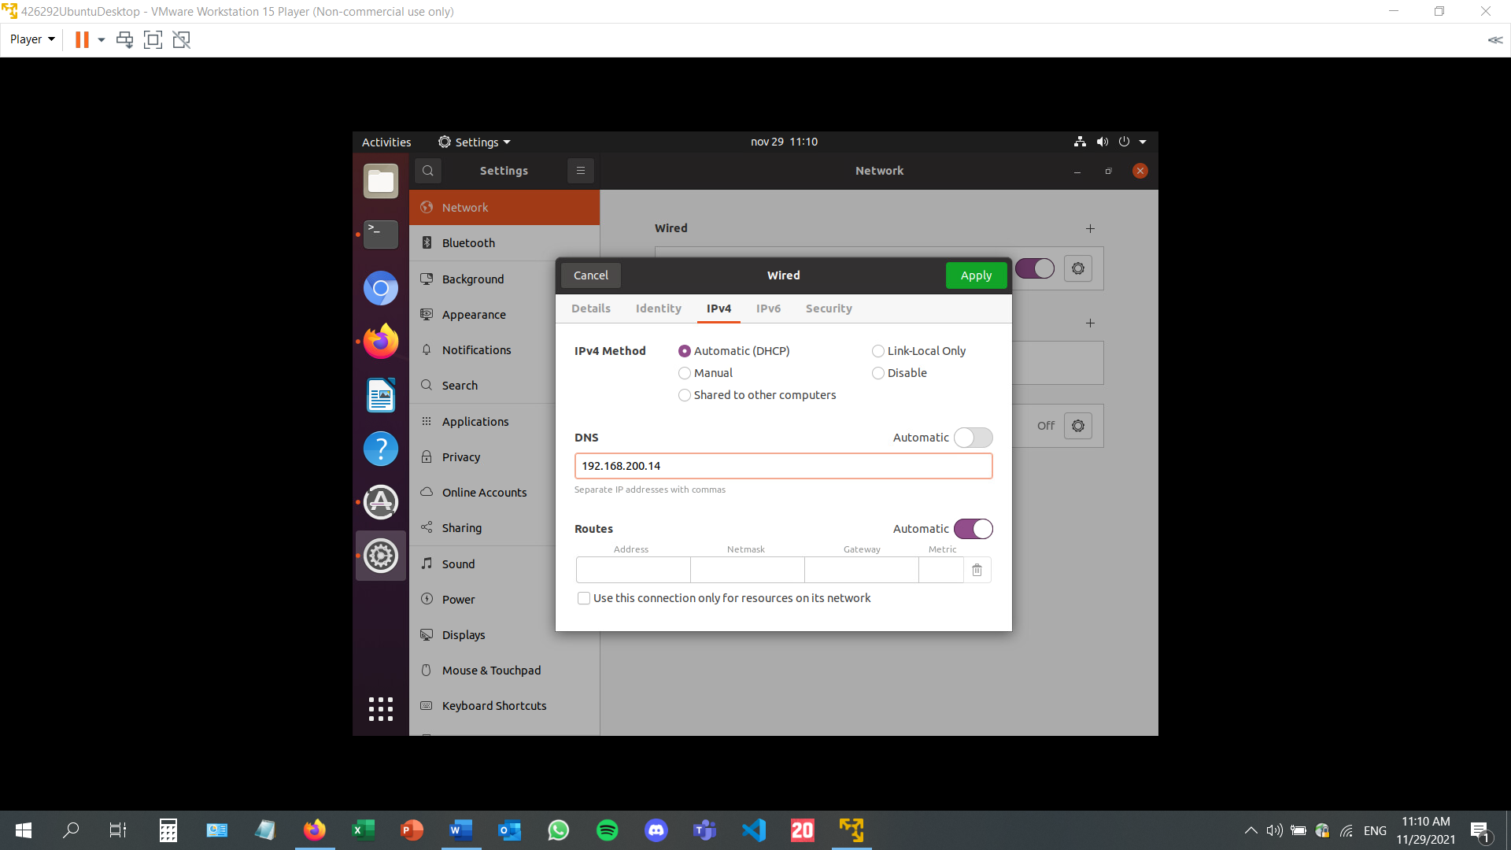

Going to system settings on the pfSense website. Changing the DNS resolution behavior setting to using local DNS.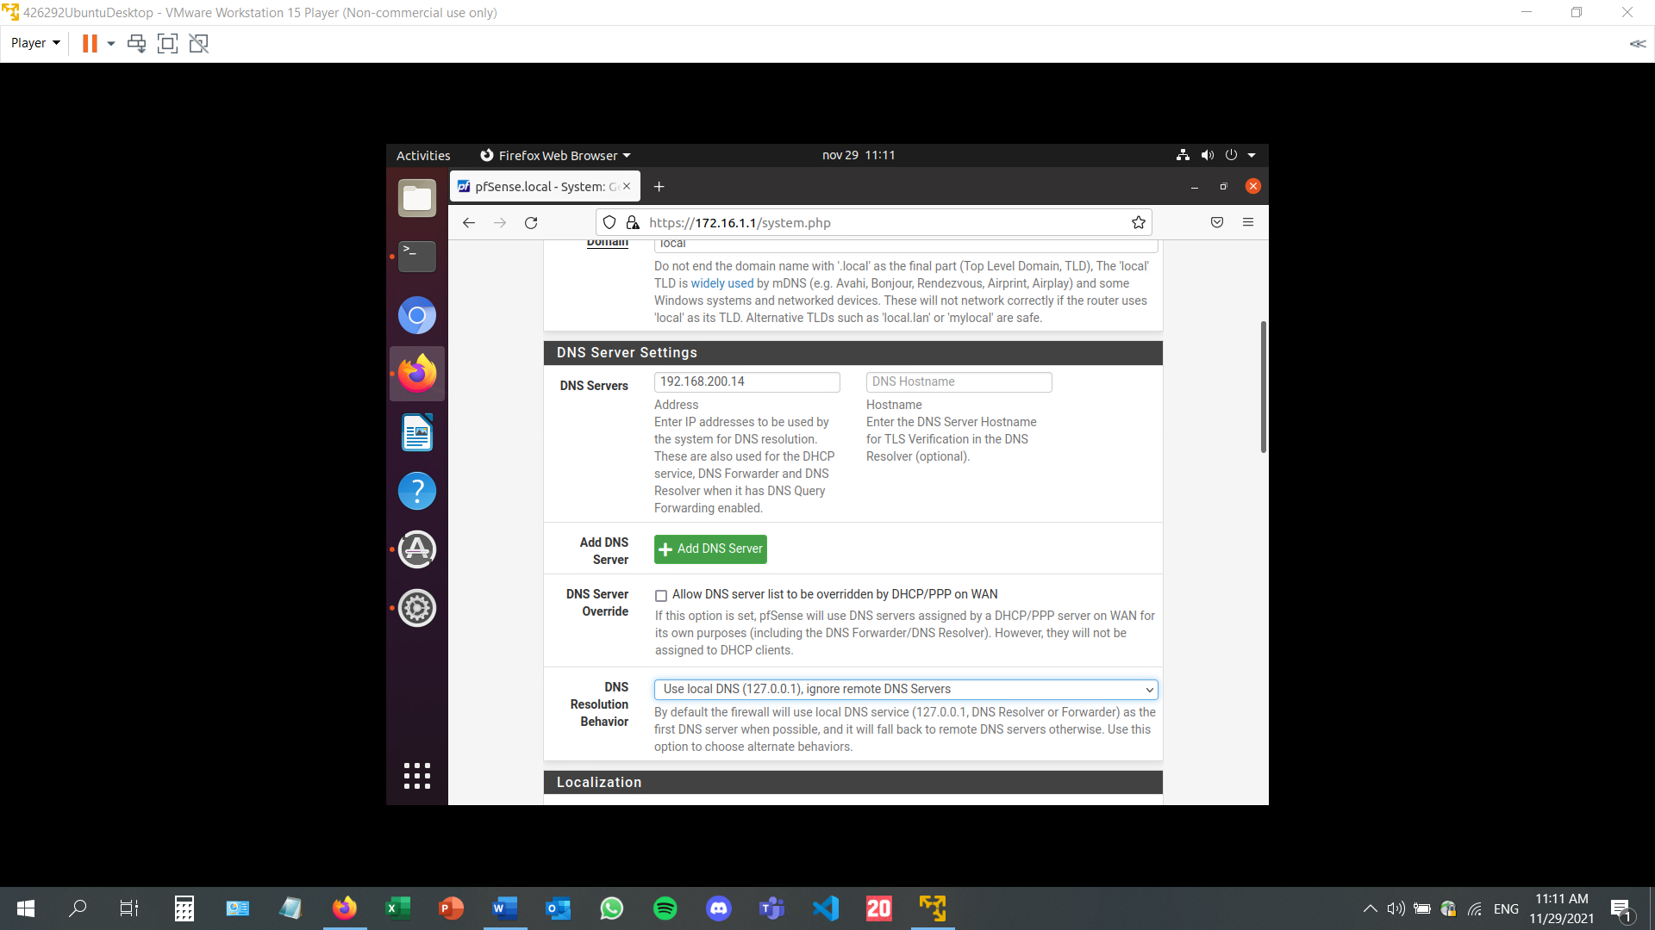

In order to check if the DNS is running, after applying the previous settings, I will ping google.com. If it works, it means that the server is running.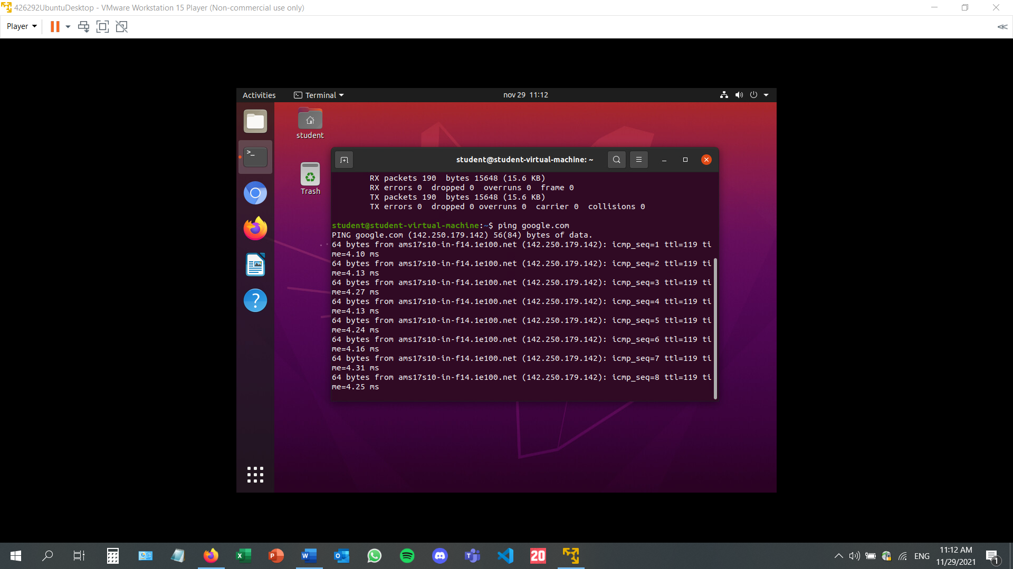

To further test the DNS, I tried pinging the DMZ. It is successful.

Setting up the firewall on the pfSense website. I am adding a new alias. I am assigning the IP of the host, a description stating what this alias does, and the name, in this case RFC1918. This alias is needed for establishing a rule in the next step.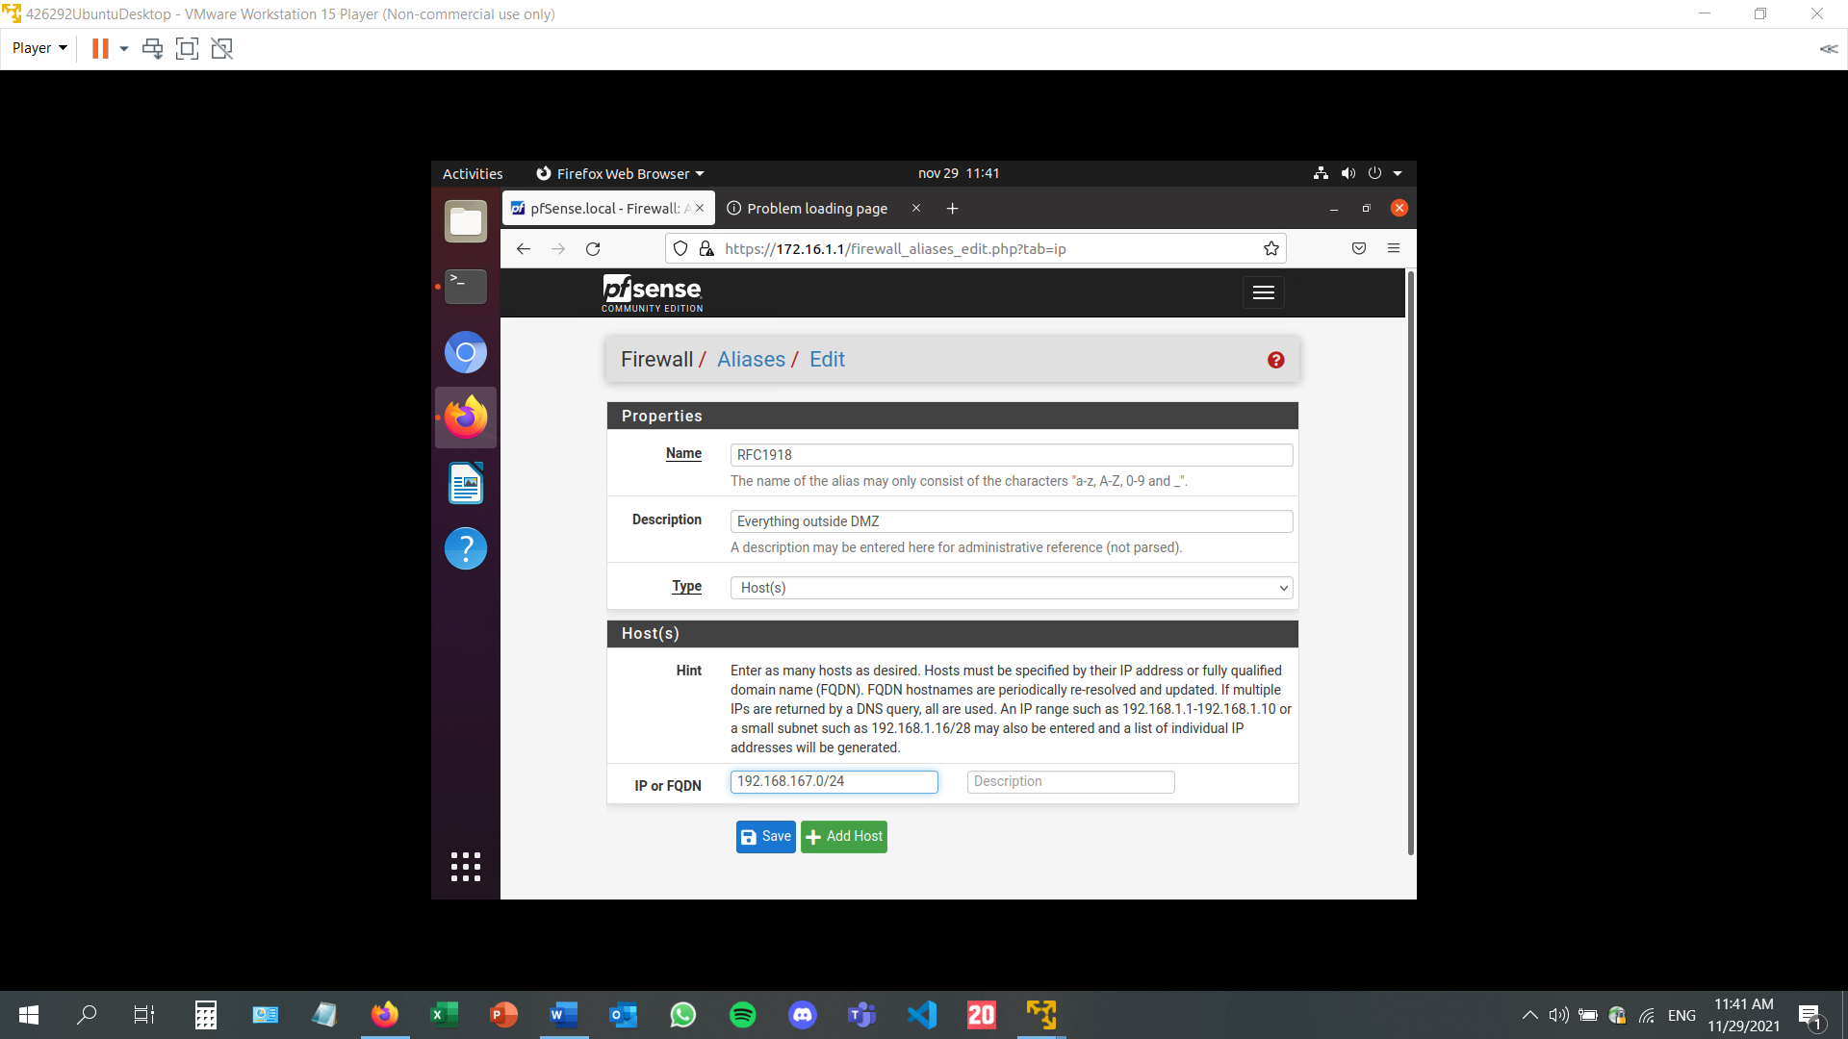

Rules can be put in place for the DMZ, WAN, and LAN separately on the pfSense website.As an example, I have created a rule which has the recently created alias as a destination. This rule, as the description states, prevents the DMZ from accessing the outside network. If this rule is turned on, I will no longer be able to access the internet on the DMZ machine.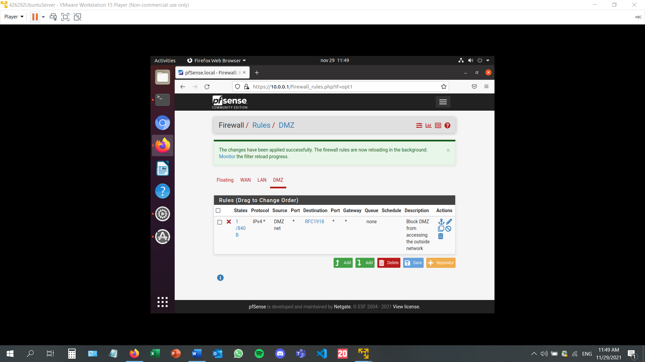

On the ubuntu desktop machine (the WAN), I am trying to ping the DMZ. On the upper part of the terminal, the packets could not be received, but afterwards there was no problem. This is proof that the settings and rules established on the pfSense website work, and the firewall is actually functional. When the action is set to pass, the ping is successful, but when the action is set to block, the ping instruction will not work.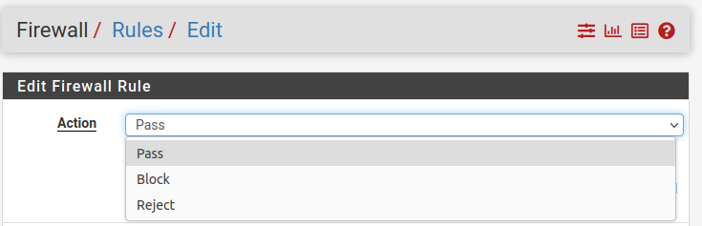

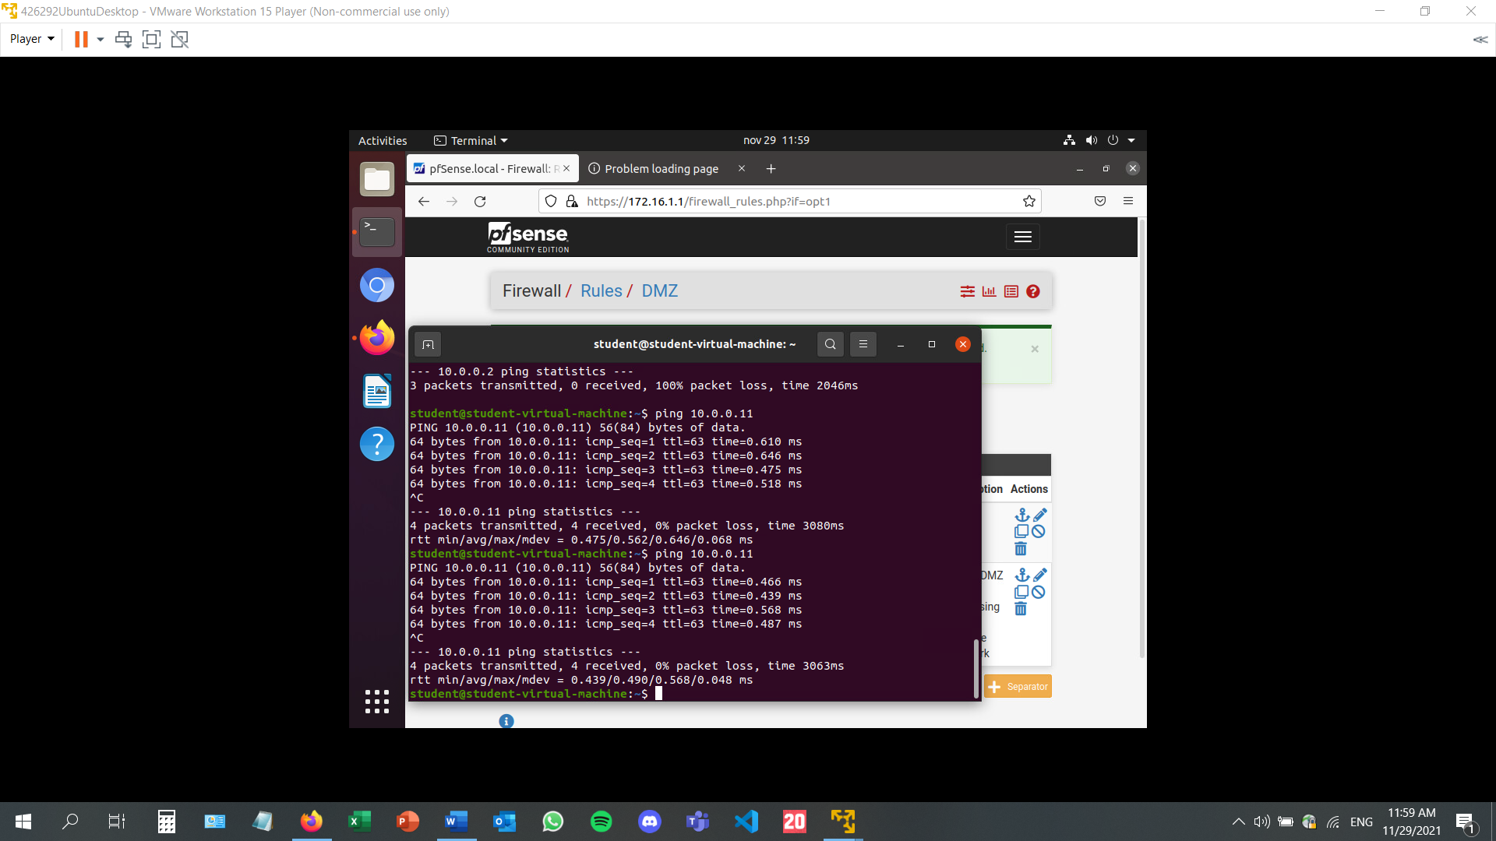

Setting up a web server:

This requires apache2 to be installed. This can be done by typing ***sudo apt-get install apache2*** in the terminal. If the installation has been successful, if the user types the machine’s IP address, the default apache screen should be displayed. 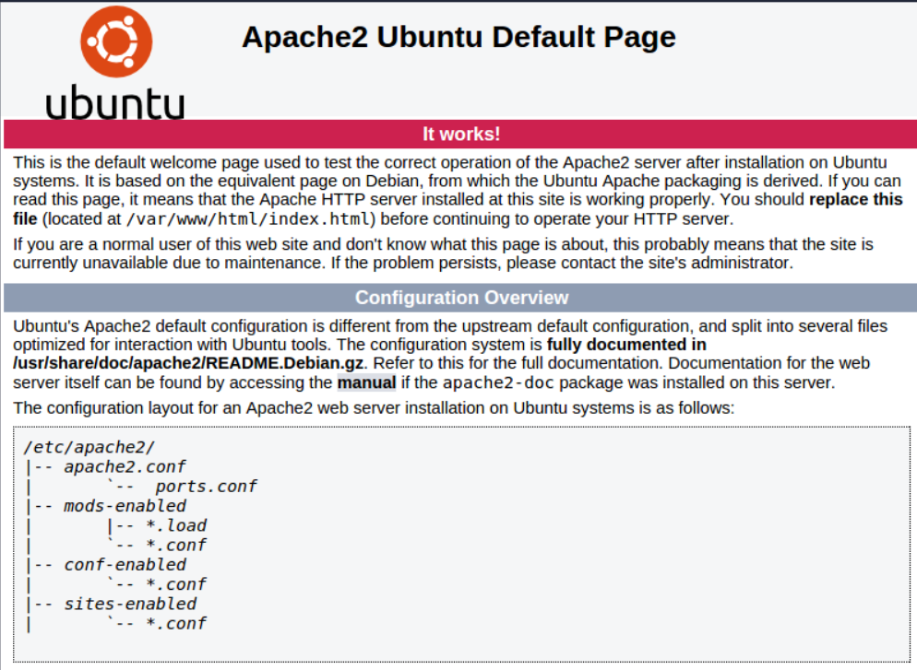

The page also shows to configuration of the apache2 folder. The default-000.conf file contains default information such the server name or server alias for example. I have created a new file, called localdomain.conf for my own web server, copied the content of the default file and then pasted it. I have modified it to suit my needs. 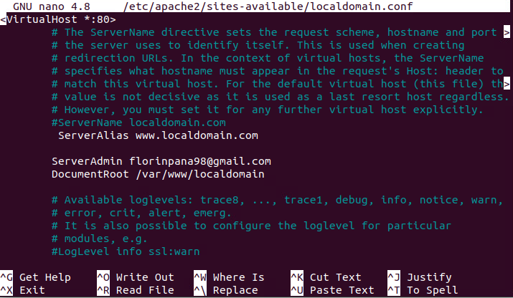

Next up, I am going to change the aspect of the webpage in order to display my own instead of the apache default: 

Typing this command opens the html file: 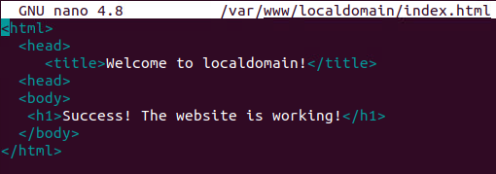

The web page now shows this: 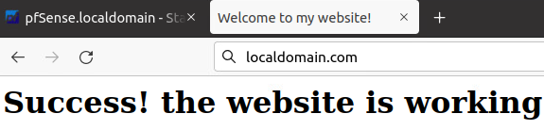

The virtual host website is now up and running.

* References:
* <https://www.youtube.com/watch?v=GZLB3s_YhZ8&list=PLseqMIwVJlNIlauKIp95HLRYNU0BH98pm&index=4>
* <https://docs.netgate.com/pfsense/en/latest/recipes/example-basic-configuration.html>
* <https://ubuntu.com/server/docs/web-servers-apache>
* <https://www.contradodigital.com/2021/02/19/how-to-host-a-single-website-behind-a-pfsense-firewall/>

# Security Engineer 3 – Secure Network Connections

* **Generate a self-signed certificate on your web server.**

The web server I am working with is called localdomain.com and it has been created after configuring apache2. I have created the localdomain file by copying the content of the default file into it and making some modifications. The default file contains some default settings and values that need to be changed according to the user’s needs. For instance, in the new localdomain.conf file, I had to change the server name to localdomain.com, the server alias to *.localdomain.com, the server root to /var/www/localdomain, and the server admin to one of my email addresses. Any potential errors with the servers are sent via email to the address provided. The server alias is a tool that helps the user access the website even if they write something ahead of localdomain.com, such as “www”.

The certificate file is the place where the generated certificate is being stored.

The certificate is generated by typing the following command:

*sudo openssl req -x509 -nodes -days 365 -newkey rsa:2048 -keyout /etc/apache.key -outt /etc/apache2/ssl/apache.crt.*

This will generate an interactive menu, in which I am typing the user data and website data, which will be present in the certificate: country, company, email address, etc.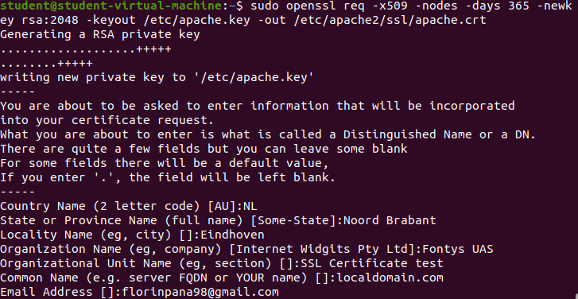

Once this has been done, I can go check the certificate on the web browser: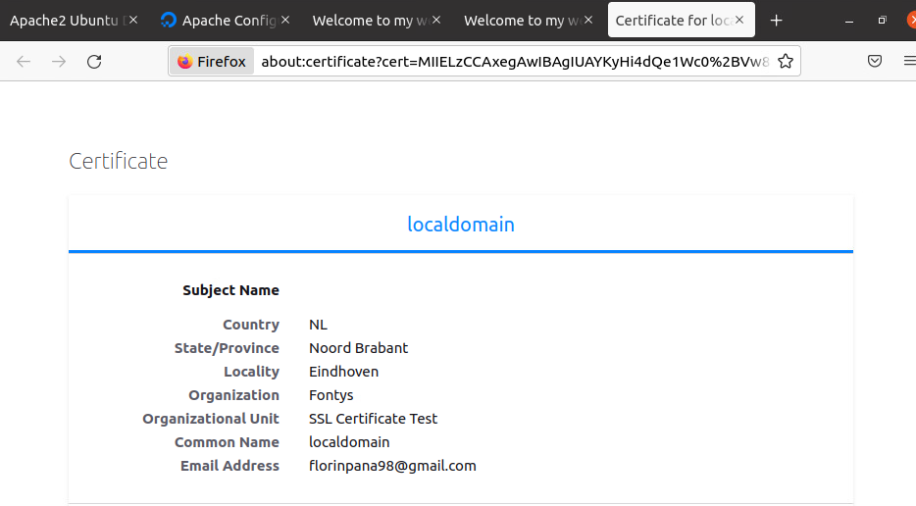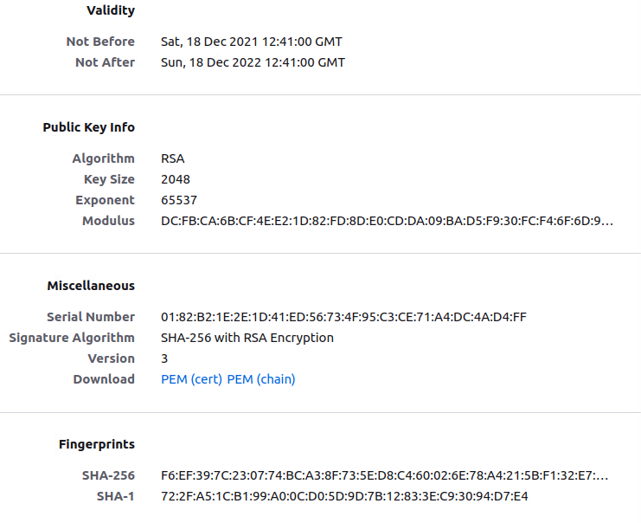

* **Execute this command on your webserver:**

$ openssl s_client -showcerts -connect localdomain.com:443

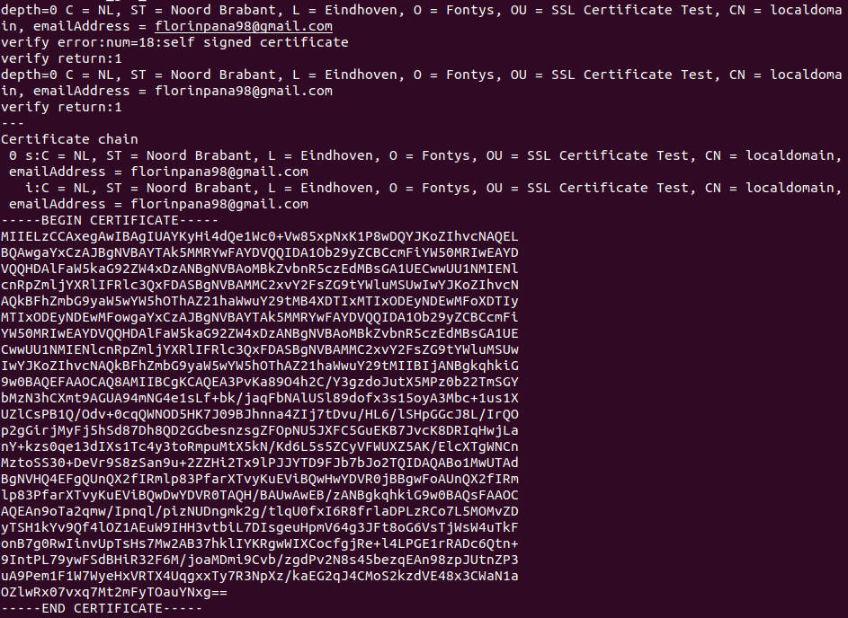

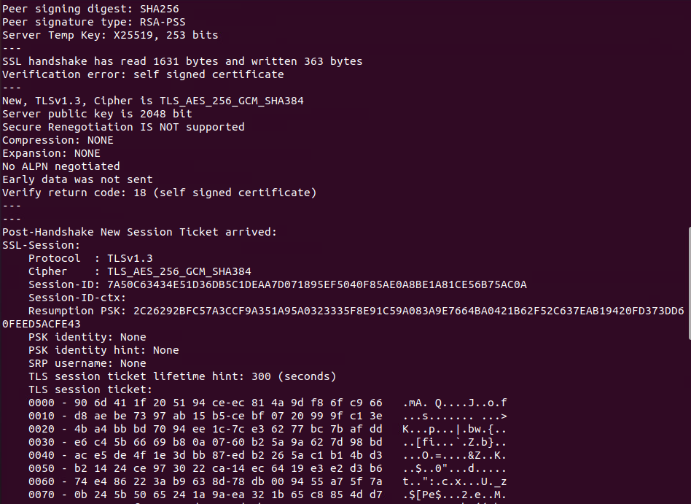

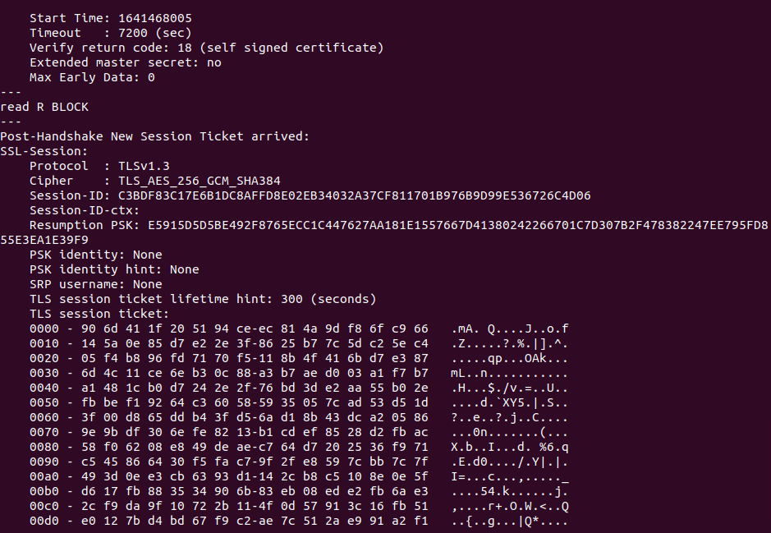

* **A digital certificate contains a lot of information, this can also be seen in the output of the command above. What information can you find in the digital certificate? Make a comparison between a self-signed certificate and an extended Validation certificate (recognizable at the green area within the URL). Execute the same command, but now for a website with EV-certificate.**

Getting a certificate from Instagram.com: 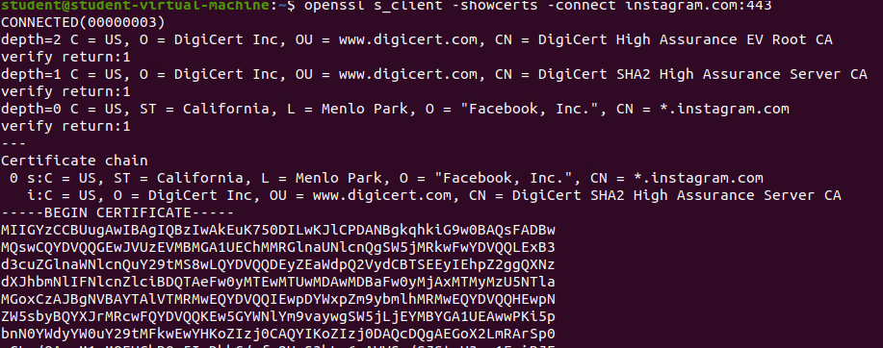

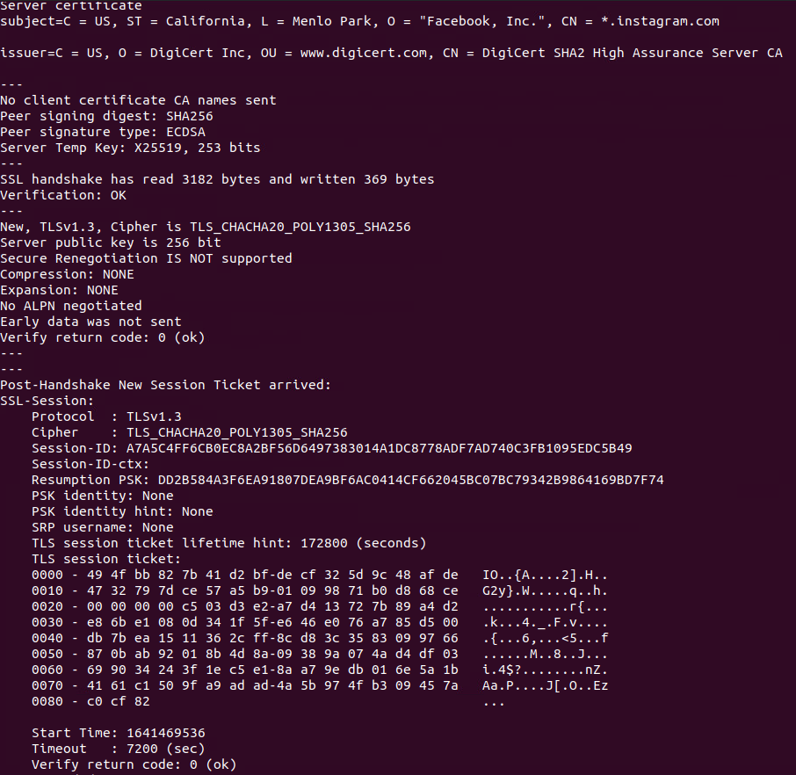

* **What are the similarities and differences between the certificates?**

Both certificates are quite similar, the structure is the same, and the overall content is following the same template, showing the origin, subject, creator, etc.

The main difference is the return value. Its purpose is to tell if the certificate is self-signed or not. The certificate is considered to be valid only if it is secure. In some instances, a certificate could work but not be considered valid because of its lack of security. Self-signed certificates are not safe, but for the purpose of this exercise it is good to study them and understand their way of working.

* **SSH exercise:**

The first step is installing ssh on the ubuntu terminal.

The IP address for the ubuntu machine is 172.16.1.11.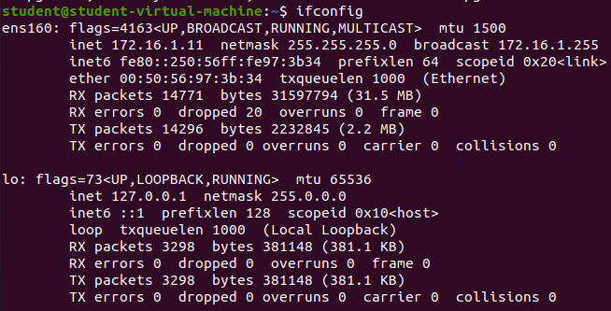

I have installed PuTTY on my windows machine. I have entered the IP address of the ubuntu machine and the SSH connection.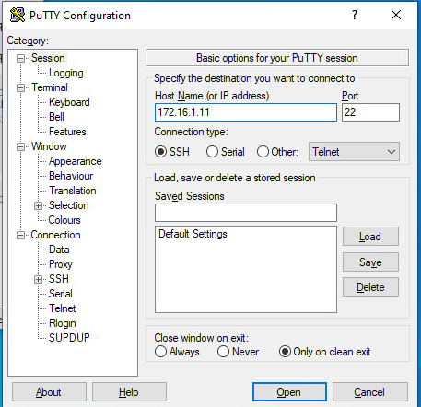

After pressing the Open button, a terminal is being displayed, where I am asked to type the credentials. I am logging in as student, this being the main username and password for both machines. The terminal also asks for a verification code. The full explanation for it, along with screenshots, can be found on the 6th chapter of the Security Engineer Learning Outcome: System Hardening.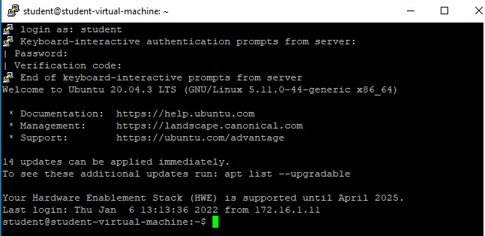

The login has been successful. The connection has been established. The who command shows the users that have logged in: student pts/2 is the windows machine, and student pts/1 is the ubuntu machine.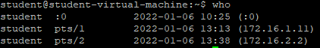

* **Make screenshots of wireshark to capture the 4 steps of the process.**

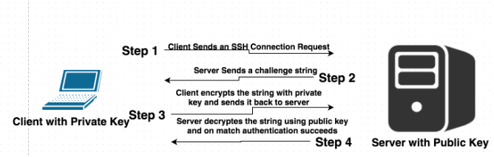

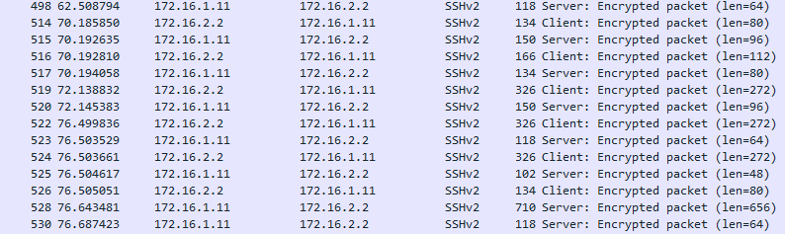

I have opened Wireshark before doing all the steps in PuTTY in order to capture all the packets. As can be seen in the first screenshot, the client sends a message to the server, requesting to setup a SSH connection. The server responds by sending back a challenge string. This is an automatically generated string, and random, that is used as an excrypted form of authentication which prevents the unencrypted password from being transmitted. The client will attempt the decryption of the message. If they succeed, the connection is established. The string value of the decrypted message is compared to the original value by the server. The second screenshot shows a successful connection and constant communication between the server and the client using encrypted messages. The client encrypts the string message with a private key and sends it to the server, while the server decrypts the string message.

* **Sources:**
* <https://networkencyclopedia.com/challenge-handshake-authentication-protocol-chap/>
* <https://documentation.help/PuTTY/you-what.html>
* <https://ubuntu.com/server/docs/web-servers-apache>
* <https://www.digitalocean.com/community/tutorials/how-to-install-the-apache-web-server-on-ubuntu-20-04>

# Security Engineer 4 – Secure Remote Access and Management (VPN)

* **Create a VPN connection from a WAN-VLAN Windows 10 machine to your own Seclab demo network. You can realize this by configuring OpenVPN on your pfSense firewall.**

I have opened the pfSense firewall and entered the pfSense website on my ubuntu desktop machine. From there, I went to create a certificate authority called OpenVPN-CA.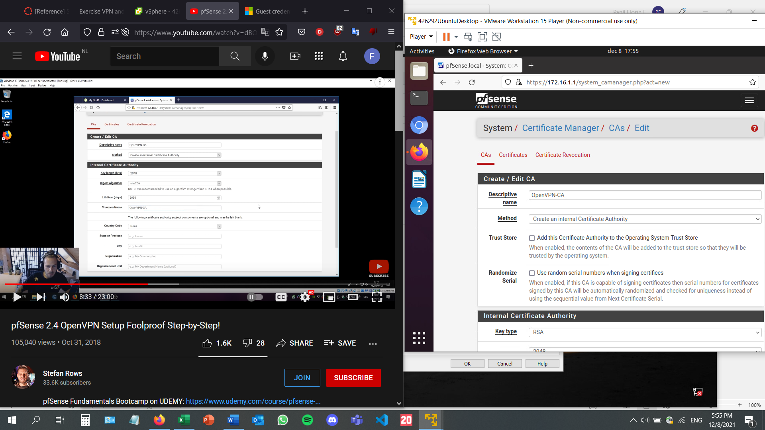

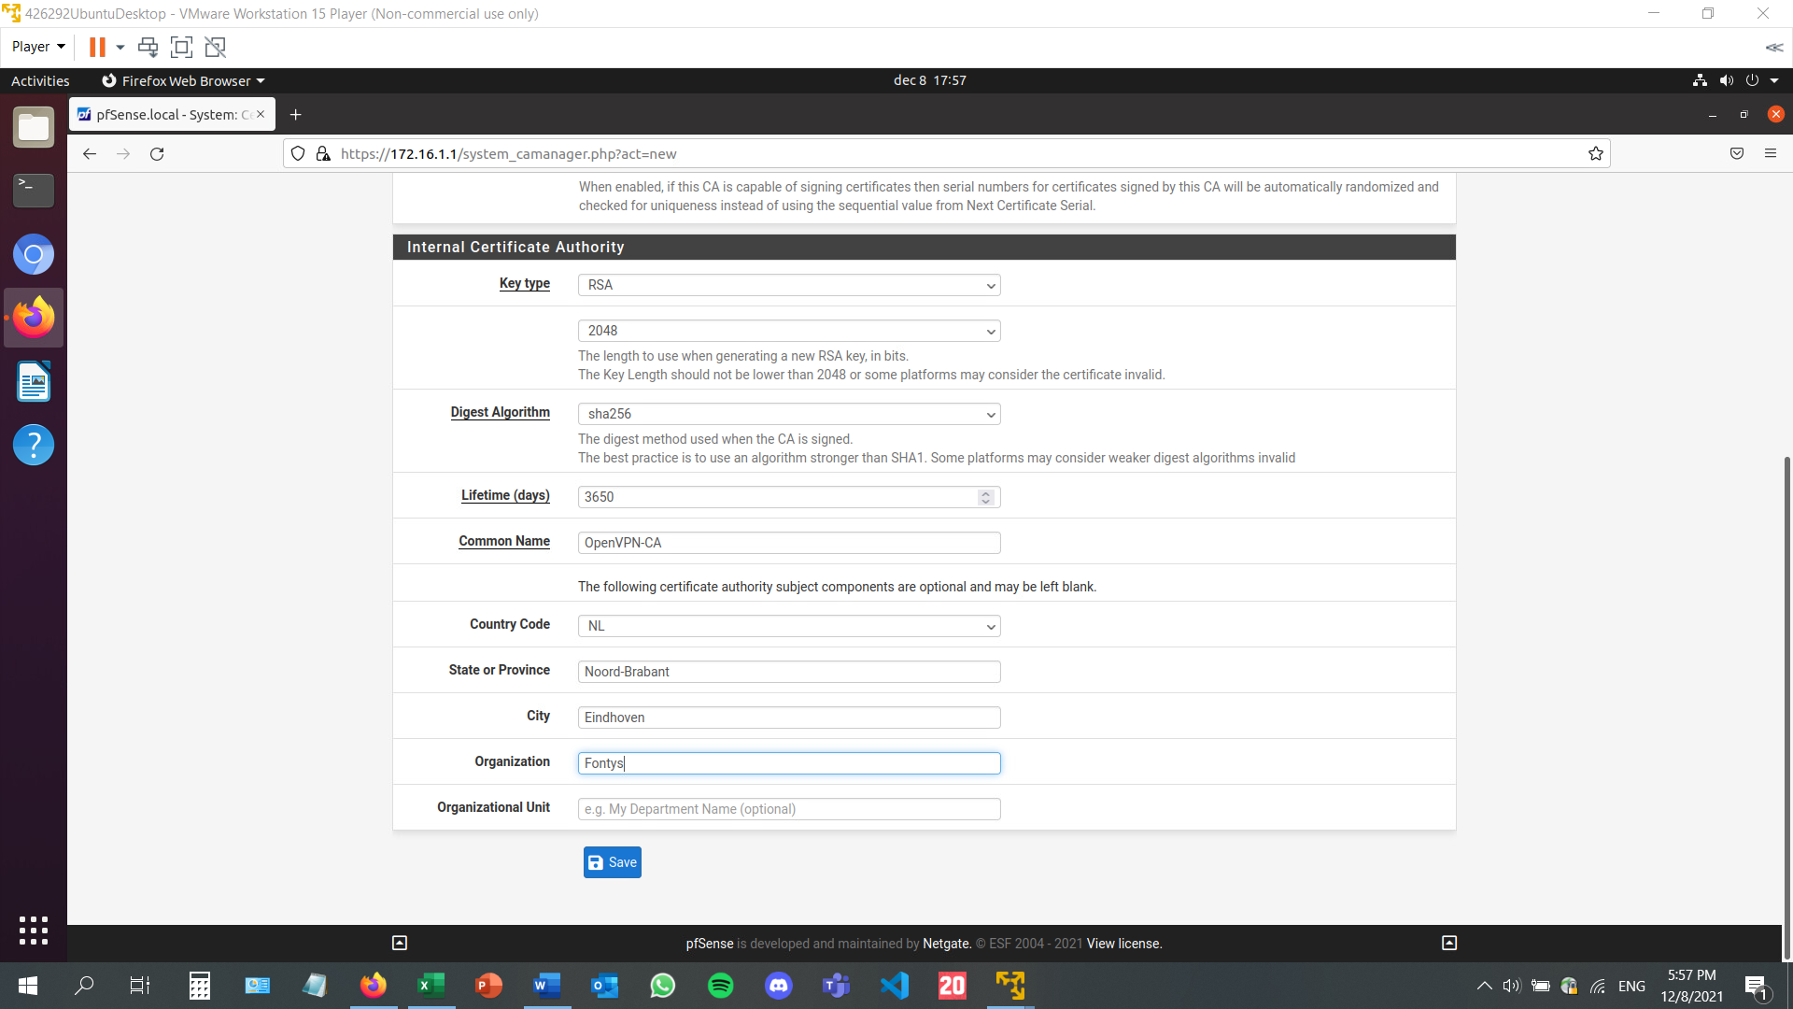

After its creation, the certificate authority can be seen in the CAs menu: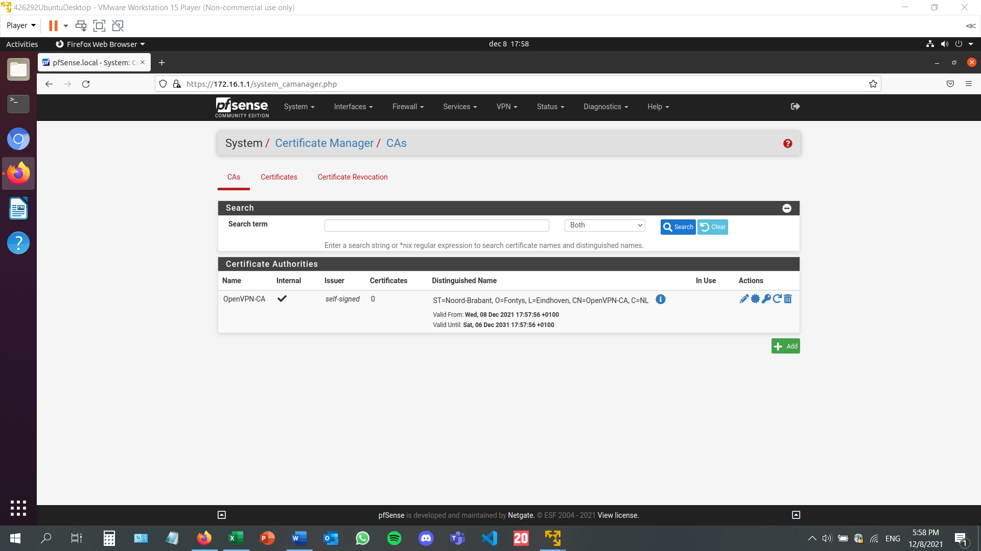

After this, I have pressed the Add button to create an internal certificate, called OpenVPN-ServerCert: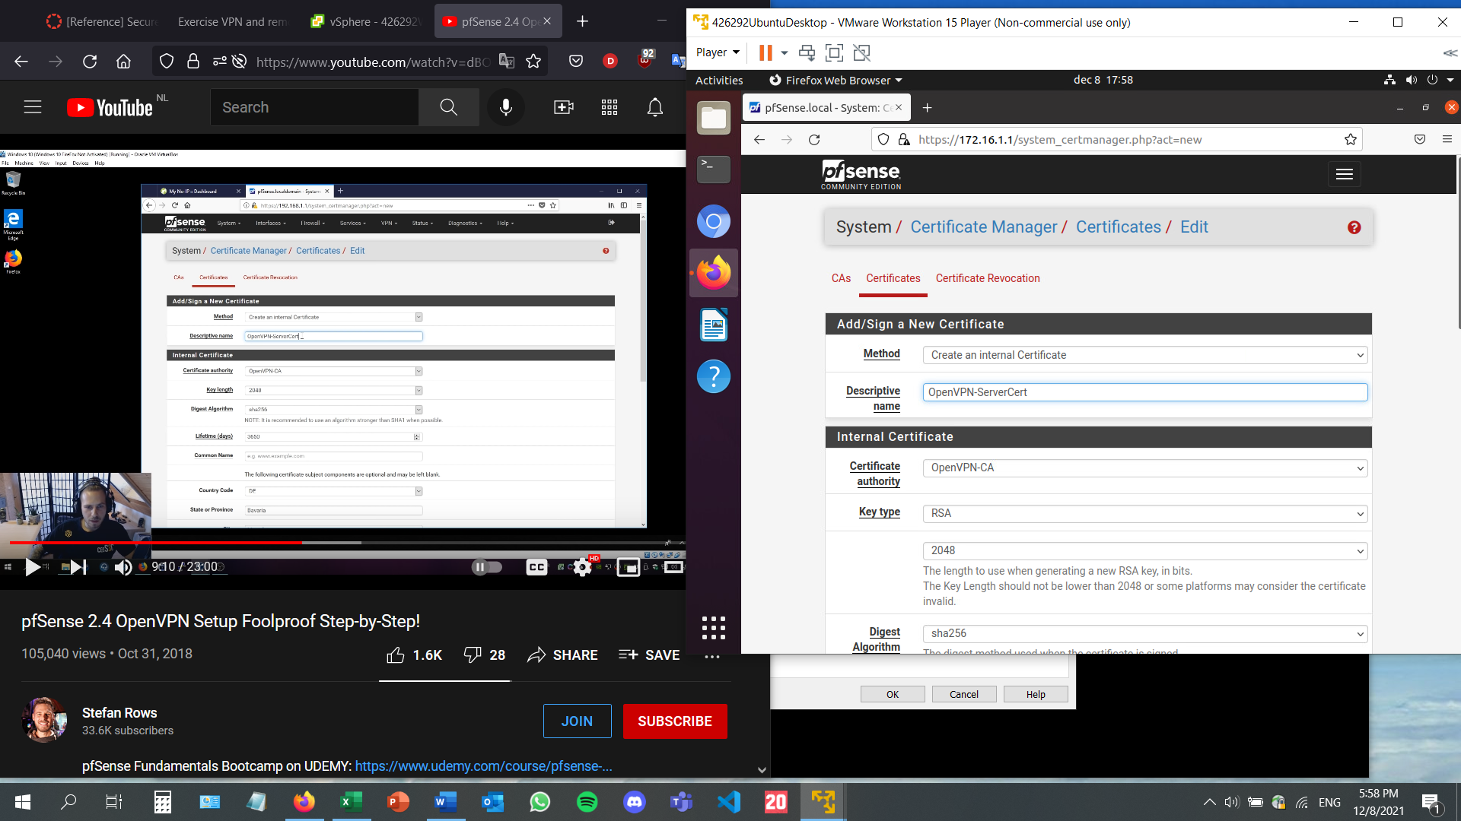

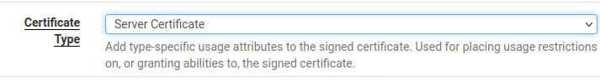

The certificate authority needs to be OpenVPN-CA, the one I had just created previously. Next up, I have to create a new VPN user. On the creation menu, I need to write down a username and a password. These are the credentials I am going to use once the VPN is set.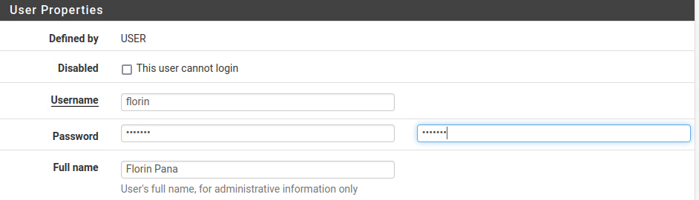

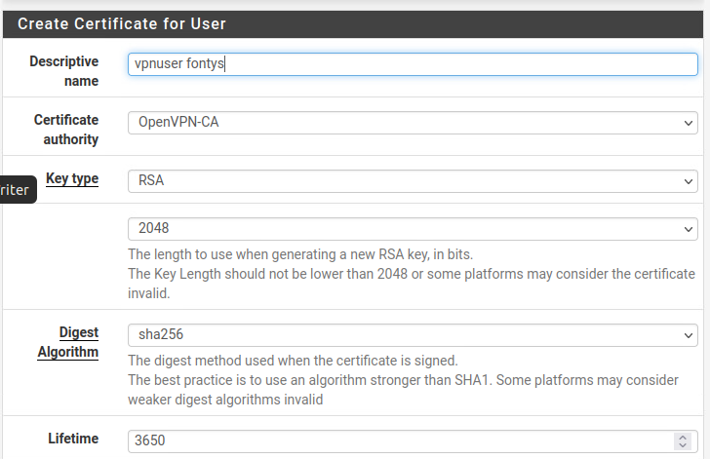

After saving, I can look at the users in the user manager tab. The second one is the one that I 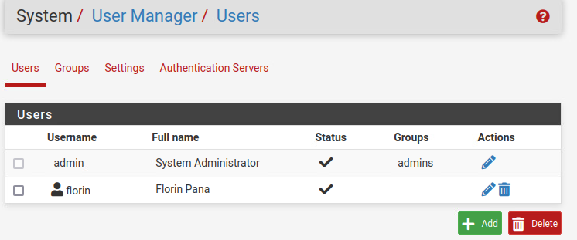

Next, I need to install the OpenVPN package. That can be done by accessing the package manager page and look for it on the available packages.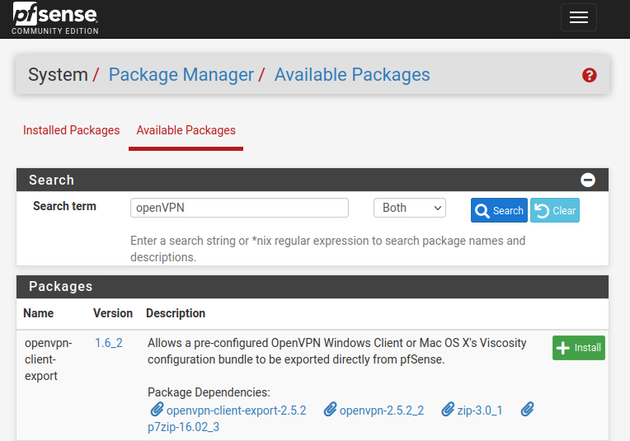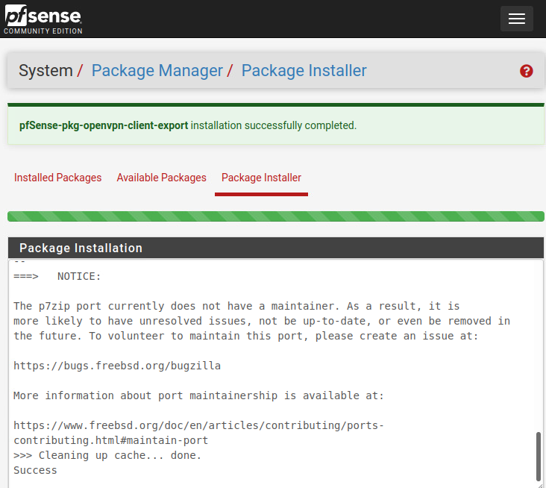

After the successful installation, OpenVPN needs to be set up on pfSense. Therefore, for the next step I have accessed the OpenVPN page on the VPN menu and selected the wizards page. The type of server should be Local User Access, and the certificate needs to be the one created just before, OpenVPN-ServerCert.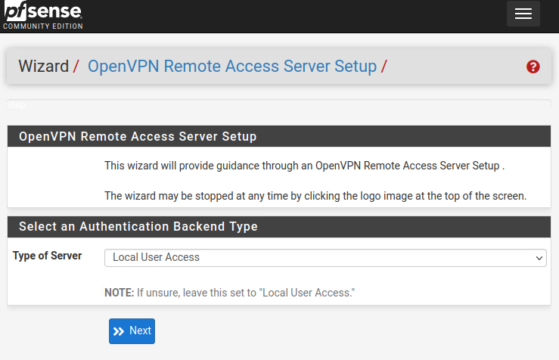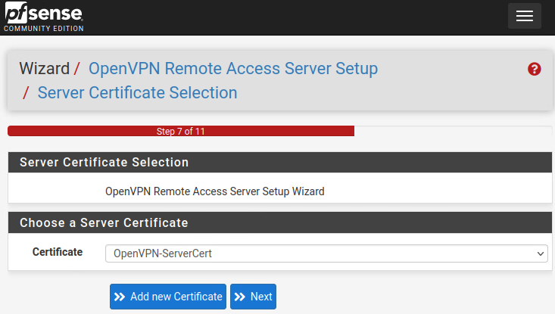

The local network is the IP address of the ubuntu server I am working on, except the last number will be a 0, because it will give an error and I will not be able to start my OpenVPN server. The IP address will be followed by the subnet mask, which is 24, as seen in the configuration of the pfSense firewall. For the tunnel network, a different subnet (network inside a network, making the initial network more efficient). As a consequence, the third number of the IP address has been changed from 1 to 2. If nothing is written down on the concurrent connections textbox, there will not be a limit. For security reasons, the selected number is 1. This way, only one customer can connect to the OpenVPN at a given time.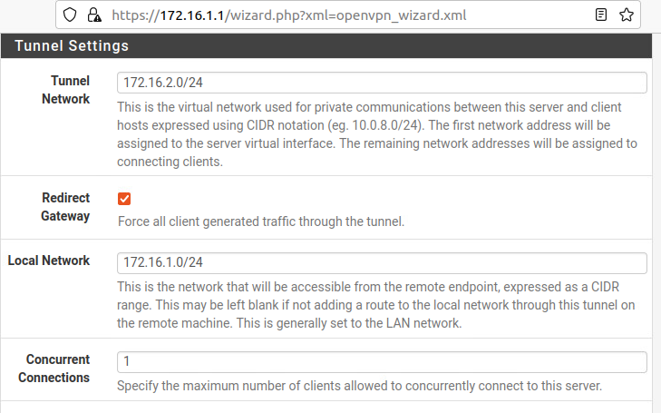

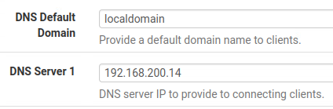

The OpenVPN is now set.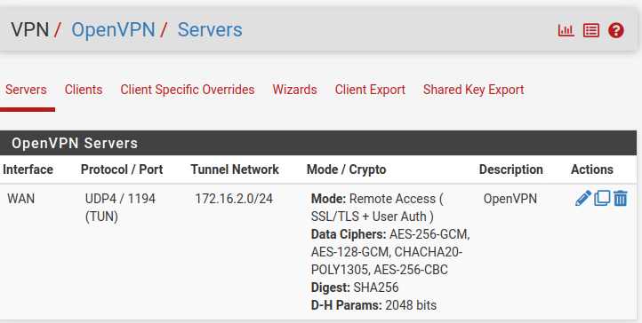

On the status/services page, it can be seen that OpenVPN is up and running.

Next up, I need to export the client.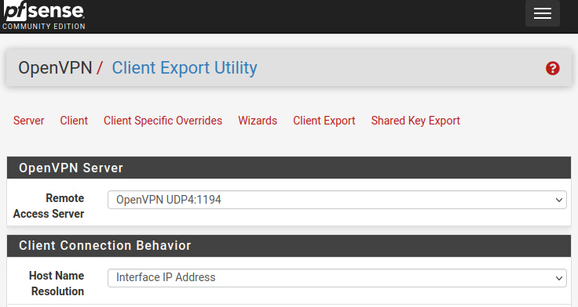

Once this step has been completed and saved, the OpenVPN clients is shown, containing the user, certificate name, and exports from which to choose. The current windows installer (64-bit) has been downloaded.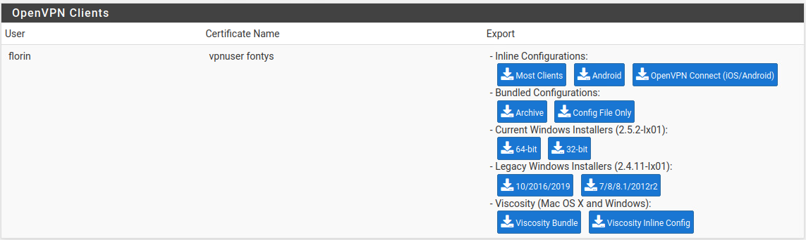

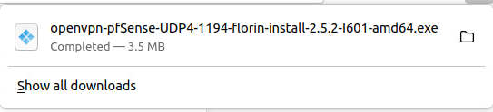

I have placed the executable file on a USB drive, and then deployed a windows machine from one of the seclab templates. I have placed the USB drive in there and installed the file.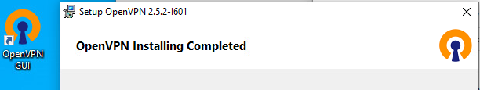

After opening the OpenVPN GUI, I have to type the username and password that I have set on the pfSense configuration of the OpenVPN, while creating the user, which can be seen in some of the earlier screenshots.

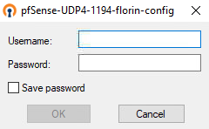

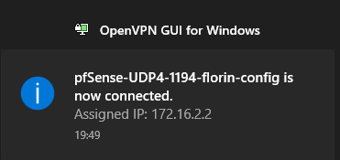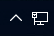

As it can be seen in the screenshot above, the assigned IP is almost identical to the one of the ubuntu desktop machine, where the pfSense website is open, another sign that the VPN works.

# Security Engineer 5 – Intrusion Detection and Prevention

* **Add the Suricata IDS package to your PfSense firewall.**

First of all, I am going to use the 13th instruction in the pfSense machine in order to check if everything is up to date.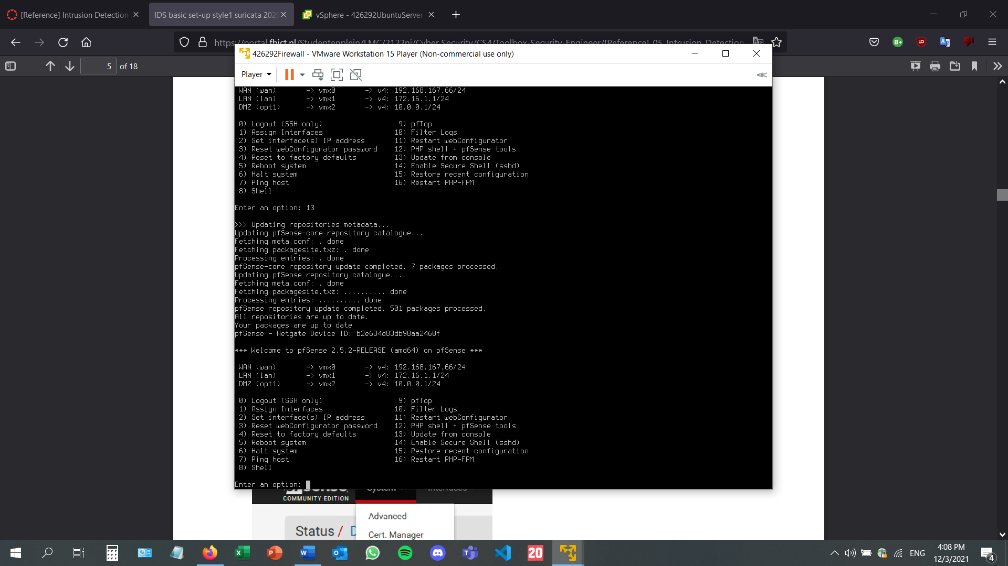

Once all the packages are up to date, I can proceed to the next step. On the pfSense website, I will go to the available packages page and install Suricata.

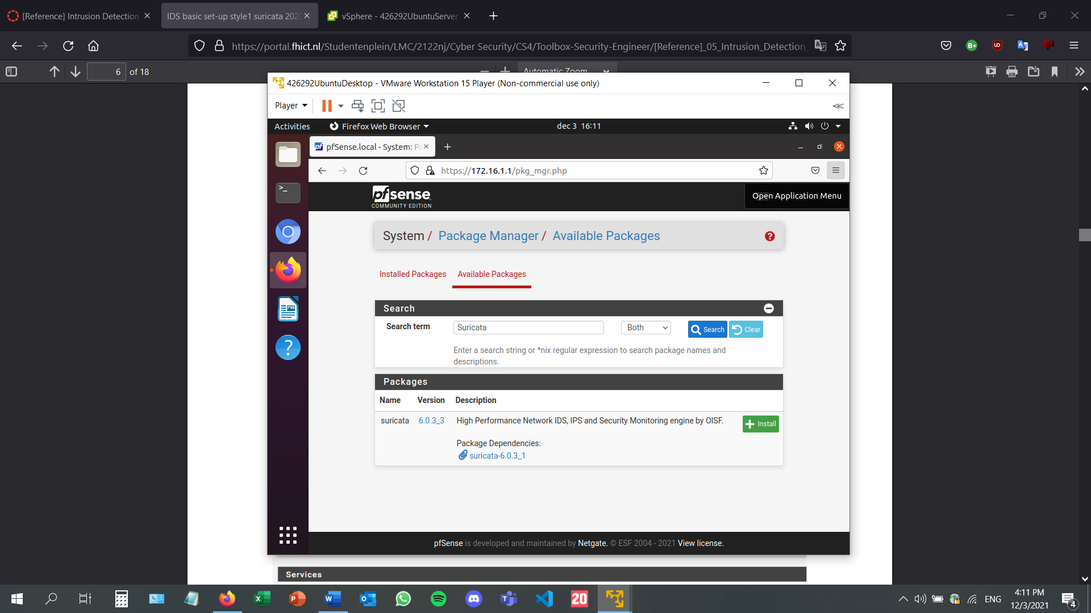

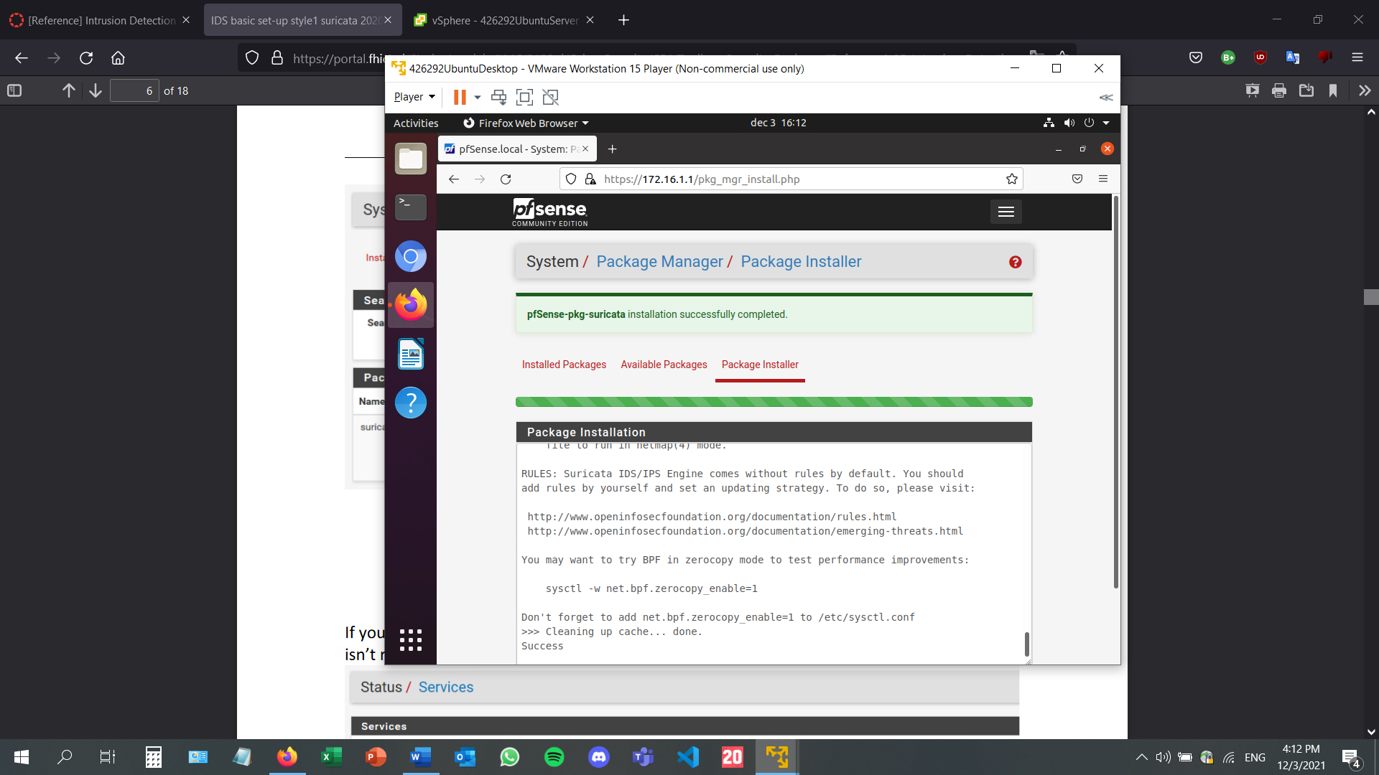

Checking for the Suricata package on the services page. It is not yet active, as it must be configured first.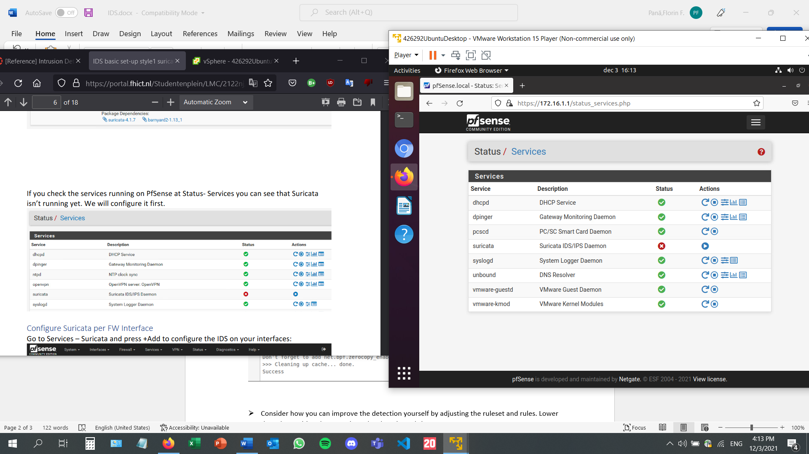

Adding an interface: adding a description and saving.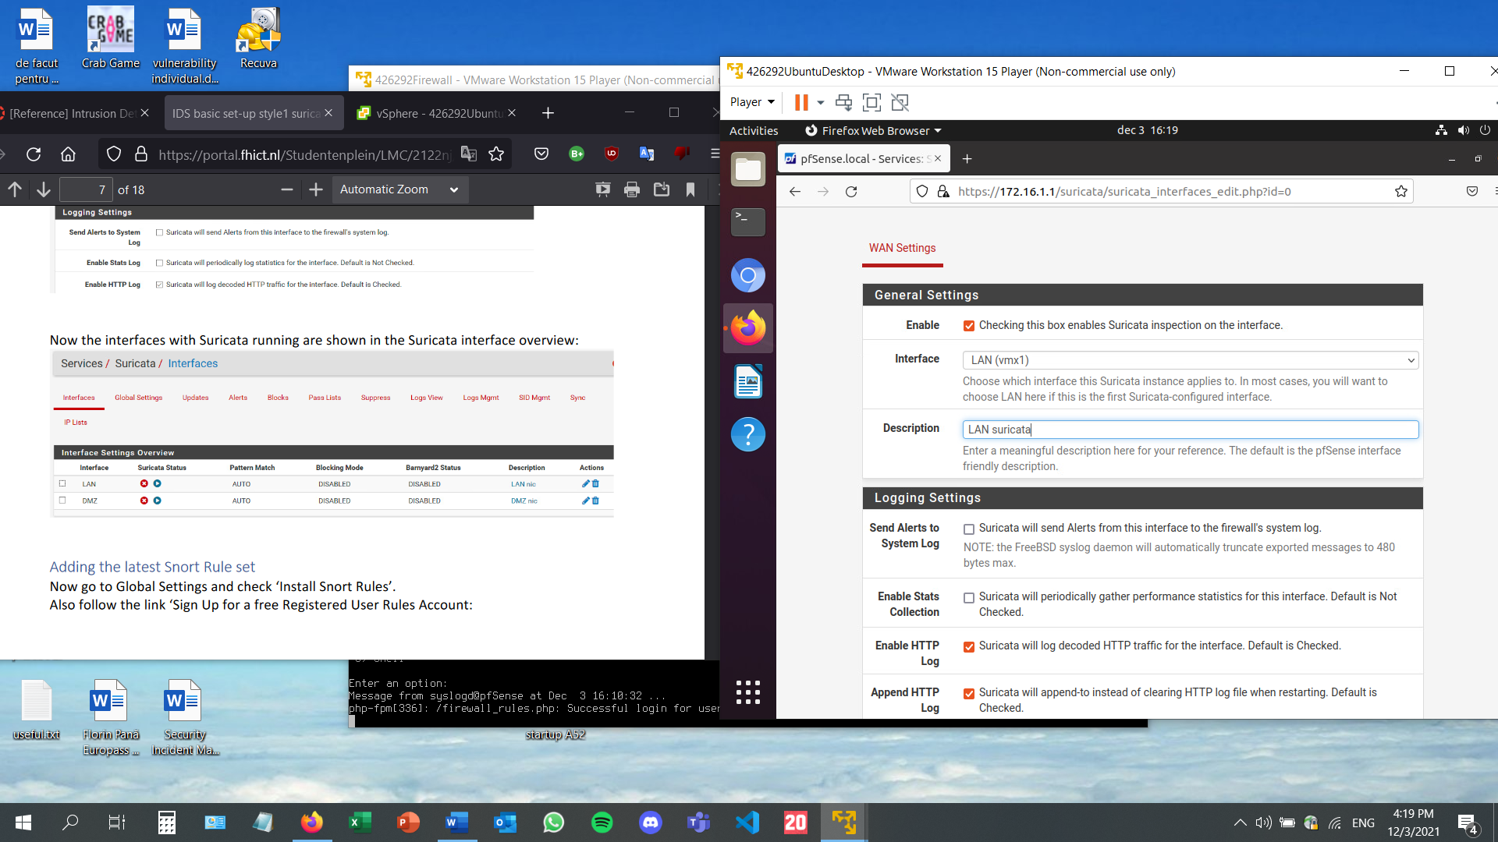

The interfaces that have been created can be viewed here: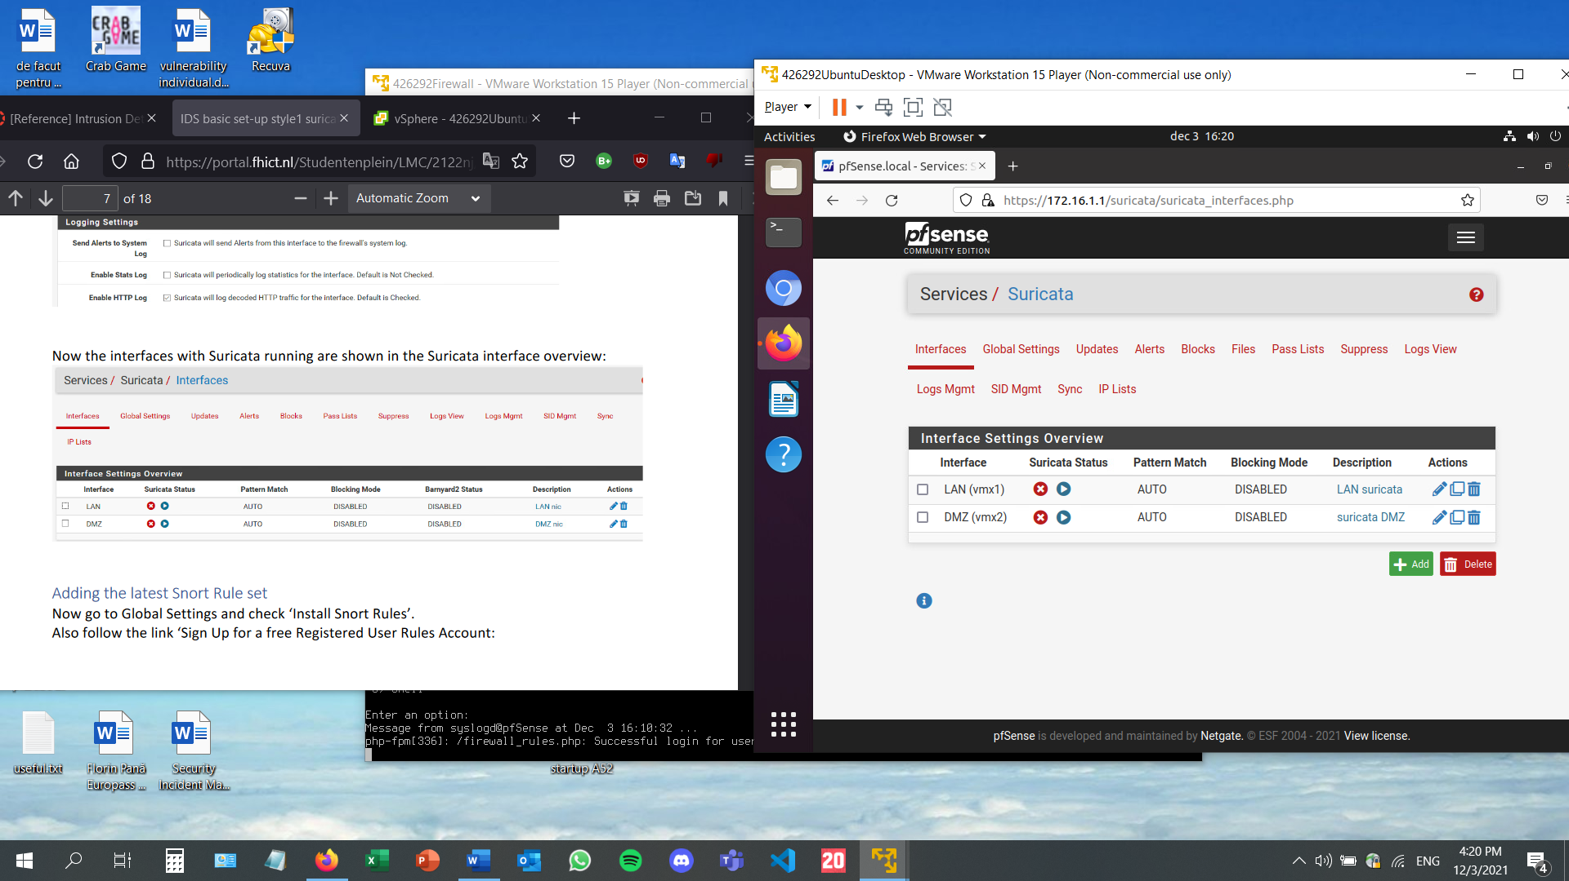

Going to global settings to install the snort rules: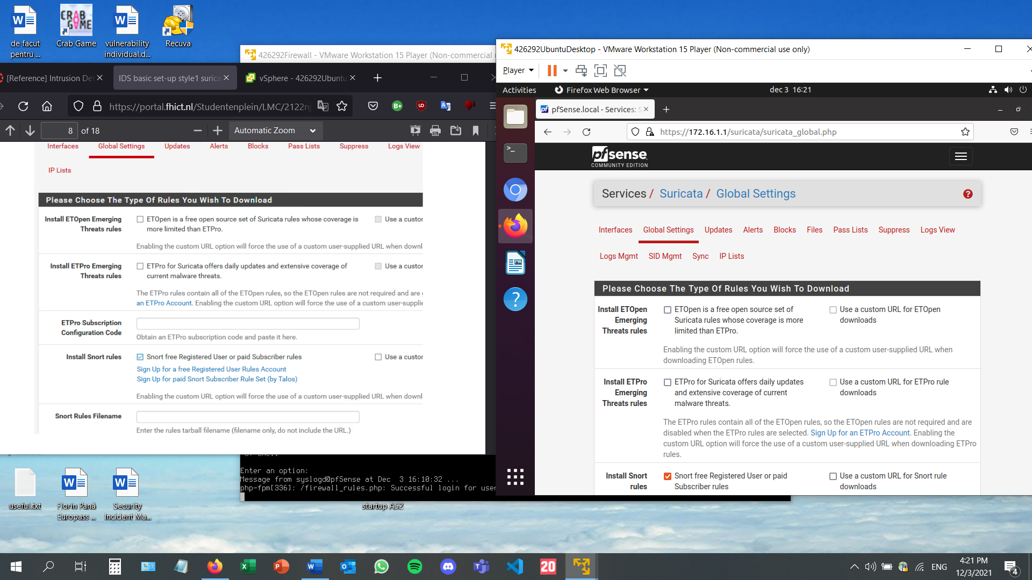

Creating an account at <https://www.snort.org/users/sign_up>: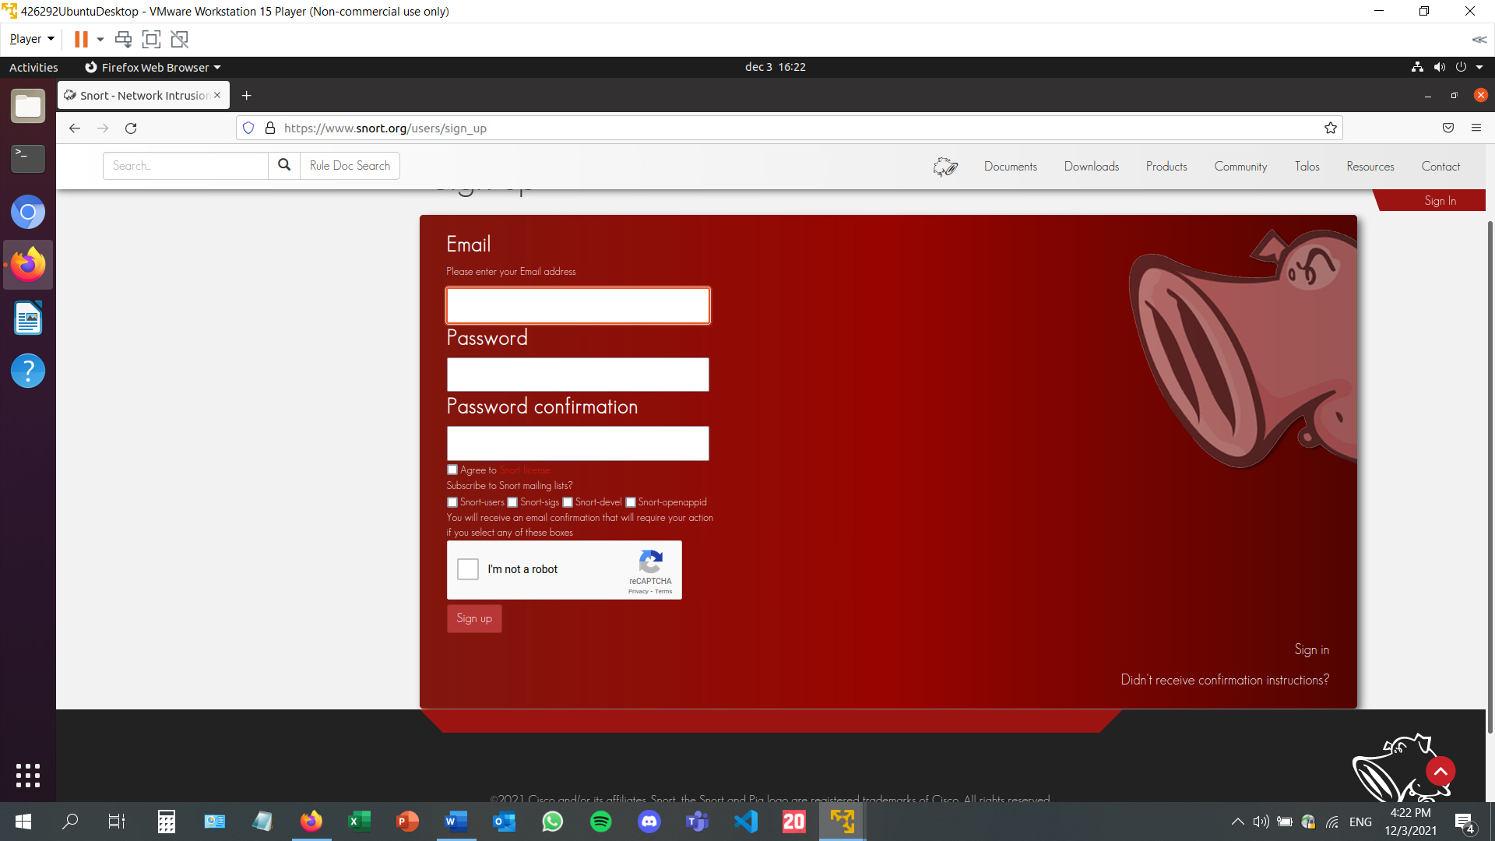

Once the account has been created, the Oinkcode has been generated. It is blurred in this screenshot: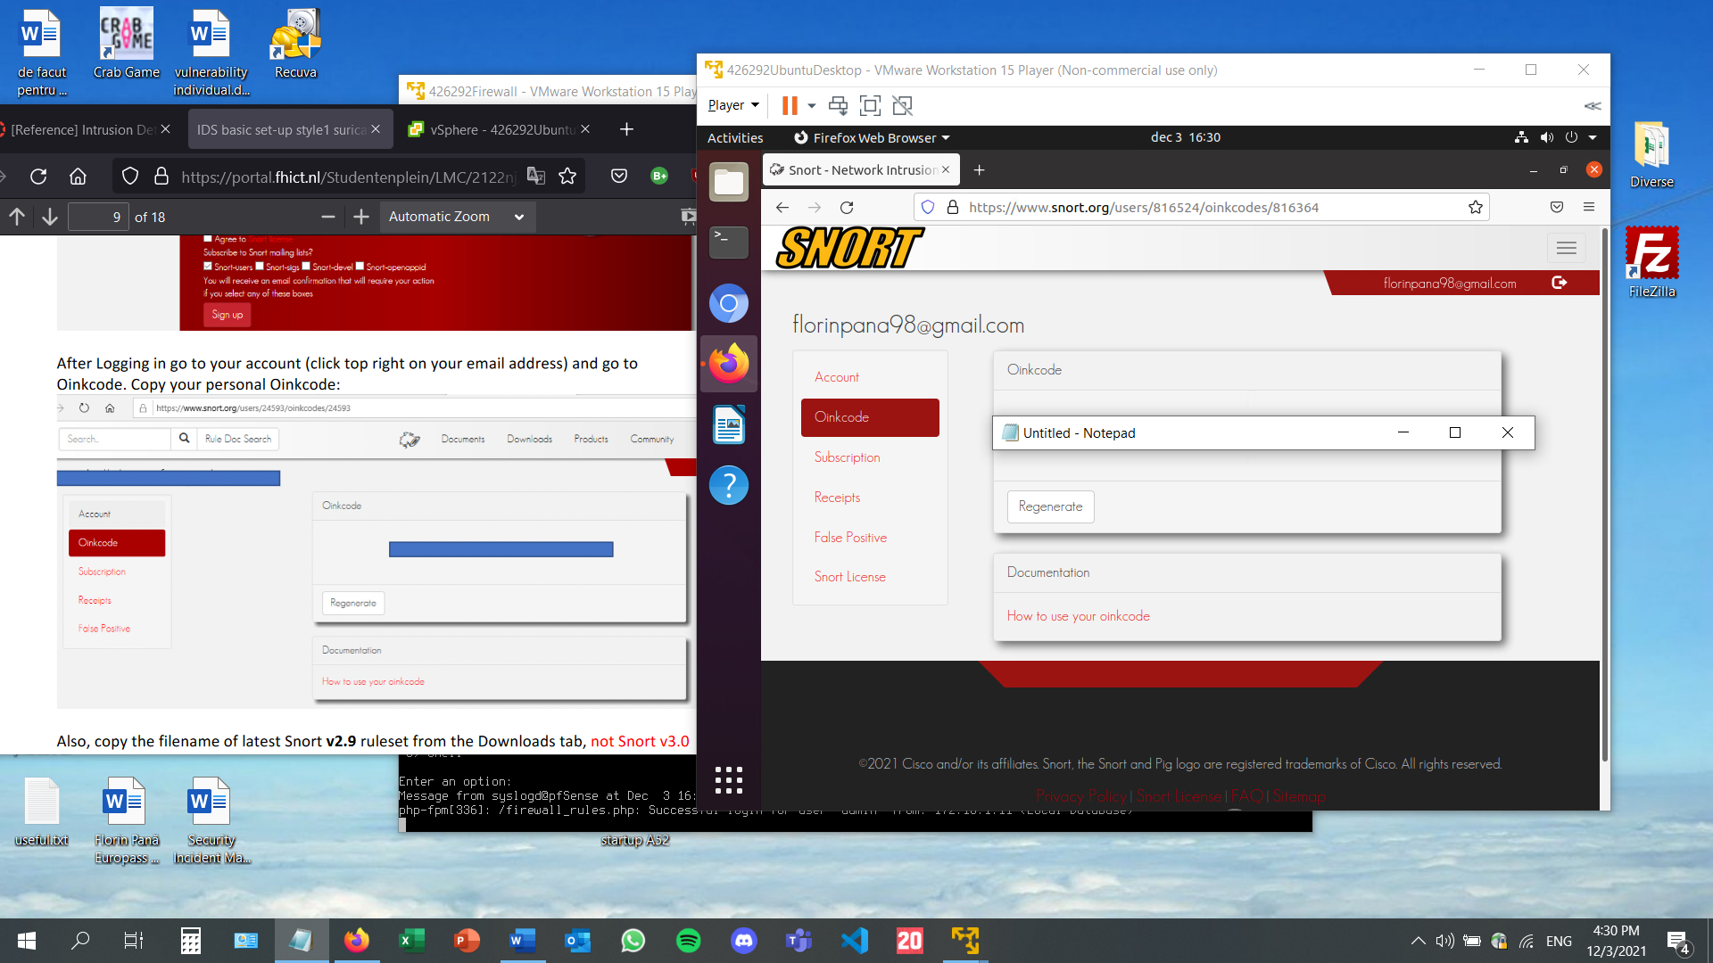

Downloading the latest Snort v2.9 ruleset. The v3 ruleset is not reccomended for this configuration. In this case, snortrules-snapshot-2983.tar.gz is the right file to download.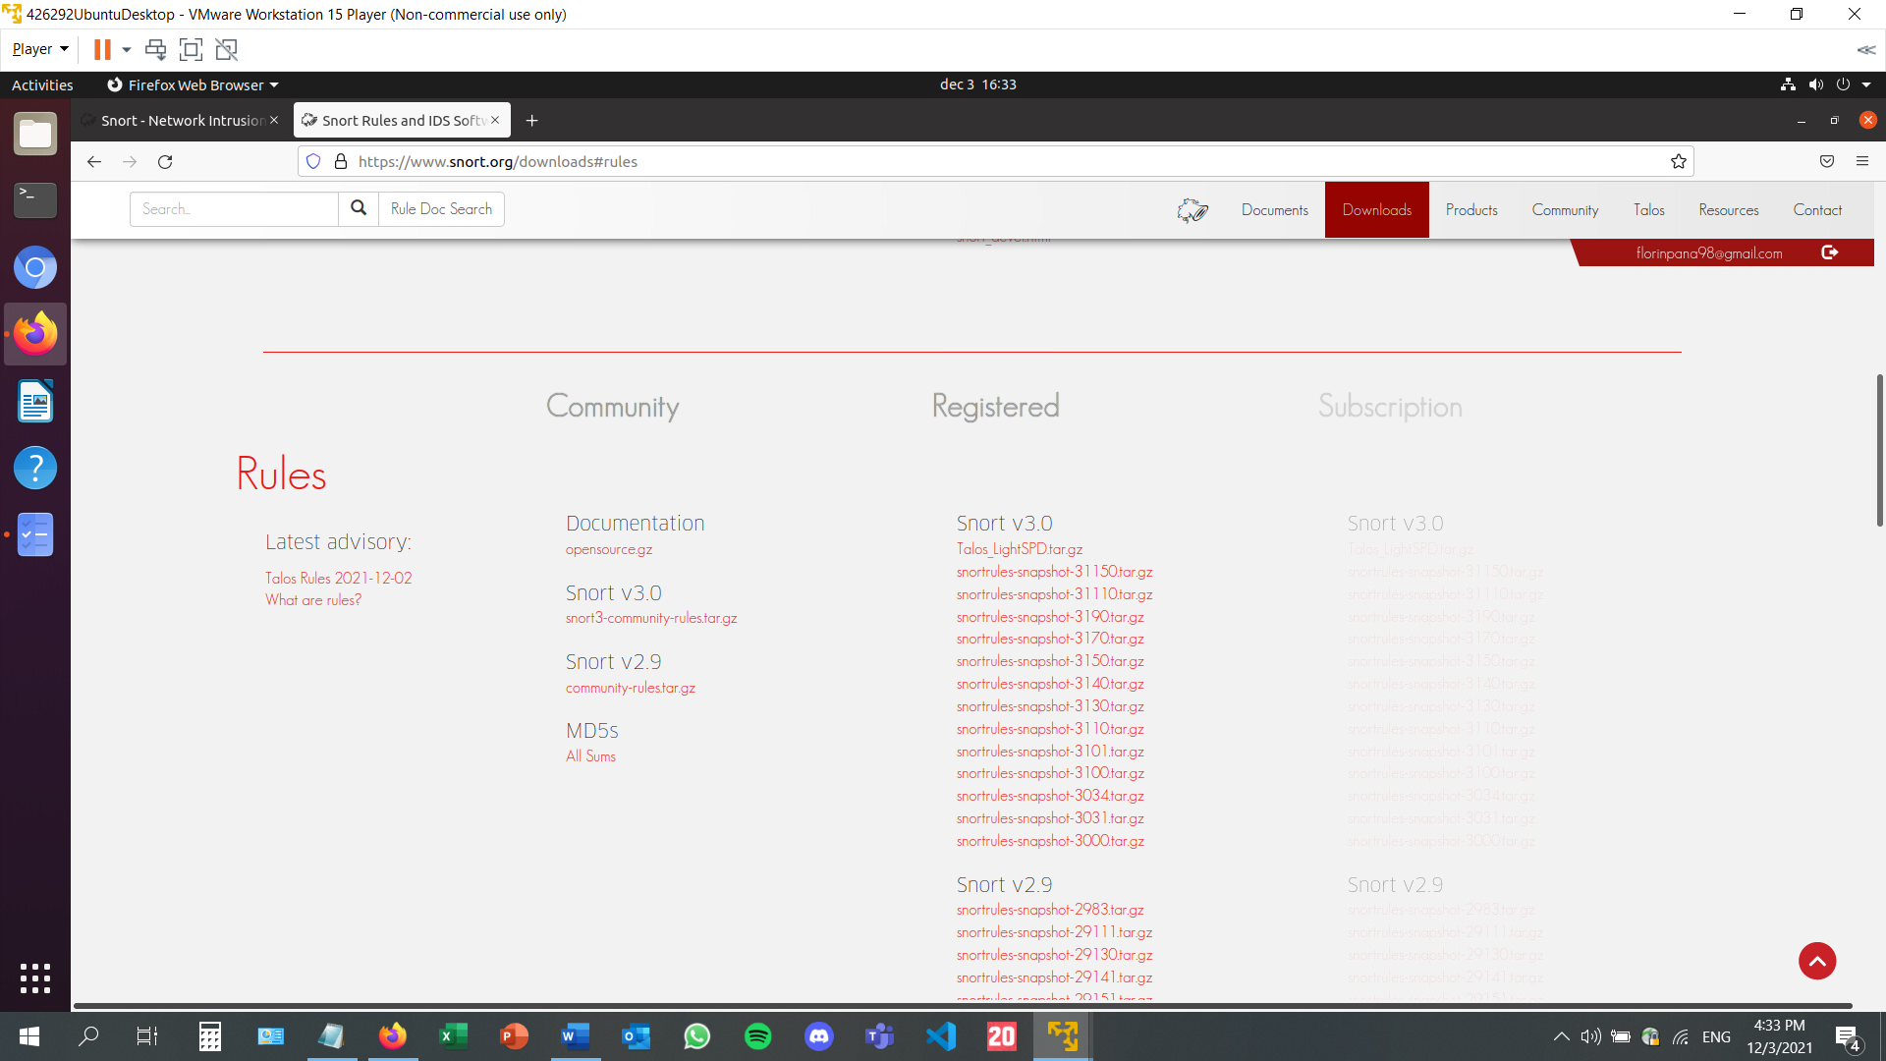

The Oinkcode and the ruleset file name will be filled in the Suricata Configuration menu.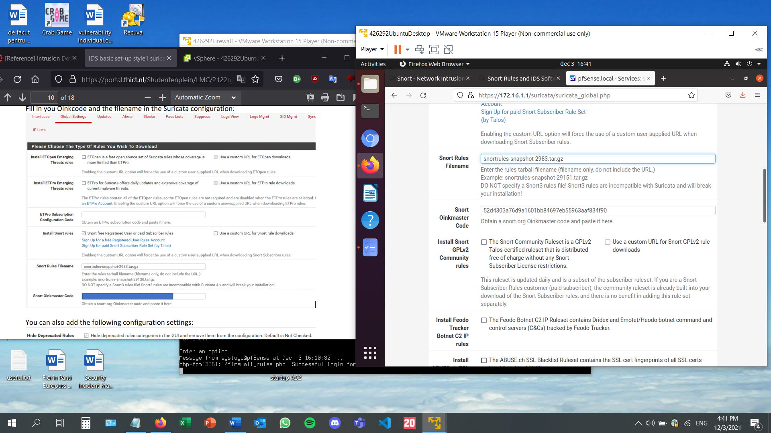

Further adding configuration settings: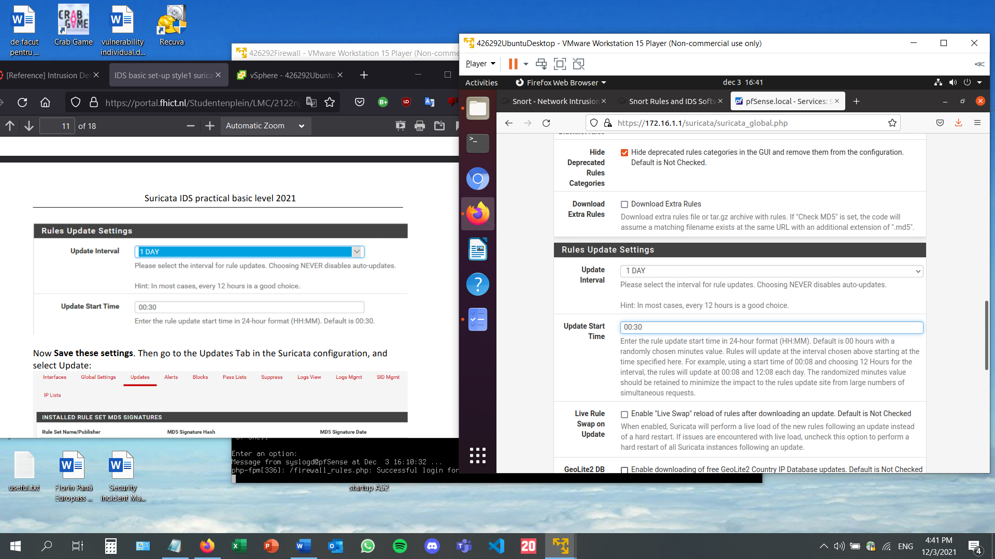

After saving the configuration, the rule set will be updated.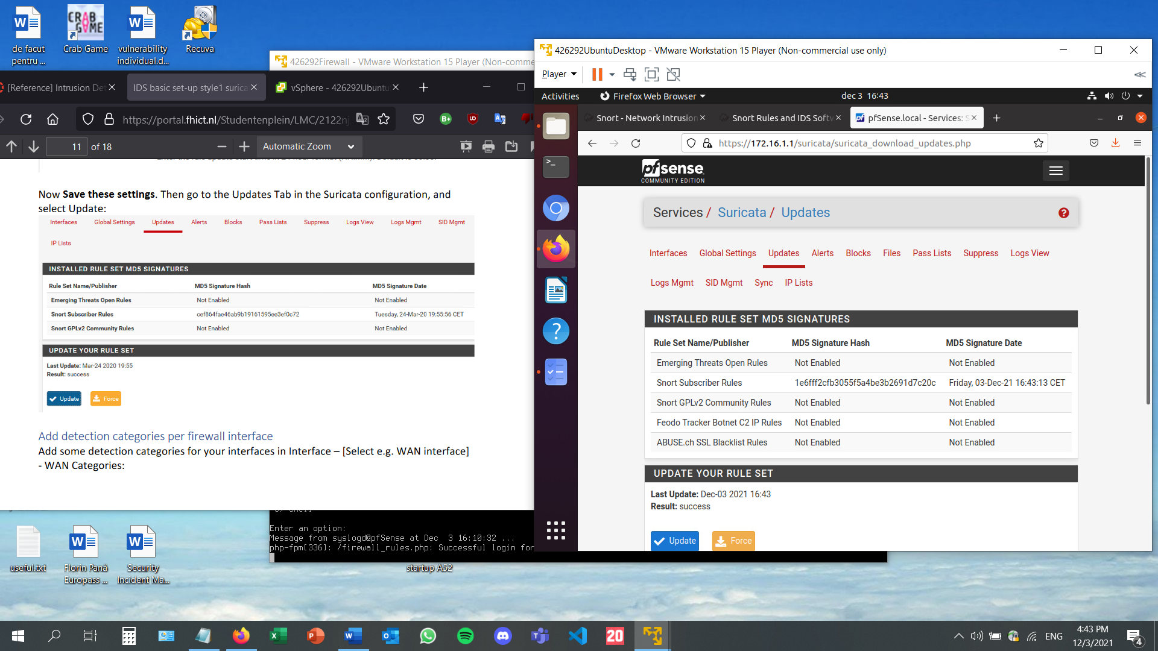

Adding detection categories for my created interface in the Interfaces menu by ticking the following boxes:

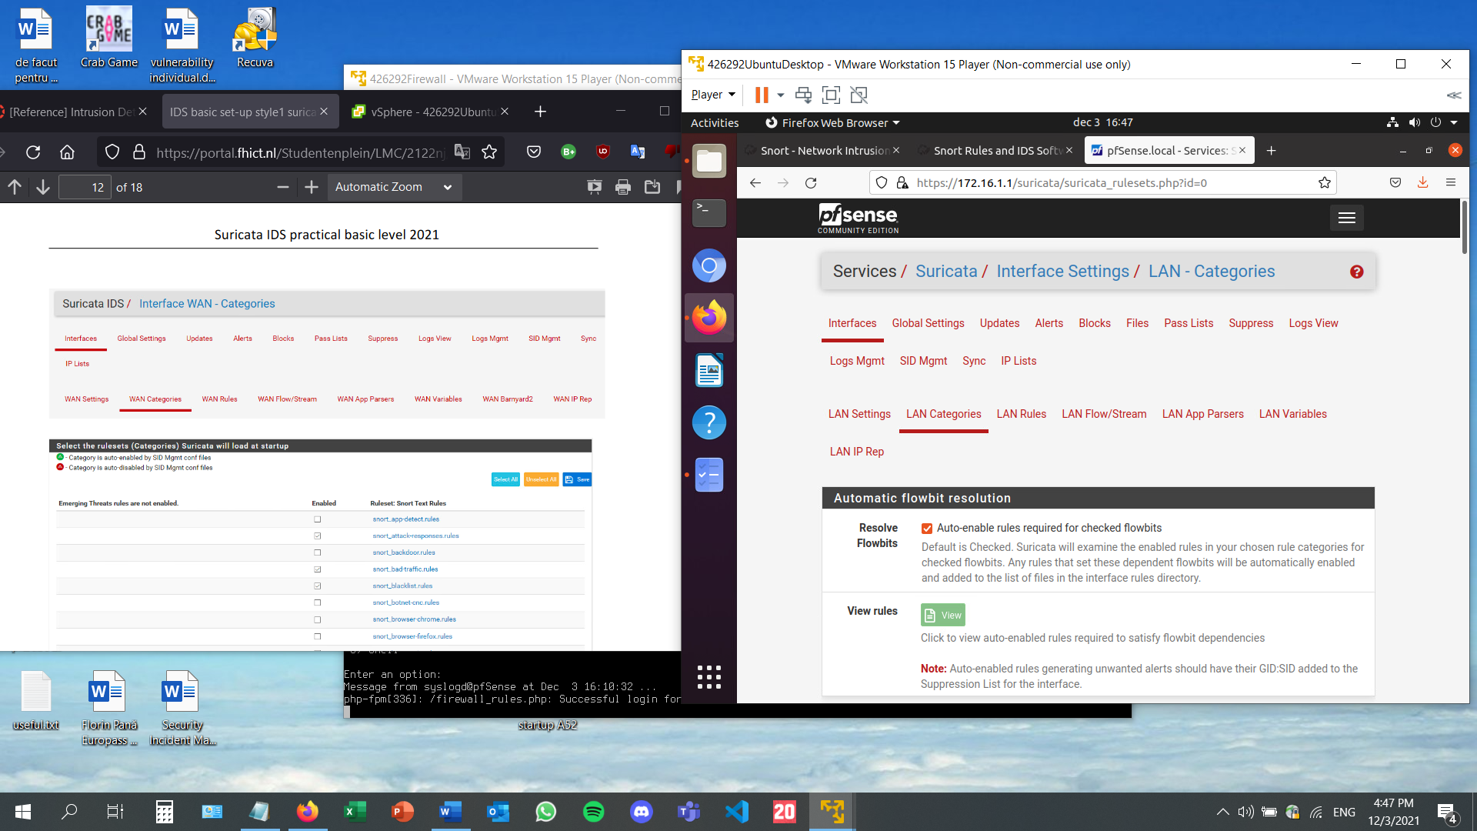

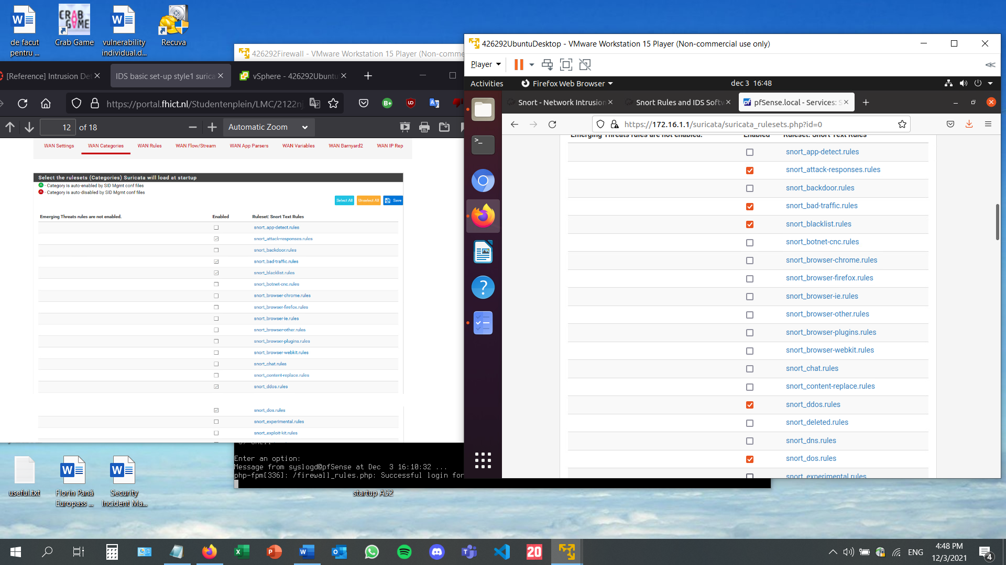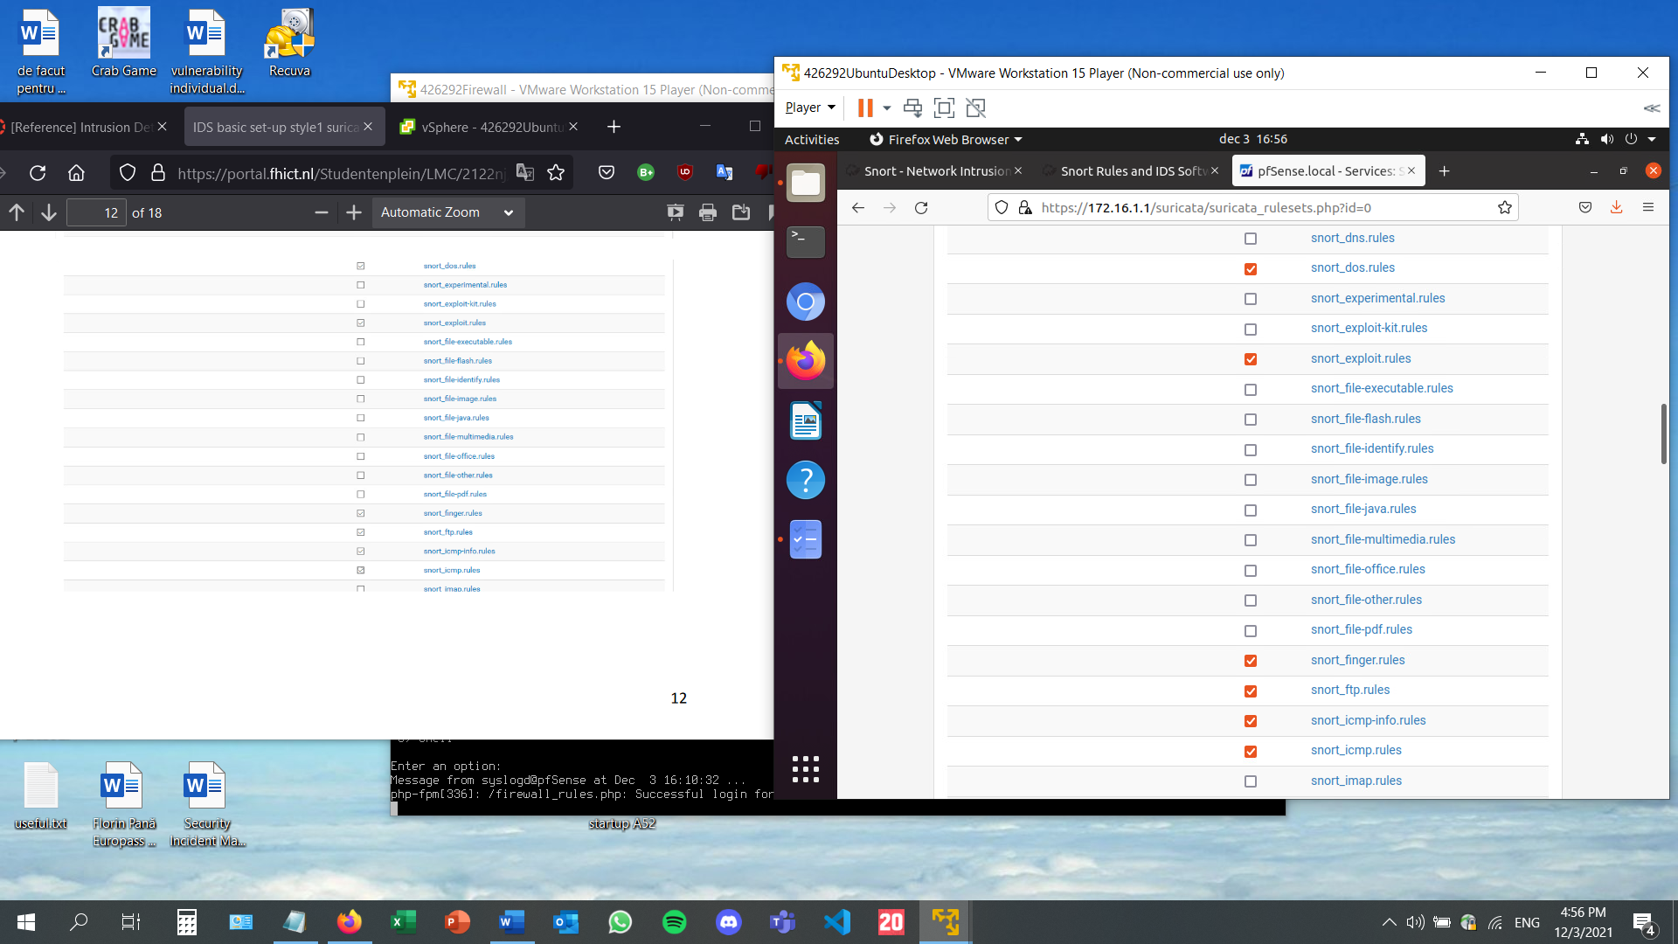

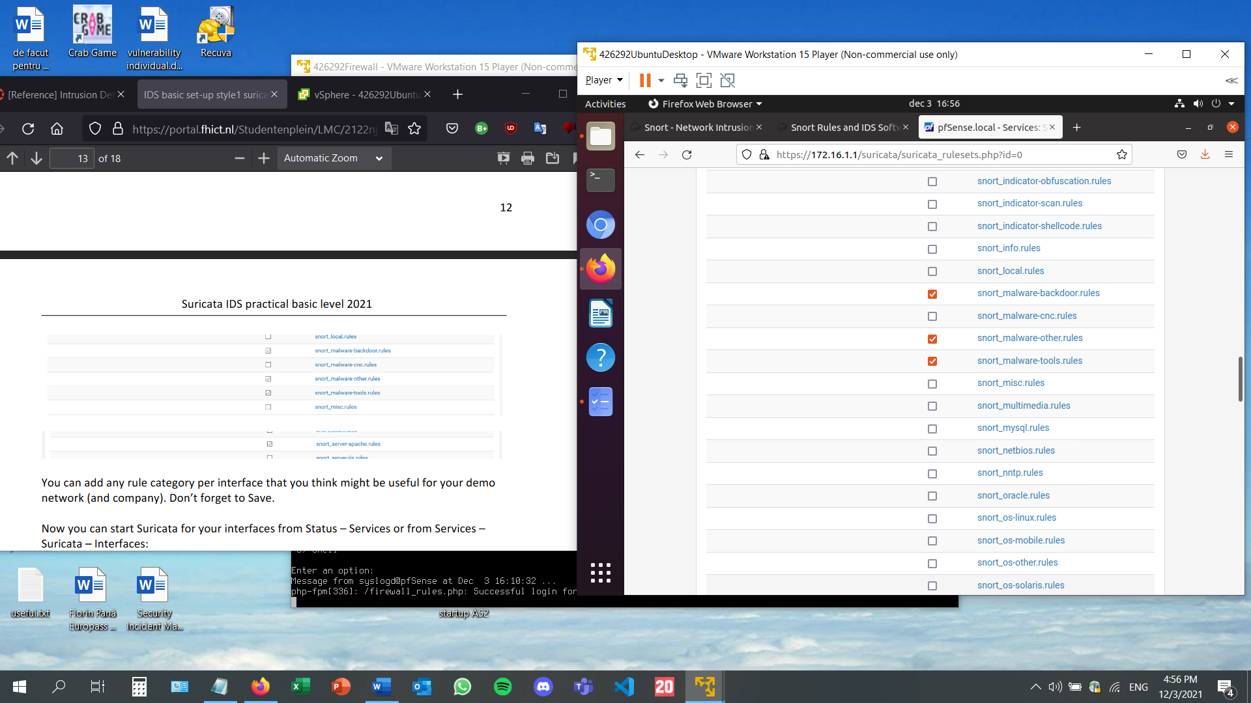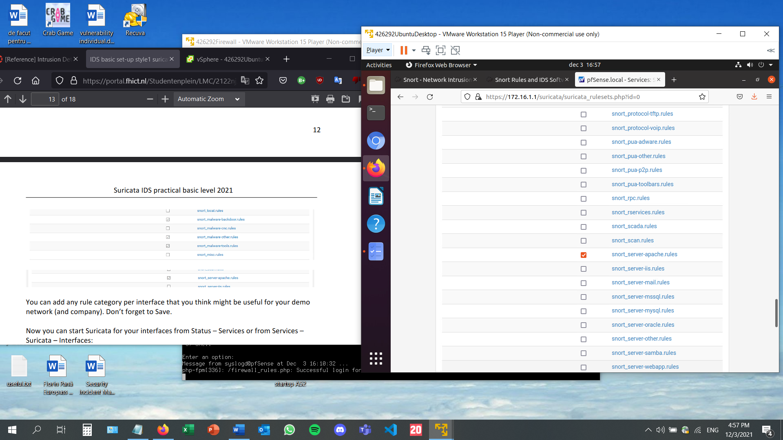

Now that the settings have been saved, Suricata can be turned on.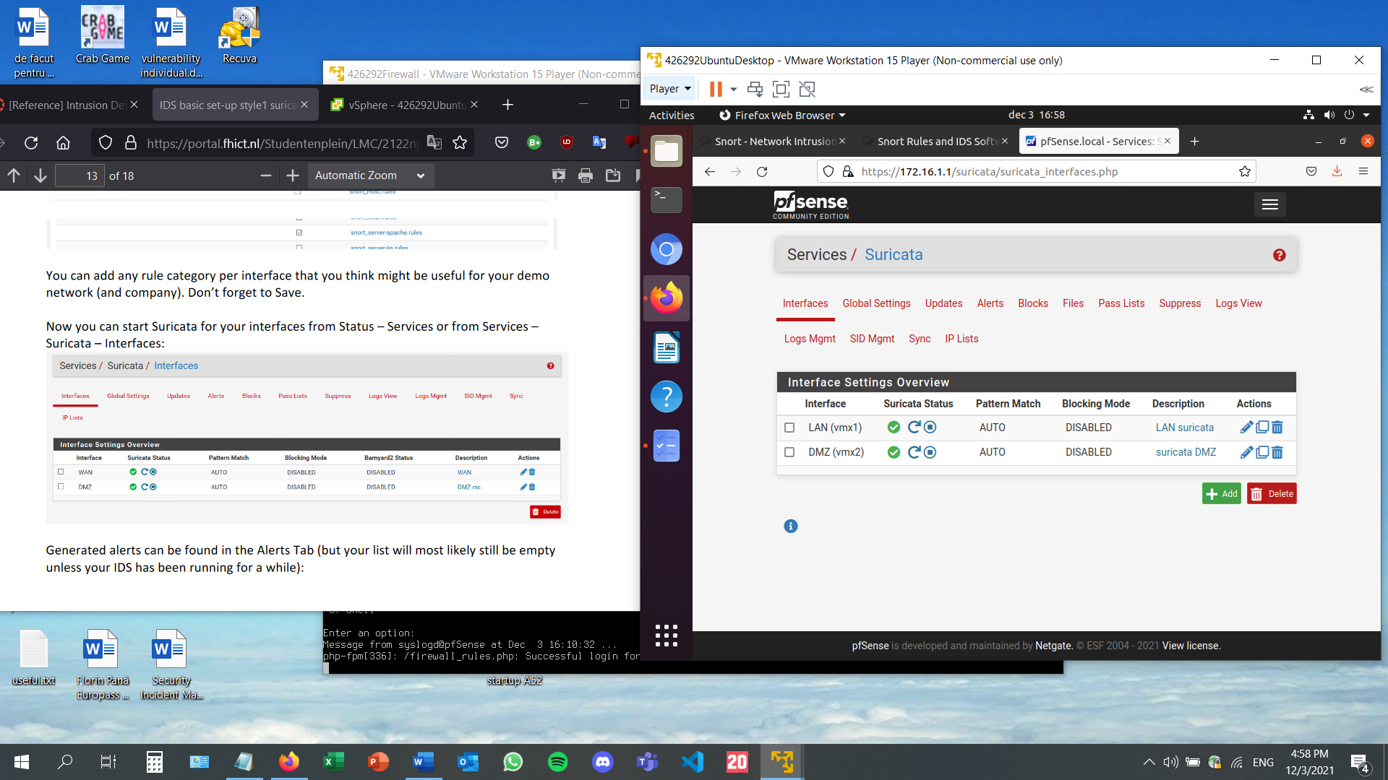

Checking the alerts tab. Since Suricata has just been set up, it is empty. Over time, alerts will be shown in the table below.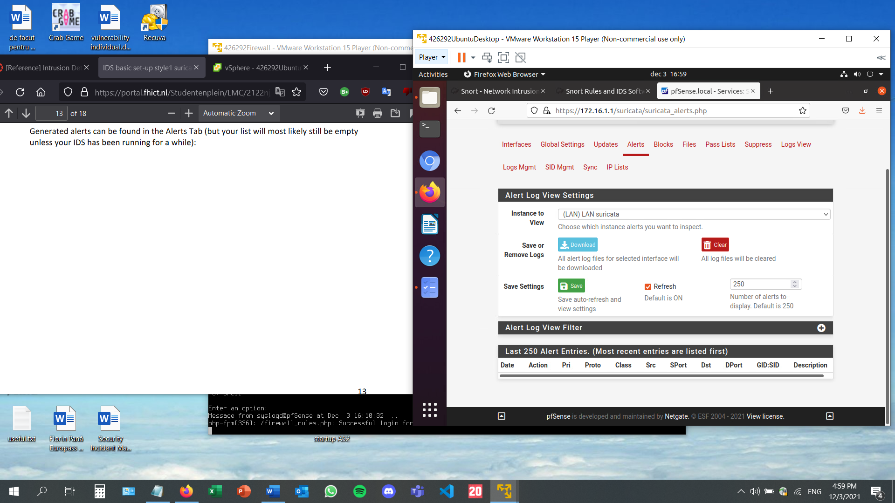

After waiting for a while, the alert entries started to appear: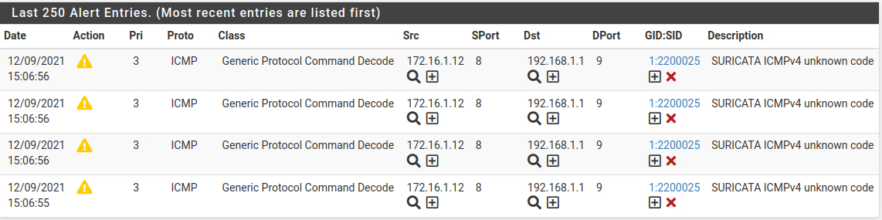

* **Consider how you can improve the detection yourself by adjusting the ruleset and rules. Lower the False Positives by removing rules that give FP's in your tests.**

The main focus is on lowering the number of false positives. This can be achieved by going on the rules menu: 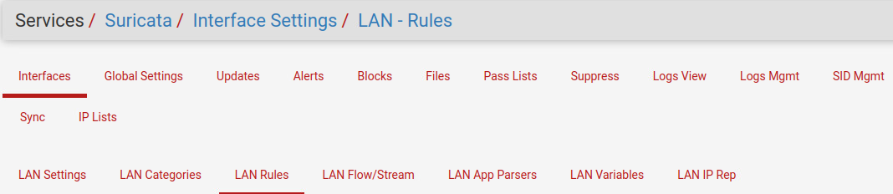

In order to do so, the rules menu must be accessed.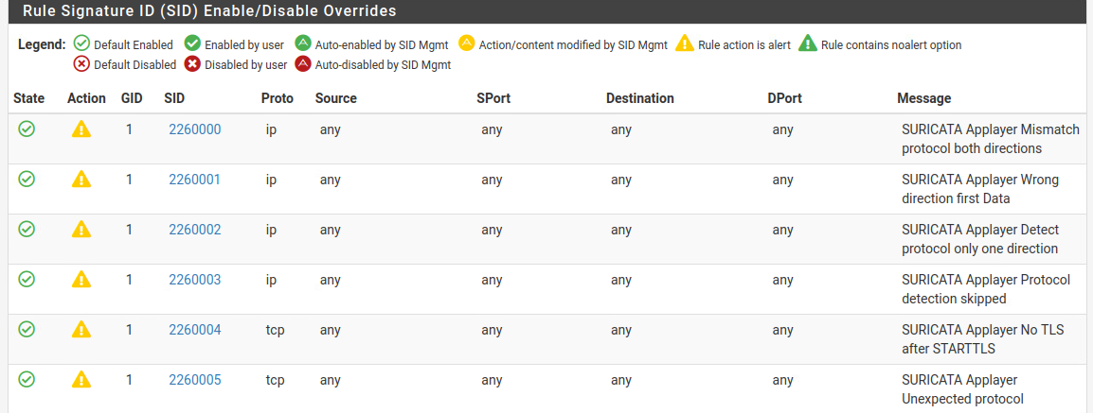

By pressing on the green dots on the left end side of each rule signature, their status can be updated from enabled to disabled. I have disabled the rules I have created for testing purposes as well.

This is the alert entries tab after having removed the false positives:

* **Show tests and test results in your documentation.**

There are multiple ways of testing the IDS.

On the suricata menu, on Rules, the custom.rules file can be modified to generate specific alerts. Imputted text: alert tcp any any -> any any (msg: "My own testevent  
detected"; content:"blah"; nocase; classtype:web-application- attack; sid:9000550; rev:1;)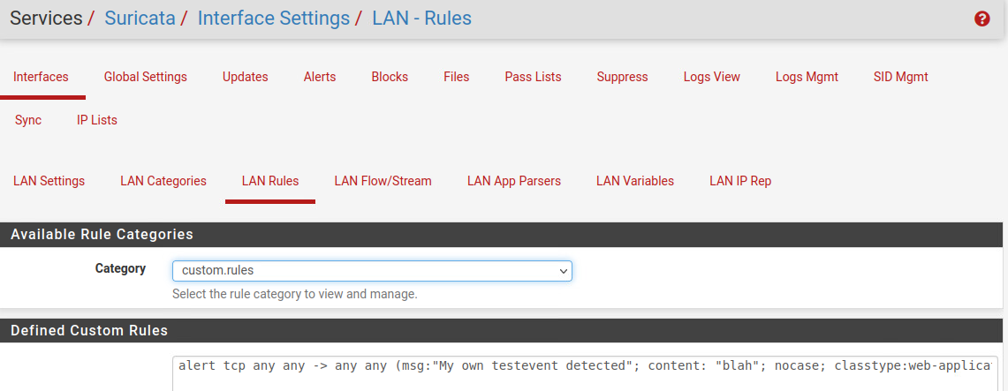

The generated alerts can be seen in the alerts tab:

CanaryTweet can be used as well. After the normal link, the text “*/?test=CanaryTweet*” needs to be written, and a custom error, for testing purposes, will be generated.

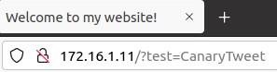

Looking back at the alerts tab, the canary event can be seen: 

* **Document which intrusions or anomalies you want to detect for company X. What rules or rule categories could be used, and which ones are not needed?**

An IDS is extremely important because it can detect hackers and prevent malware from making its way into the system.

The rules that detect files such as doc, excel or binary files are extremely important because an executable file can be renamed with a different extension before being sent to another device, and in the case of a virus, it can return to its original extension once the transfer had been made.

I believe that some of the options from the “invalid option” could be overlooked mainly because they can be due to the user pressing the wrong button or mistyping their password or username. There are plenty other rules that detect user input more in detail. For instance, there are rules that check for XSS, CSRF or SQL injection attempts.

* **Explain the difference between NIDs and HIDs and IDS and IPS, and the meaning and relevance for your company X.**

NID stands for Network-based Intrusion Detection System, also known for network IDS, is used to examine the network traffic. A network intrusion system has to include a packet sniffer to gather network traffic for further analysis. Collecting all of the data for analysis is difficult and dumping all of the traffic into files is not practical. So, with the help of NIDS, only the selective data can be captured. For instance, if a rule about type of worrisome HTTP traffic is in place, the network intrusion detection system can only capture and store HTTP packets that display those particular characteristics.

HID stands for Host-based intrusion detection system, and it is used to analyze events on a computing device rather than the data traffic that passes around the computer. HID mainly operates by taking and looking at data in admin files (log files and config files) on the computing device that it protects. Host intrusion detection system creates backups of the config files so that the settings can be restored in case of a malicious attack.

Host-based Intrusion Detection systems examine particular host-based activities, such as the software used, or the accessed documents. The Network Intrusion Detection systems examine the network traffic between computers. Therefore, NIDs can discover a hacker until he can generate an unauthorized attack, whereas HIDs will not understand anything is wrong until the hacker has breached the machine. Both are necessary for sniffing the network for suspicious activities.

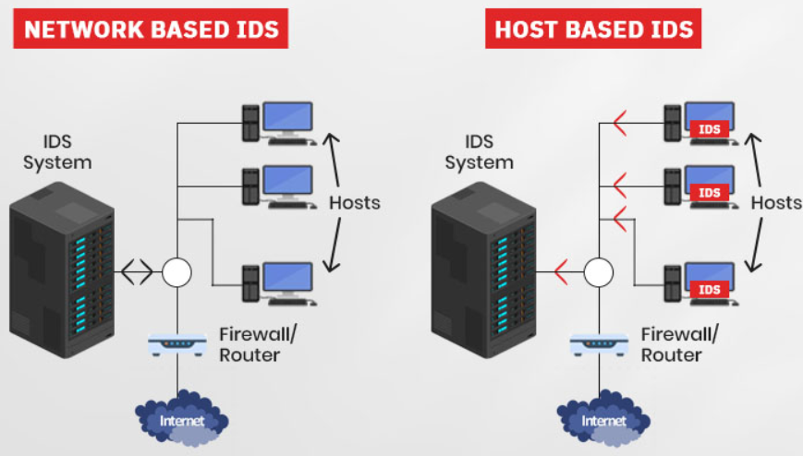

IDS stands for intrusion detection system and is used to analyze and monitor network traffic for signs that indicate attackers are trying to break into the victim’s network. IDS systems compare the current network activity to a threat database to detect several kinds of behaviors like security policy violations, malware, and port scanners.

IPS stands for intrusion prevention system, and it is located within the same area of the network as the firewall. IPS proactively denies network traffic based on a security profile if that packet represents a known security threat.

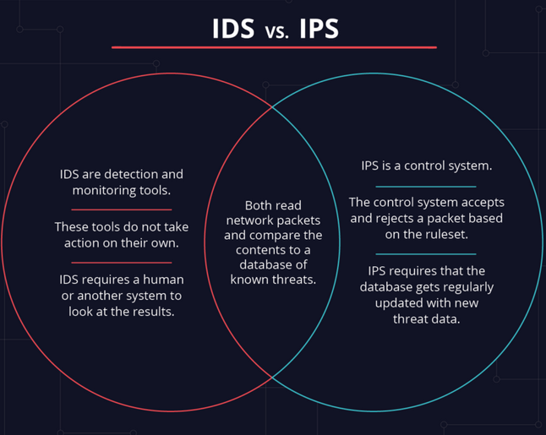

* **Resources:**
* <https://www.temok.com/blog/nids-vs-hids/>
* <https://www.varonis.com/blog/ids-vs-ips/>

# Security Engineer 6 – System defense

* **Is your laptop hardened? Write down in your portfolio how you have hardened your laptop and how your laptop's system hardening can be improved?**

Compared to the beginning of the Cyber Security semester, yes, my laptop has been hardened in multiple ways. Of course, it is not fully hardened, as this is an ongoing process. The first step I have taken in securing my laptop was to include password protection on several files that contain sensitive information. Also, I have created two backups of my important files: one of them is stored in a different location within the computer, and the other one is stored on an external hard drive. I had the bad habit of using the same password on multiple accounts. I have updated all the passwords, all of them are different now and all of them contain lowercase and uppercase letters, numbers, and special characters, in order to make password cracking as difficult as possible. I went back to some of the websites that I have created during the last few semesters in Fontys, as an extra activity, and added extra protection, such as defense against SQL injections, cross-site scripting, and cross-site request forgery. Through the creation of a previous BoK document, I now have a fully functional VPN, which makes internet navigation much safer. A system’s hardening can always be improved. I can always invest in better quality anti-virus software and create a firewall for my system as well, not just on my virtual machine network.

* **Configure two-factor authentication using the google authenticator.**

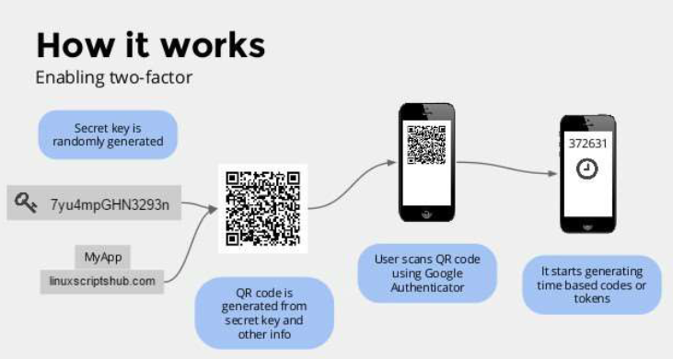

Firstly, I will install google authenticator using the following command:

After the installation, I will type *google-authenticator* and the following question will pop up: The selected answer will be yes.

After that, a QR code will pop up on the terminal. I have installed Google Authenticator on my phone and scanned the code. Then, the phone app generated a new 6-digit code every 30 seconds.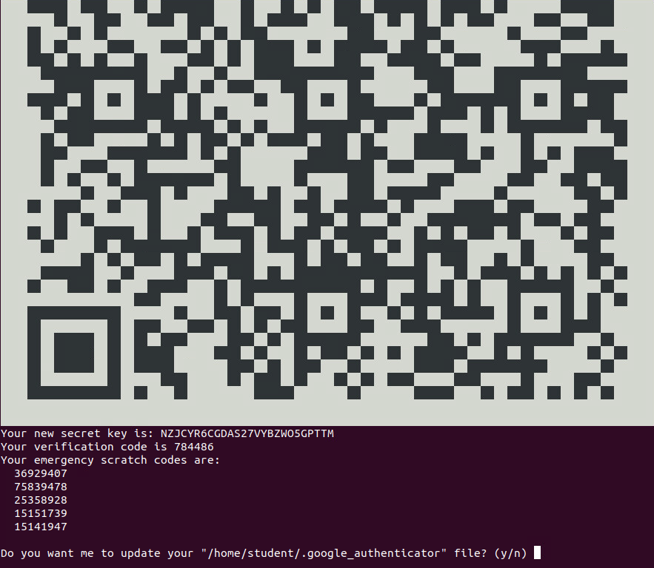

All of the following questions require a ‘yes’ answer. The first one is no in the screenshot only temporarily, for testing purposes. These answers update the Google configuration file and enhance the security.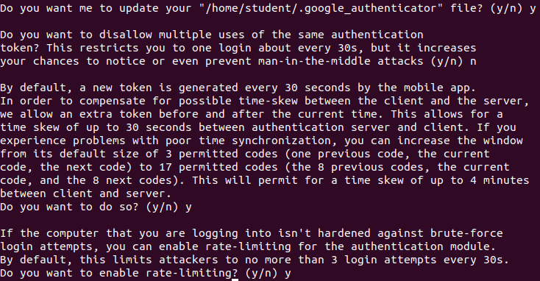

Next up, I am opening the SSH configuration file:

The following 2 parameters in the screenshot should be set to yes. The first one was set to no by default, while the second one was already set to yes. 

The permit root login instruction must also be set to yes. Initially, it was set on prohibit-password. This change allows the root user to user two-factor authentication, by allowing the root to login via SSH.

PAMstands for pluggable authentication module. It provides an easy way to plug different authentication methods into the Linux system. To enable Google Authenticator with SSH, PAM and Challenge-Response authentication must be enabled. After saving and closing the file, restarting the SSH daemon will enable the change.

The next step is to type *sudo nano /etc/pam.d/sshd*. **#One-time password authentication via Google Authenticator** and **auth required pam_google_authenticator.so** have been added to the file. These lines enable one-time password authentication.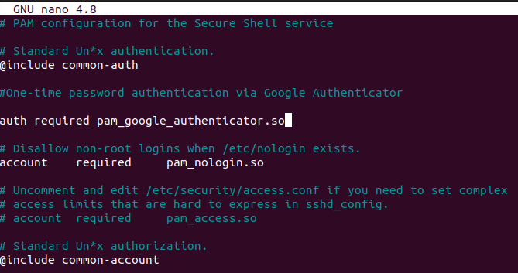

After saving and closing the file, the two-factor authentication should be enabled. In order to test it, I typed the following command: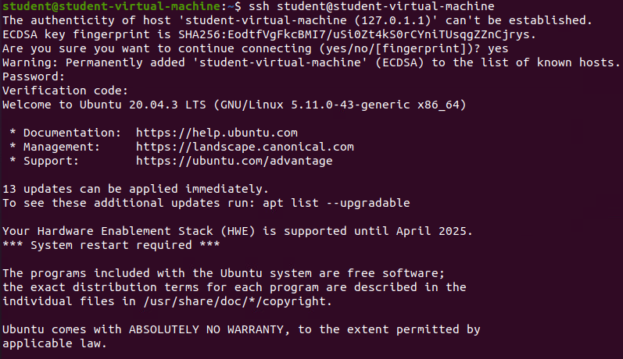

It is now functional. The terminal asked not only for my password, but also for the verification code. I typed the 6-digit verification code from the Google Authenticator on my smartphone and I managed to log in.

# Security Engineer 7 – Law, Standards & Compliance

* **Check the relevant subjects from the GDPR explanation document and explain why it is important for your project report.**

GDPR stands for General Data Protection Regulation. It provides a set of standardized data protection laws regarding the processing of personal data across all member countries of the European Union.

A project report in this instance should contain the findings of the project team that can be discussed, given the presence of the non-disclosure agreement. Part of the report is a thorough analysis of the GDPR and how the team has been compliant throughout the project work.

AVG is the dutch interpretation of the GDPR, given that every country can come up with its own specific guidelines. AVG governs the GDPR guidelines but also distributes its own in-depth guidelines. Therefore, the team should also study the particularities of the AVG.

It is also important to know that processing personal data can result into a fine. The team needs to be very careful with the data they are manipulating or data that they access in order to avoid such issues.

The team also needs to be careful about everything that can be classified as personal data, for which the GDPR rules apply. According to the definition, personal data is the data by which a person can be identified. The term personal data should be interpreted as broadly as possible when gathering information.

It is also important to categorize the personal data. It includes information such as religion, physical conditions, personal information in general. In order to be able to process it, an exception must apply. The Data Breach Notification Obligation includes personal data that contains race, ethnicity, political standings, religious beliefs, memberships, medical files, sexual preference, genetic research, and biometrical data. While working with data, the team must know what can be classified as personal data in case of a data breach, since they are obligated to notify the authorities. Reporting of data leaks is mandatory. The notification about data breaches needs to be sent to the Dutch Data Protection Authority.

Risk analysis is also an important step. The scope, nature and context of the data processing need to be considered before the start of the actual processing. An assessment of the impact needs to be done. This way, the risks are lowered when the team starts working.

While working with personal data, technical and organizational security measures are essential for a good workflow. Personal data needs to be processed in a manner that ensures its security, including protection against unauthorized or unlawful processing and against accidental loss, destruction, or damage. Integrity and Confidentiality parameters from the CIA diagram are to be taken into consideration.

# Security Analyst 1 – IT basic monitoring

* **Set up basic monitoring for your network by using NagiosXI in the Seclab.**

First of all, I am deploying the NagiosXI template: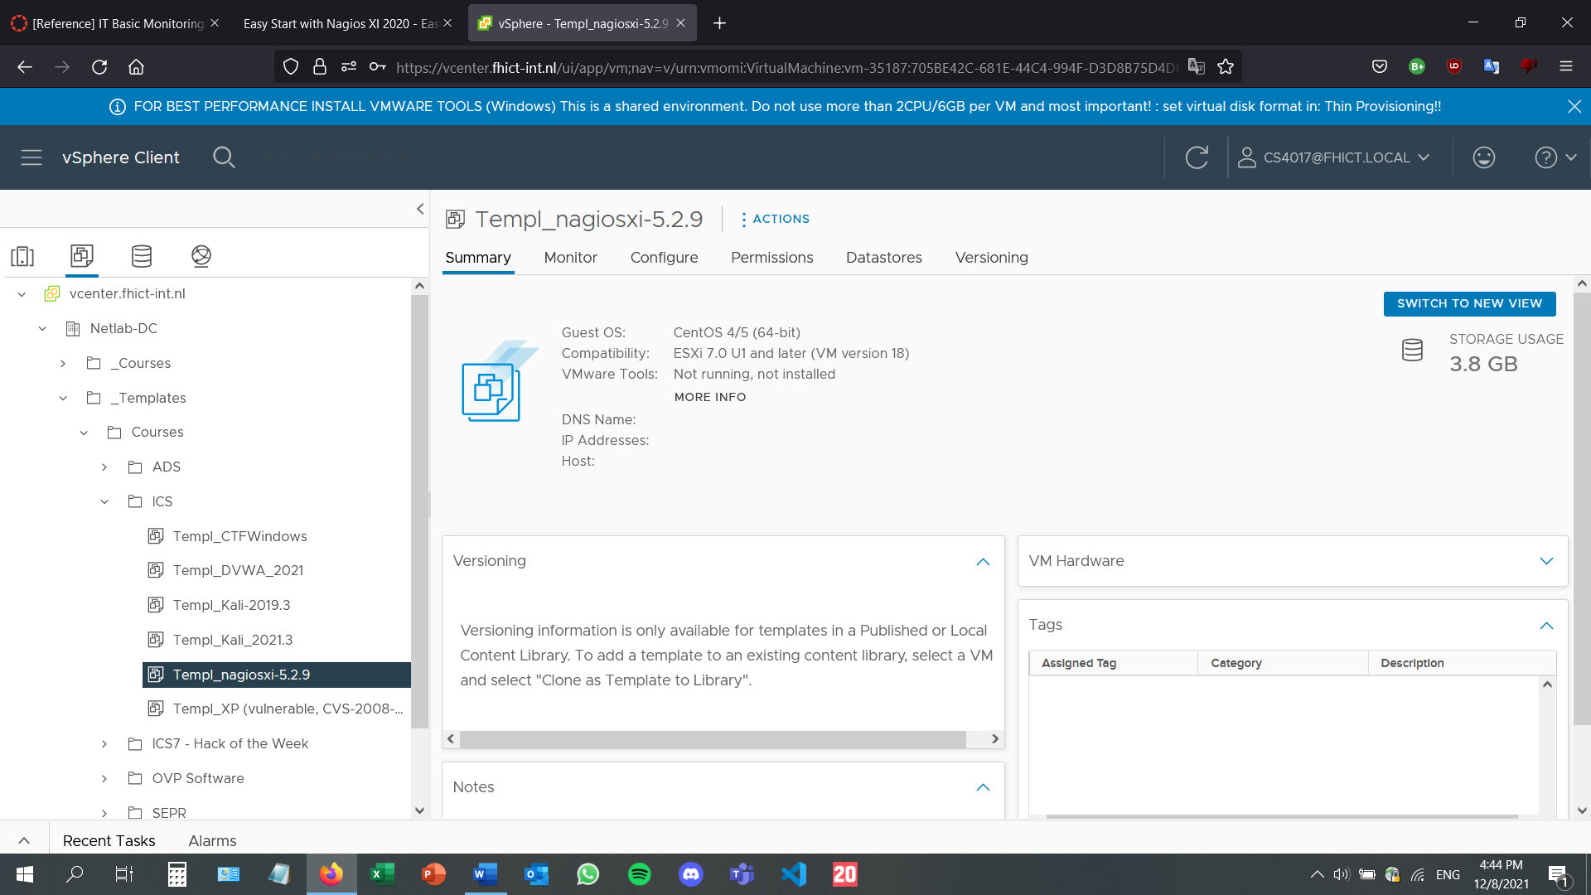

The machine has loaded correctly. It displayes the credentials and the IP address, along with the website URL that displays the left part of the screenshot.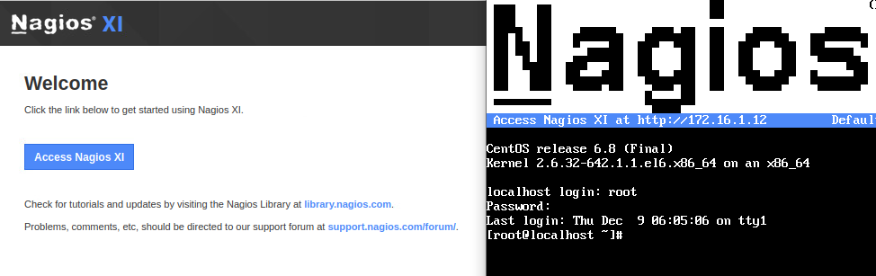

Proceeding with the NagiosXI installation and setting up the password:

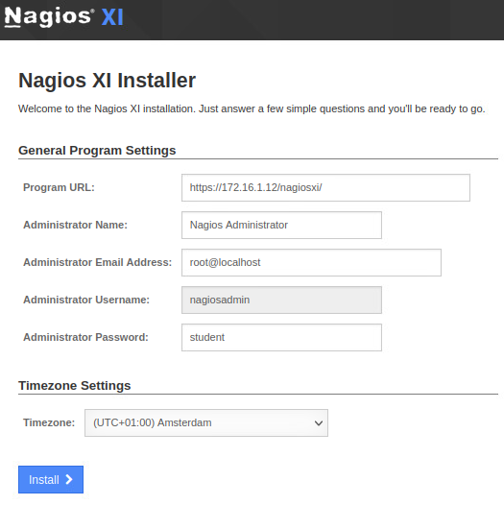



Once this is done, the website redirects me to the home dashboard page.

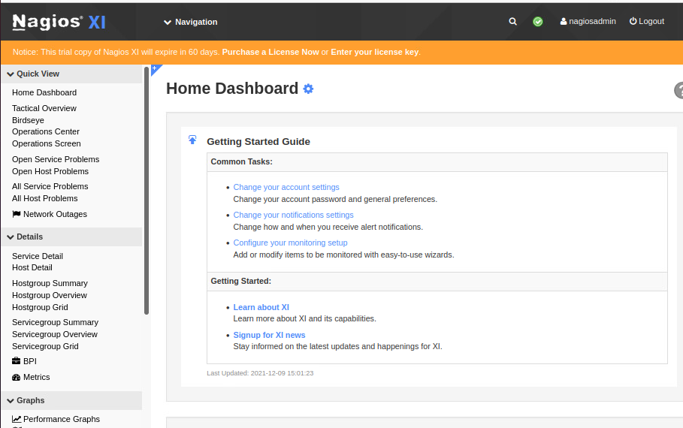

From here, I am going to the monitoring setup for cofiguration, and I am using the auto-discovery tool running my private VLAN (A).

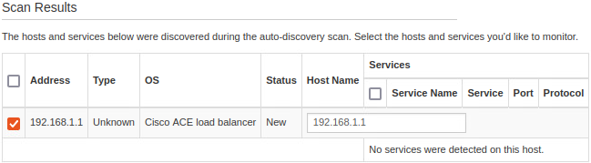

From here, I can press the Show Results button, redirecting me here:

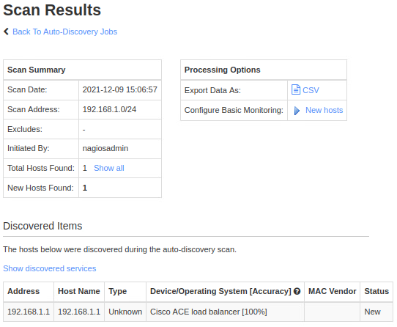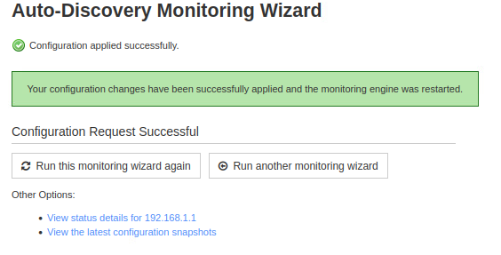

Now the scanned hosts will appear in the overview:

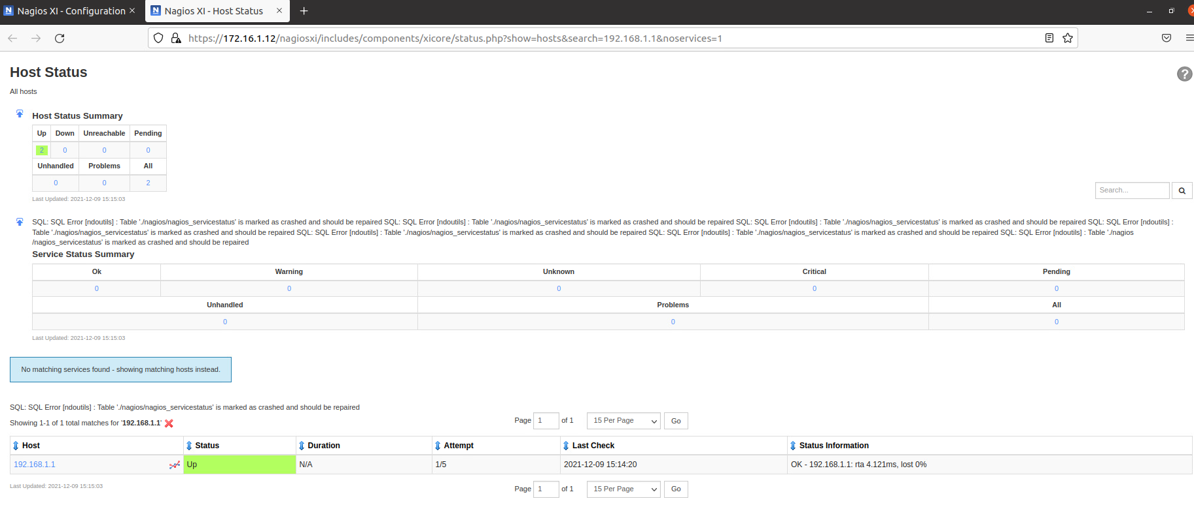

Adding the NRPE package to further monitor another server; it can be found on the pfSense website, on the package manager.

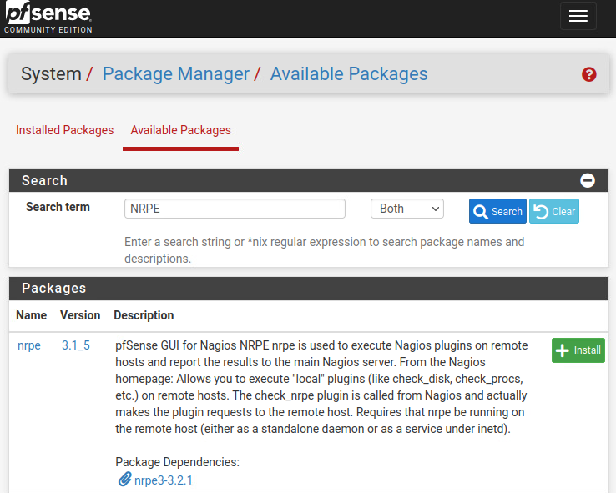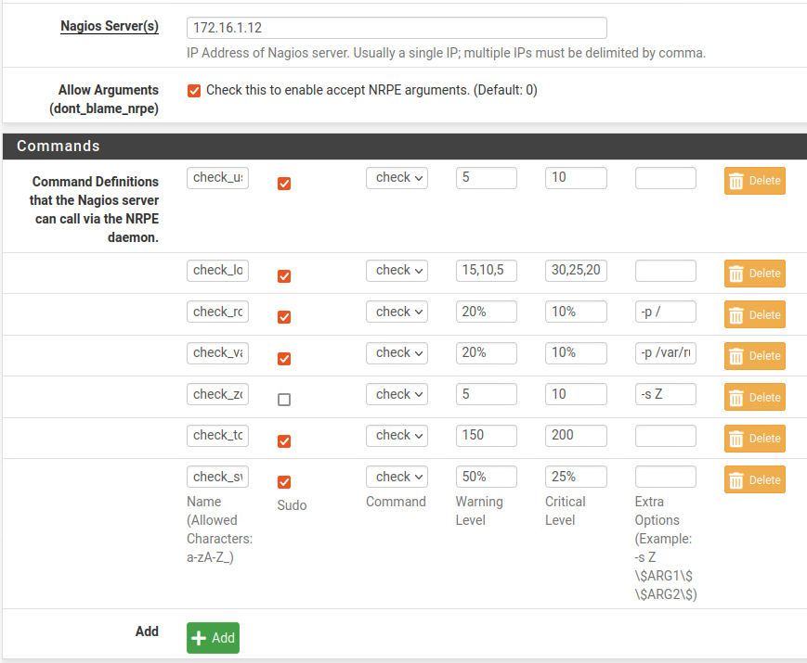

Once the NRPE package has installed, I can return on the Nagios website to configure it there as well.

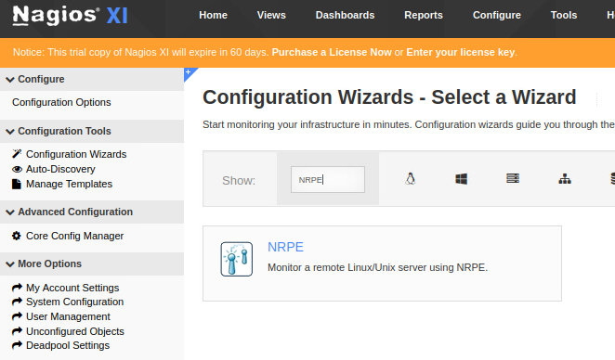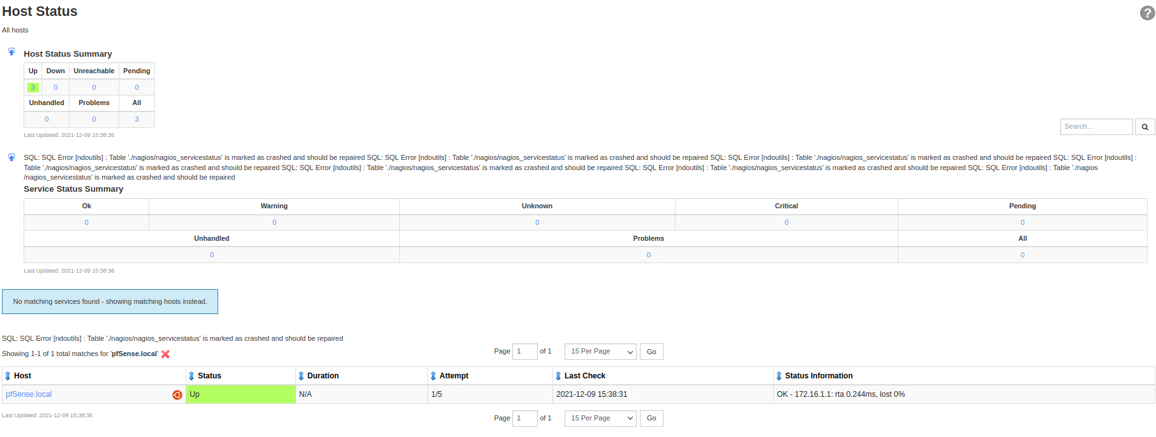

* **Explain in your BOK Document what you chose to monitor and why and how you configured your setup. Also include results and screenshots of tests and the working intended functionality.**

I have chosen to monitor my firewall server which I have set up at the beginning of the Security Engineer BoK (see Security Engineer 2 for details).

# Security Analyst 2 – Security Incident Management

* **Think about a security incident that could happen in your 'basic knowledge company'. Perform a triage and work out a complete response as it should be done in your company. Try to include realistic roles/employees from your company in the process where needed. Do assumptions on what happened and on Indicators of Compromise.**

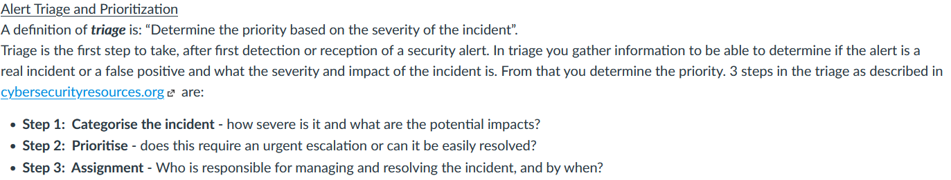

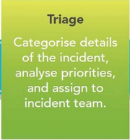An incident in this instance can be caused by human error, hacking, fraud, sabotage, or malware. Security incident management is a process which has the goal of restoring the normal operation of a service as quickly and efficiently as possible. Triage is one of the steps that need to be taken during this process, along with alert reception, response, and the incident review. In this document I am going to address a hypothetical attack on my exercise company, DartsMasters.

This document will analyze the scenario in which DartsMasters is attacked by malware.

* Categorizing the incident

Malware attack is an attack using a malicious program or code that is harmful to systems. It seeks to damage, invade, or disable computers, or computer systems. Given the nature of the attack and the possibilities, the potential impact can range from mild to severe.

* Prioritizing

Malware attack requires urgent attention and measures due to its potentially severe impact and unpredictability. This big range of risk in which it can fit means that as much attention as possible needs to be put in solving this issue, even if it later proves to be minor.

* Assignment

This is a cyber security issue, so an IT specialists team is required to manage and solve the problem. This team can also help prevent such incidents by educating the employees on the matter and teaching them not to do actions that might cause the malware to enter the computer network, such as opening suspicious links or downloading suspicious files.

The second part of this document focuses on the response, which includes the technical, management, and legal sides.

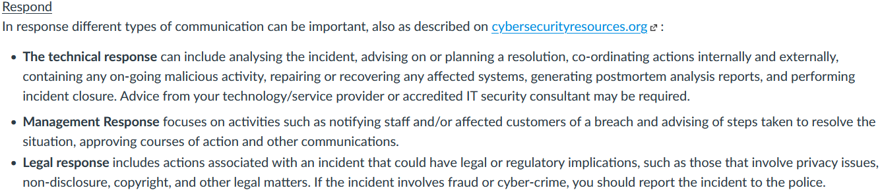

* The technical response – created by the security team

The security professionals and systems administrators have assessed the damage and have done so by examining the indicators of compromise. In this case, they found unknown applications in the system, anomalous spikes of requests in company files, unusual traffic going in and out of the network, as well as suspicious activity in privileged accounts.

The security team advises on hiring a team of security professionals who can repair the damage done to the system, and who will neutralize the threat. Given the nature malware has, the only prevention is education on the matter, therefore the employees of the company will have to attend a workshop about malware, and suspicious activities and places on the internet. Otherwise, our team can start working on a solution, but it will take longer, and it might not be as effective. As a worse case scenario, we can reset the computers and get our data back from the backup files, given that backup is done daily. However, this way we will lose everything that has been registered since the malware attack began.

* The management response – created by the management board, after analysing the security response

All the staff will be notified of the malware problem that the company is currently facing. The employees will be reminded of the main security precautions that they can take, and they will be advised to pay maximum attention for the time being, or if necessary, to cease all activities that include a computer. This information can be sent via e-mail, or even by text message, in case the employees can no longer access the computer. This assures that the information reaches everyone. The IT department can create an automated message which will be sent to all the employees.

* The legal response – created by the human resources branch of the company

The incident will cause an investigation. Its purpose is to determine whether or not an employee has purposefully allowed the malware inside the company’s systems. The data engineers could check if any secret information has become accessible and if there are any data leaks. In case they find any, the police will be notified immediately. If the employee who accidentally let the malware inside the system, disciplinary measures will be taken and decided by the board.

# Security Analyst 3 – IT security monitoring

* **Experiment with the open-source network security monitoring sensor “Zeek” in one of your internal networks.**

Connecting to the virtual machine using ssh: the password is the one of the current virtual machine and the verification code is from Google Authenticator (see Security Engineer 6 for more details): 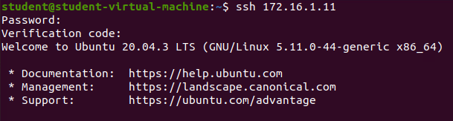

The 2 commands from the screenshot below enable package installation from an external source: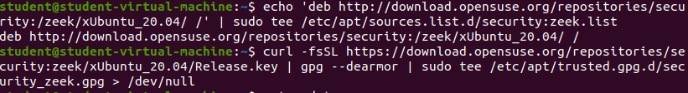

A sudo apt update makes sure that everything is up to date and ready for the future installation. 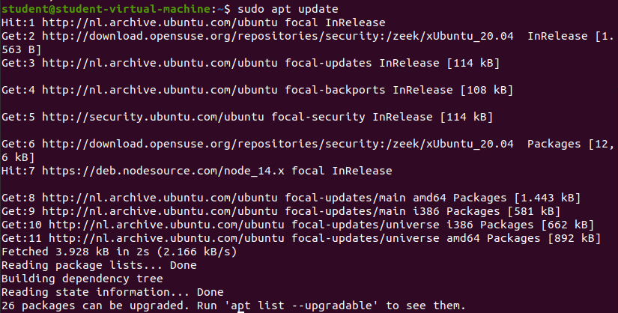

Afterwards, I can now install zeek using the following command:

Midway through the installation, this screen pops up on the terminal, asking for a postfix configuration. The chosen option is “No configuration”. That way, the current configuration of Zeek remains unchanged.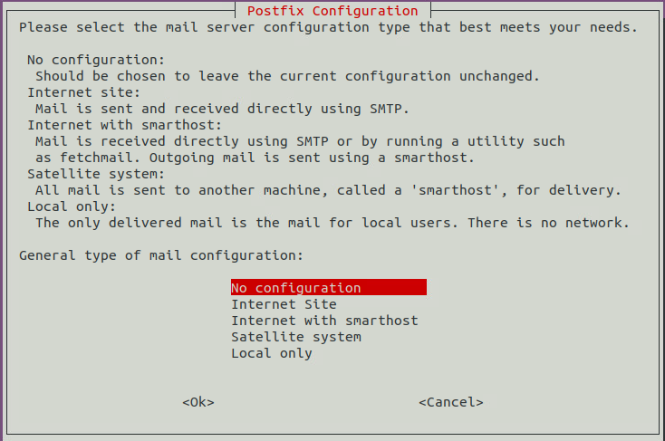

Checking if zeek has been installed and if the version is the correct one: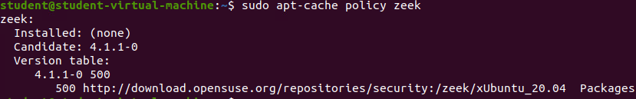

Adding the zeek binary path to PATH:

3 of the config files need to be edited in order to replace some default values to the ones of the current virtual machine. The first one is node.cfg, where the interface needs to be changed from eth0 to ens160, the interface of the virtual machine.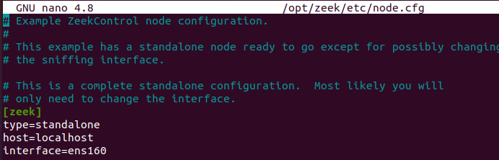

Next up is zeekctl.cfg, where MailConnectionSummary will be changed from 1 to 0, MailhostUpDown will be changed from 1 to 0 as well, and LogRotationInterval will be changed from 3600 to 86400.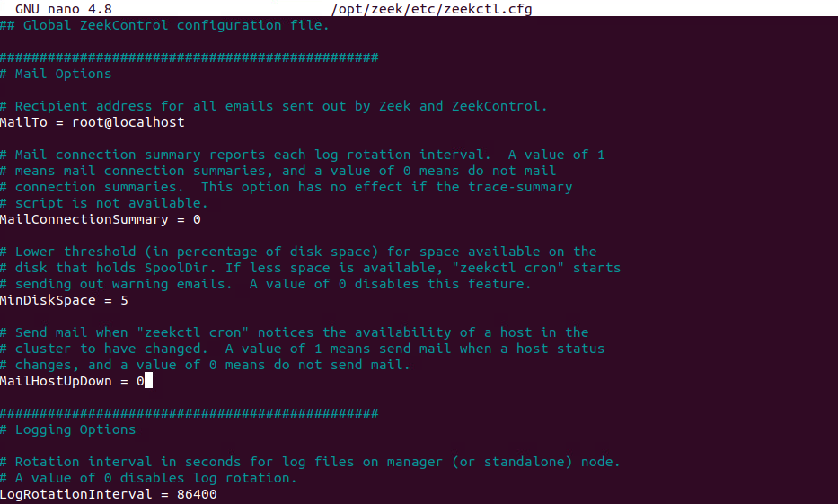

Finally, the network.cfg file will only contain the IP address of the LAN machine in the pfSense network constructed throughout the Security Engineer Learning Outcome.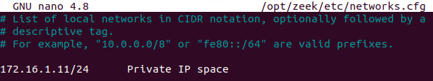

Now that the configuration has been done, the following command will be entered to open zeekControl: 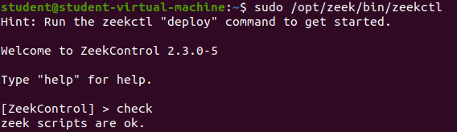

ZeekControl is up and running. Since this is the first time it is running, the install command will be entered: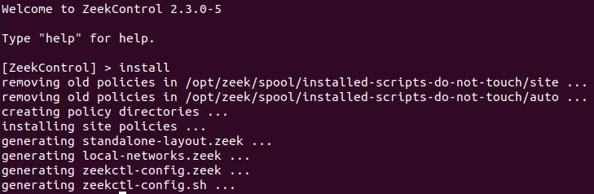

The status command can also be entered. Here it shows that the service is running: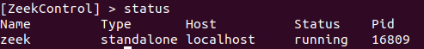

* **Show some Zeek-logging screenshots.**

Now that Zeek has started properly, typing the following 2 commands facilitates the access to the log files. Finally, a cd command to the logs folder ensures easy access: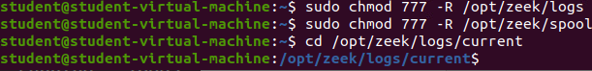

Visualising the conn.log file: 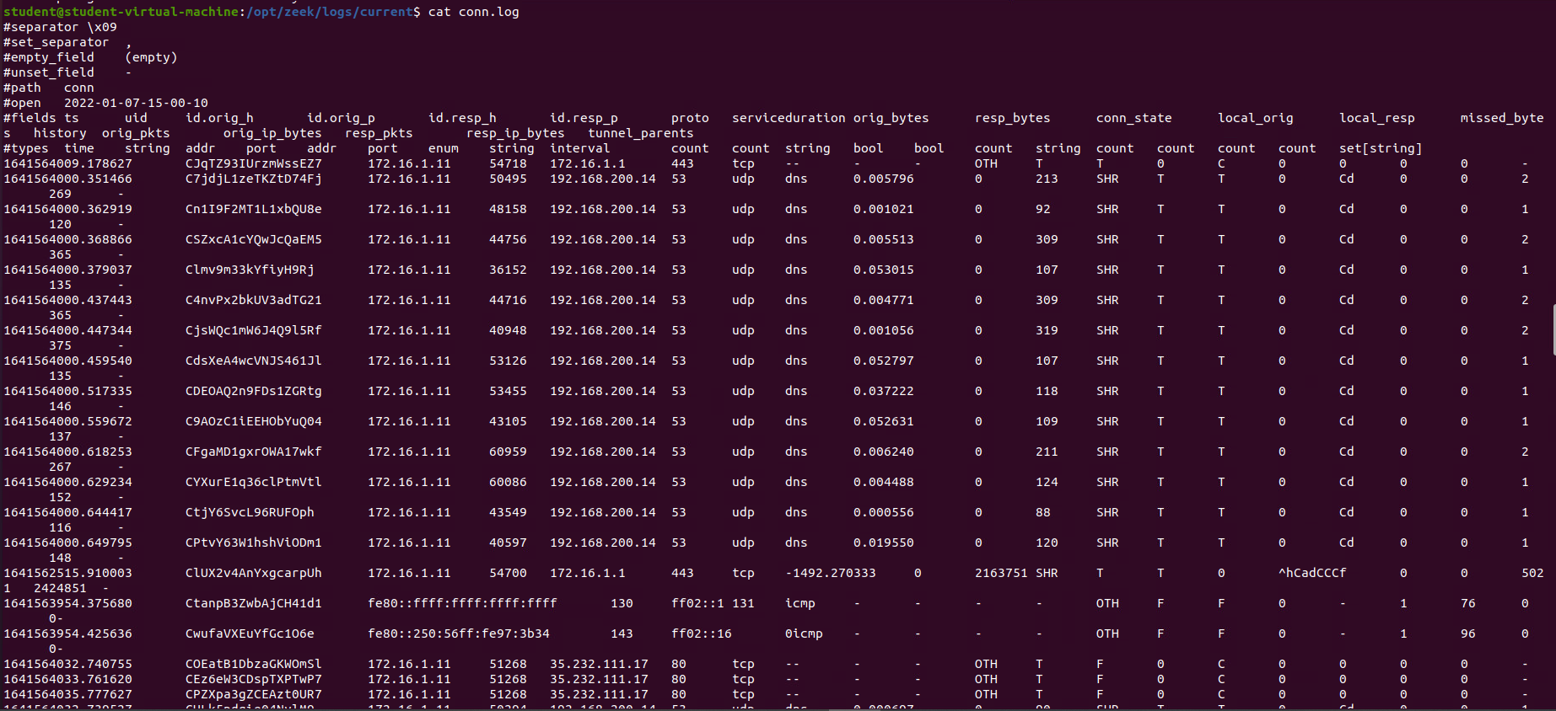

The conn.log file contains the live logging; therefore, it includes all the logging in one file. It contains an entry for every connection seen on the wire, with basic properties such as time and duration, originator and responder IP addresses, services and ports, payload size, etc. This log provides a comprehensive record of the network’s activity.

Visualising the http.log file: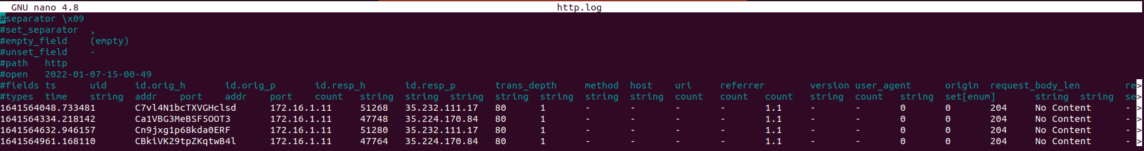

The structure of information is the same as in the conn.log file, but some parameters are different, such as the depth string or the trans string. Also, the number of instances displayed is much lower because the http.log is less active in many environments. In some cases, however, organizations implement technologies or practices to expose HTTPS as HTTP. Http.log offers a platform for examining normal, suspicious, and malicious activity. Due to its nature, it can generate a large number of false positives.

Visualizing the weird.log file: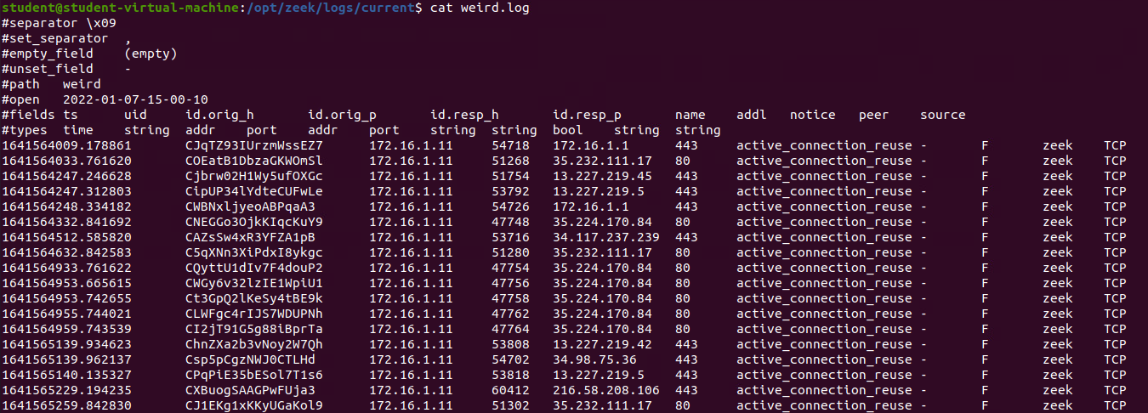

Weird.log contains unusual activity that can indicate malfunctioning connections, traffic that does not belong to a particular protocol, malfunctioning or misconfigured services, or even an attacker attempting to make their way past a sensor without detection.

Visualizing the notice.log file: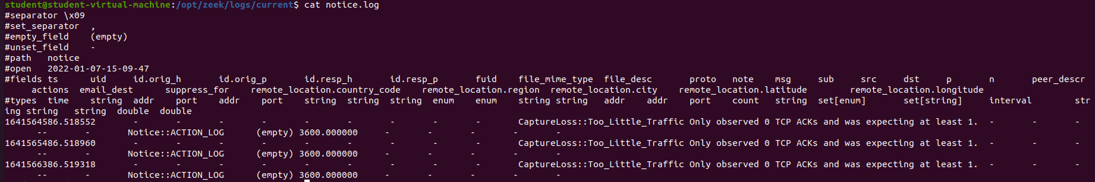

The notice.log file identifies specific activity that Zeek recognizes as potentially interesting, odd, or bad. Within the Zeek environment, such activity is called a “notice”. This is the most likely place to find a false positive because triggering Zeek to classify something as a notice can happen very often. As it can be seen in the screenshot above, the errors are also considered “notice”.

* **Explain, in your own words, the purpose of policy monitoring next to blacklist and whitelist monitoring.**

Blacklisting is one of the oldest algorithms in computer security and it is used to block unwanted entities by most antivirus software even today. Blacklisting means creating a list containing all the applications and executables that might become a threat to the network. Blacklisting is a threat-centric method.

Whitelisting is the opposite of blacklisting, containing a list of trusted entities. This method can either be based on policies like file name, product, and vendor, or it can be applied on an executable level, where the digital certificate or cryptographic hash of an executable is verified.

Policy monitoring is an analysis of the development and implementation of policies, with the purpose of identifying potential issues throughout the process, showing what needs to be improved and holding the policy implementers accountable for what they did. It is a tool that can improve policy information among stakeholders.

As a conclusion, policy monitoring is very important because it provides an overview of every process and showcases the things that need improving. While everyone is working on a specific thing, such as blacklisting or whitelisting, some employees can be in charge of the policy monitoring and make sure that everybody is doing their job correctly. This greatly improves the productivity levels and the quality level in everything the company is doing.

* **Resources:**
* <https://www.manageengine.com/application-control/whitelisting-vs-blacklisting.html#q3>
* <https://en.wikipedia.org/wiki/Policy_monitoring>
* <https://docs.zeek.org/en/current/quickstart.html>
* <https://www.manpagez.com/man/1/zeek-cut/>
* <https://docs.zeek.org/en/master/log-formats.html>
* <https://kifarunix.com/install-zeek-on-ubuntu/>
* <https://docs.zeek.org/en/v4.0.0/logs/http.html>

# Security Analyst 4 – Common vulnerabilities and exposures

* **Asses a vulnerability inside your reference company. Find the CVSS rating and try to fill in the CVSS calculator. Find out which metrics are important to your reference company. Substantiate your choices.**

Vulnerability found: Prone to Cross-site scripting attacks

The reference company used for this document is DartsMasters, which I have already used for several documents in the Risk Consultant and Security Analyst learning outcomes.

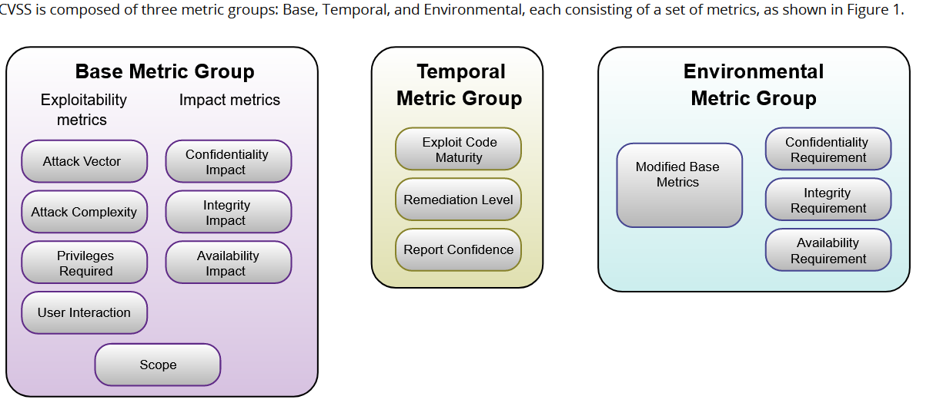

All 3 metric groups are important and comparing them is not completely fair given that they address different topics and issues. However, in terms of financial success, a good image for the company is required. A good reputation attracts clients. From this point of view, the environmental metric group is the most important. Given that the code of the DartsMasters applications is not extremely complex, the temporal metric group is not as important. The base metric group comes second in terms of importance because it is the biggest one and it ensures the quality required for a good and secure set of applications. The reason why it is less important than the environmental metric group is that because of the nature of the DartsMasters applications, the code is not overly complex, and it does not require extreme measures to ensure security. Since DartsMasters is a forum, similar to Reddit in functionality, user interaction is high, therefore the emphasis was put in securing the forms to prevent cross-site scripting and SQL injection. As a consequence, the main risk considered here is cross-site scripting, for which I have used the CVSS calculator. The results are as follows:

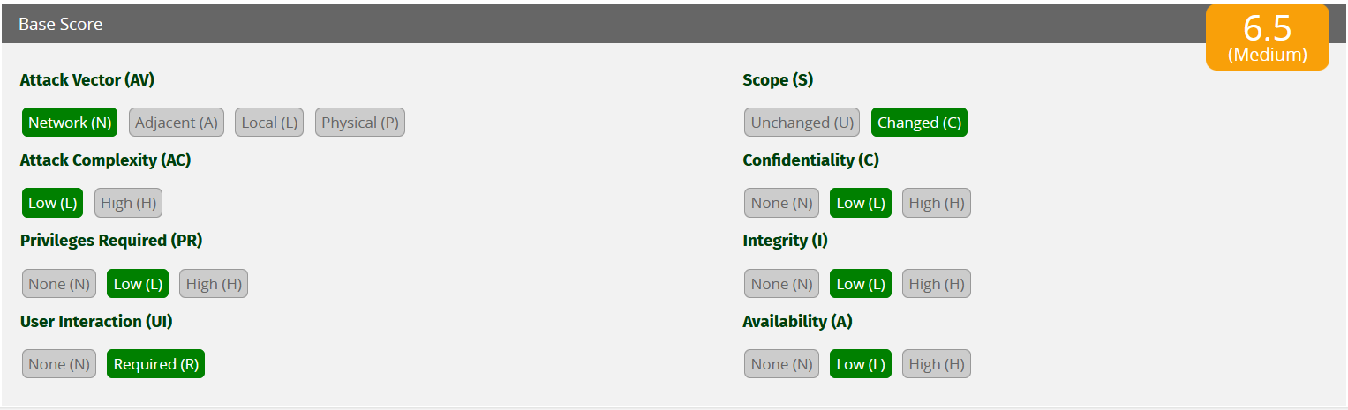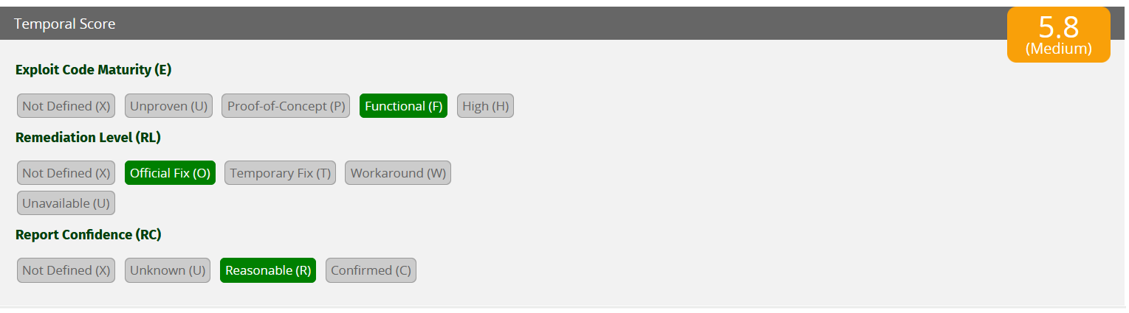 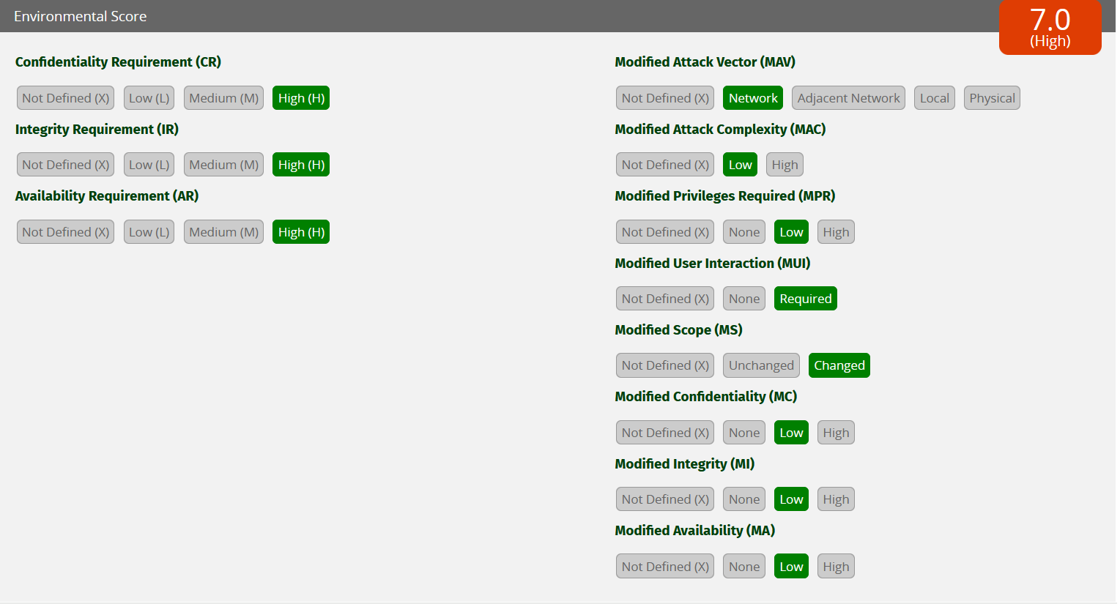

The results of the calculator are a confirmation of the order of priorities for said company, with the most focus needed on the environment metrics. Normally, on a larger scale company, the base metrics would be the most important. The other 2 metrics risks are medium, while the environment metrics risk is classed as high.